

Database Management System (CSDB-203)

**OBJECTIVES**

* To acquaint students with better understanding of DBMS
* To familiarize students with SQL
* To equip students with hands-on experience of implementing SQL for managing the database management system.

**INTRODUCTION**

This lab is about database management system. In this lab students will learn about Database from basic and they will also learn about the concept and usage of queries to manage and maintain the database using the SQL statements.

**DESIGN SKILLS / TECHNIQUES PRACTICED**

In the lab SQL statements will be used to manage and maintain the database. Students will get the knowledge regarding creating table and performing different operations on the tables.

**SOFTWARE TOOLS / TECHNOLOGY INVOLVED**

* Mysql

**EFFECTIVENESS**

This lab provides hands-on experience of implementing DBMS concepts using Structured Query Language, which ultimately helps students to understand the basic concept and usage of DBMS and provides them skills to manage and manipulate the database.

DBMS (CSDB 203) 

DEPARTMENT OF SOFTWARE ENGINEERING

NATIONAL UNIVERSITY OF MODERN LANGUAGES ISLAMABAD

**LAB OUTLINE**

| **Week #** | **TOPICS TO BE COVERED** |
| --- | --- |
| 1 | Introduction to My SQL Installation guidelines |
| 2 | Retrieving Data Using the SQL SELECT Statement |
| 3 | Restricting using where and Sorting Data using order by |
| 4 | Using Single-Row Character Functions to Customize Output |
| 5 | Using Single-Row Date Functions to Customize Output |
| 6 | Constructing ERD using VISIO or Erwin |
| 7 | Using DDL Statements to Create and Manage Tables |
|  | Lab Mid Exam/ Evaluation |
| 8 | Creating other schema objects like table level and column level constraints |
| 9 | Aggregating data using SQL Aggregate functions and group functions |
| 10 | data manipulation using SQL |
| 11 | Constructing enhanced ERD using visio or draw.io |
| 12 | Displaying Data from Multiple Tables by using joins |
| 13 | Use of Subqueries |
| 14 | Using the Set Operators |
| 15 | Views and indexes |
| 16 | Project Evaluation |

TABLE OF CONTENTS

**Lab 01: installation of mysql 5**

**LAB 2: Retrieving Data Using the SQL SELECT Statement 2**

Purpose 2

Lab Activity/Code 2

**LAB 3: Restricting using where clause and Sorting Data using order by clause 9**

**Purpose** 9

**Lab Activity/Code** 10

**LAB 4: Using Single-Row Character Functions to Customize Output 21**

**Purpose** 21

**Lab Activity/Code** 21

**LAB 5: Using Single-Row Date Functions to Customize Output & Type conversion 29**

**Purpose** 29

**Lab Activity/Code** 29

**LAB 6: Constructing ERD using VISIO or draw.io 33**

**Purpose** 33

**Lab Activity/Code** 33

**LAB 07 :Using DDL Statements to Create and Manage Tables 36**

**Purpose** 36

**Lab Activity/Code** 36

**Lab 08 : Creating other schema objects like table level and column level constraints 41**

**Purpose** 41

**Lab activity/code** 41

**Lab 09: Aggregating data using SQL Aggregate functions and group functions 47**

**Purpose** 47

**Lab Activity/Code** 48

**Lab 10: Constructing enhanced ERD using visio or draw.io 58**

**Purpose** 58

**Lab Activity/Code** 58

**Lab 11: Use of joins for displaying data from multiple tables 60**

**Purpose** 60

**Lab Activity/Code** 60

**Lab 12: Sub Queries 64**

**Purpose** 64

**Lab Activity/Code** 64

**Lab 13: Set Operations in MySQL 72**

**Purpose** 72

**Lab Activity/Code** 72

**Lab 14: SQL project evaluation lab 78**

**Purpose** 78

# **LAB 1: Installation of RDBMS (MySQL)**

## **Purpose**

* To discuss the role of rdbms
* To install MySQL

## **Lab Activity/Code**

**Step 1:**

Go to mysql.com

**Step 2**

Go to downloads and select mysql community gpl downloads and select mysql installer for windows

**Step 3**

It will show you **Generally Available (GA) Releases**. Where we can see two different installers, one is a web community installer which comes as a little file and another one is MySQL installer community. Click the Download button on the second one (mysql-installer-community)

**Step 4**

It will ask your MySQL credentials to download the .msi file. If you have your credentials, you can log in or else if you wish to sign up now you can click on the green coloured signup button.

If you are not interested in login or sign up for now, you can directly go and click on **No thanks, just start my download** option. It will download selected MySQL for you on your local machine



**Step 5**

Go to your downloads folder where you can see the **mysql-installer- community** file, right click on that file and click **Install** option.



This window configures the installer, in the middle, it may ask you for permissions to change your computer settings or firewall confirmation, you can accept and then it will take a few seconds to configure the installer.



**Step 6:** Read the license agreement and accept the license terms.

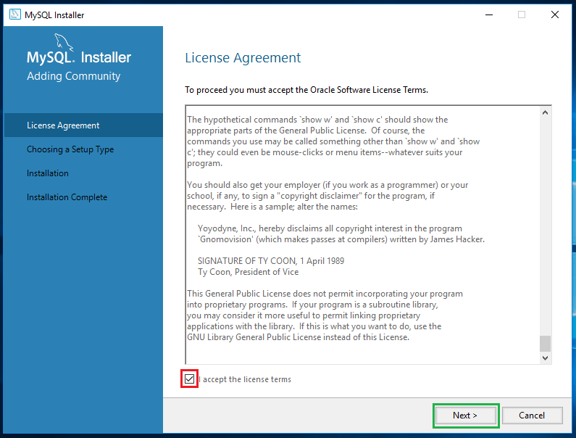

**Step 7**

This window provides you to set up different types of MySQL installations. You can set up Mysql in 5 different types as provided below. Now I am selecting the server only not I am a developer so that I need all the products which help my development purposes. Click on Next.



**Step 8**

Based on your Windows configuration, it may prompt you like “One or more product requirements have not been satisfied”. You can just click on YES.

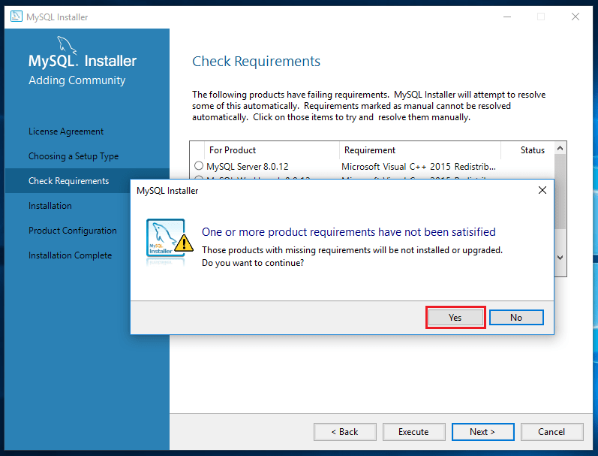

**Step 9**

**Click execute**

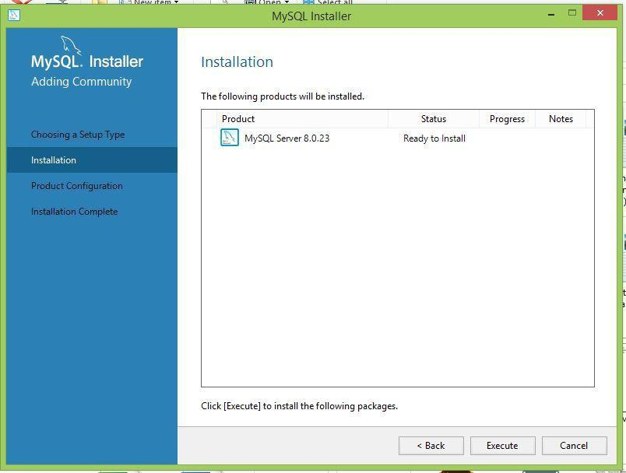

**Step 11**

Upon successful execution of all required products, now the MySQL allows us to configure the server settings. Click on Next to configure the server

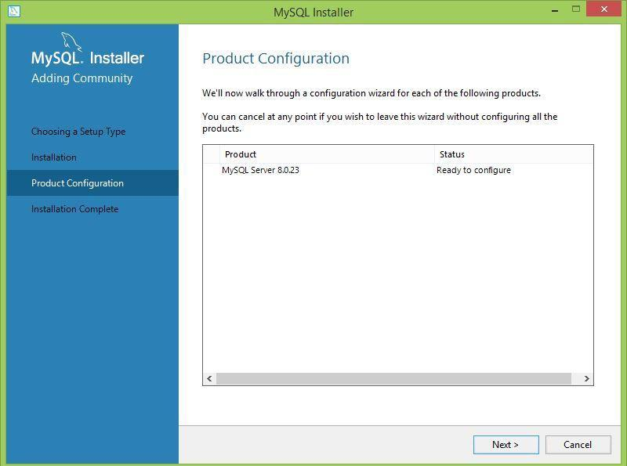

**.**

**Step 12**

**Select default setting**

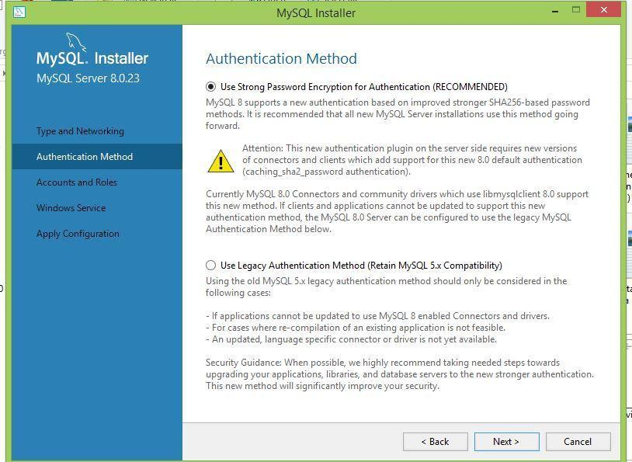

**Step 13**

**Add password**

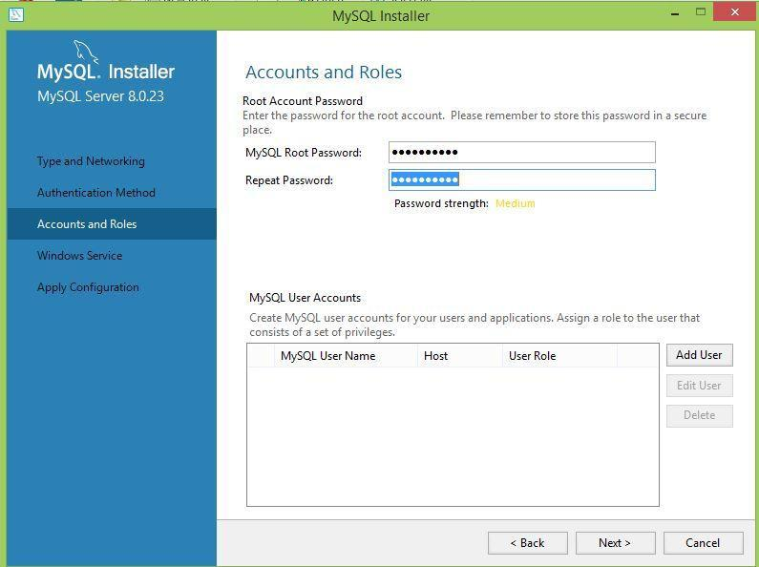

**Step 14**

**Select default setting**

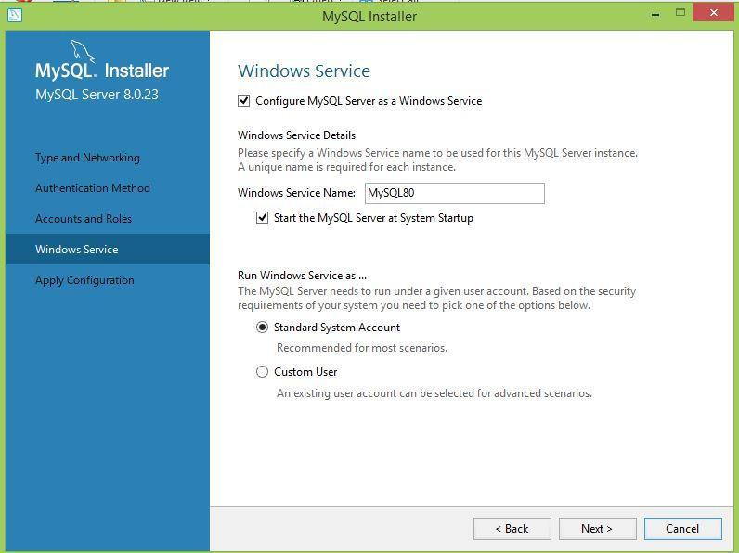

**Step 15**

Click on **reconfigure**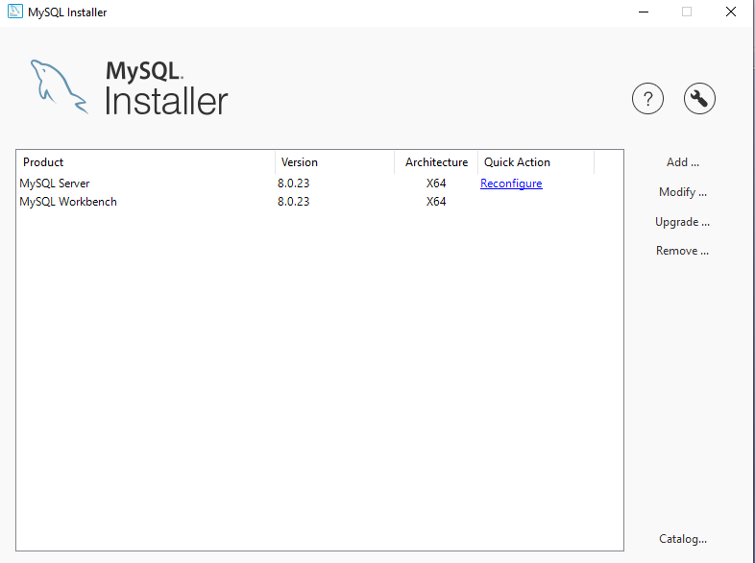

Step 16

Check named pipe and shared memory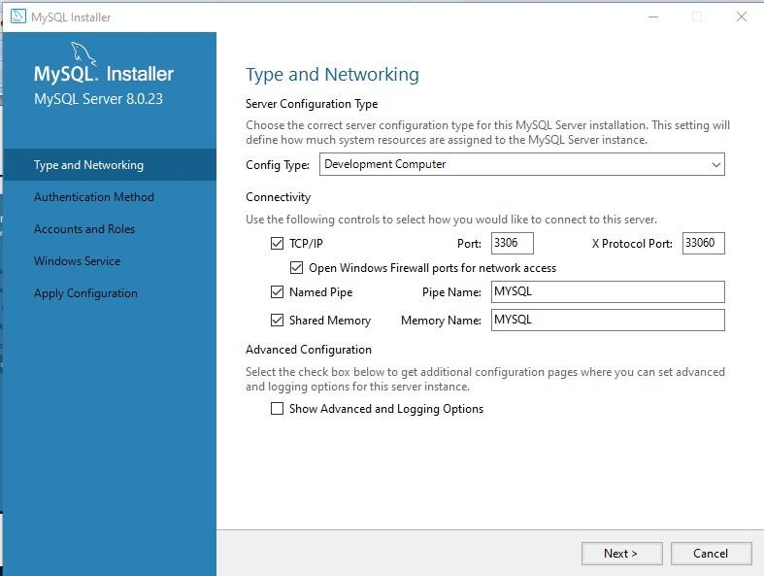

Step 17 Click next



**Step 18**

Enter root password i.e password in my case and click check it which shows green symbol and click next

**Step 19**

Again select next



**Step 20**

Click on execute and than finish

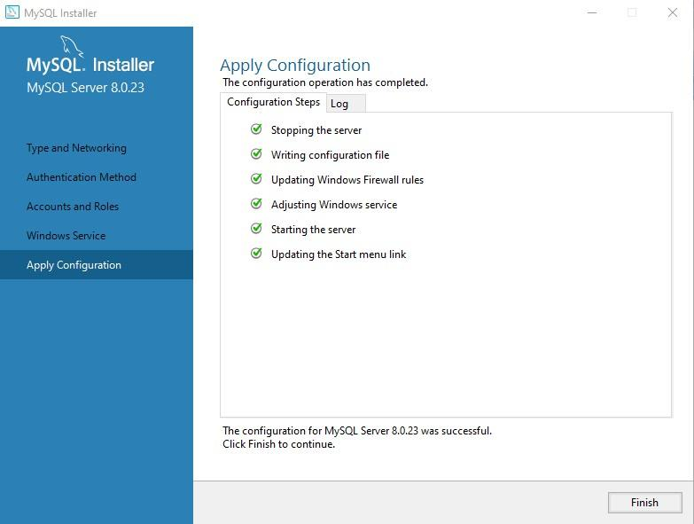

**Step 21**

Now go back to mysql.com and select downloads and select mysql community gpl downloads and select mysql work bench and click on download button in below screen



**Step 22 select complete**

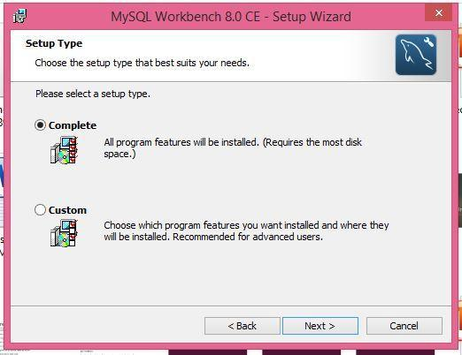

**Step 23**

Work bench is installed and screen shown is click on local instance and enter your password



# **LAB 2: Retrieving Data Using the SQL SELECT Statement**

## **Purpose**

* To list the capabilities of SQL SELECT statements
* To execute a basic SELECT statement

## **Lab Activity/Code**

**SQL KEYWORDS**

Basic SELECT Statement



* + SELECT identifies the columns to be displayed.
  + FROM identifies the table containing those columns.

**Selecting All Columns**

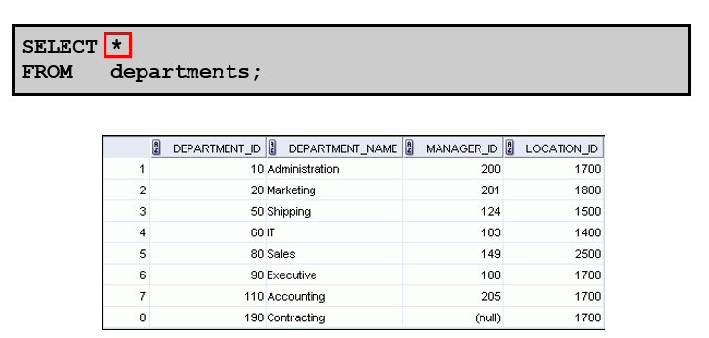

**Selecting Specific Columns**

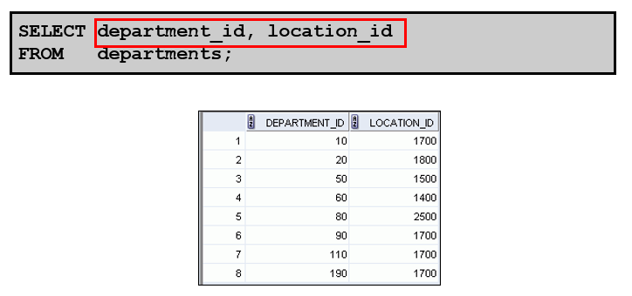

**Writing SQL Statements**

* + SQL statements are not case-sensitive.

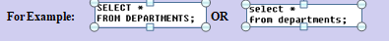

* + SSQL statements can be entered on one or more lines.



* + Keywords cannot be abbreviated or split across lines

.

* + Clauses are usually placed on separate lines

.

* + Indents are used to enhance readability.



* + In SQL*Plus, you are required to end each SQL statement with a semicolon (;).

**Arithmetic Expressions**

Create expressions with number and date data by using arithmetic operators.

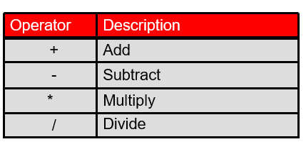

**Using Arithmetic Operators**

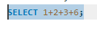

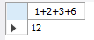

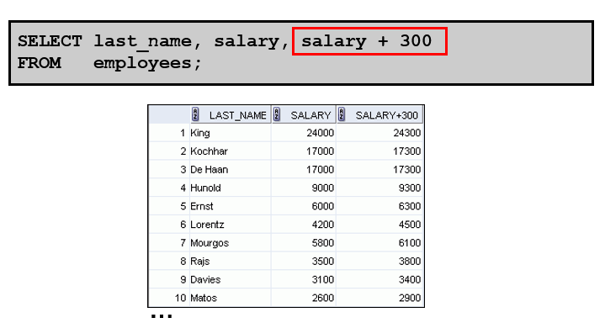



**Operator Precedence**

* **Multiplication and division take priority over addition and subtraction.**
* **Operators of the same priority are evaluated from left to right.**
* **Parentheses are used to force prioritized evaluation and to clarify statements**



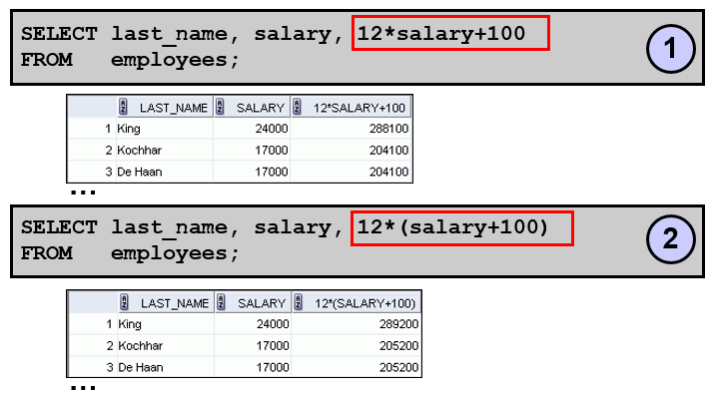

**Defining a Column Alias**

A column alias:

* + Renames a column heading
  + Is useful with calculations
  + Immediately follows the column name (There can also be the optional AS keyword between the column name and alias.)
  + Requires double quotation marks if it contains spaces or special characters, or if it is case-sensitive

**Using Column Aliases**

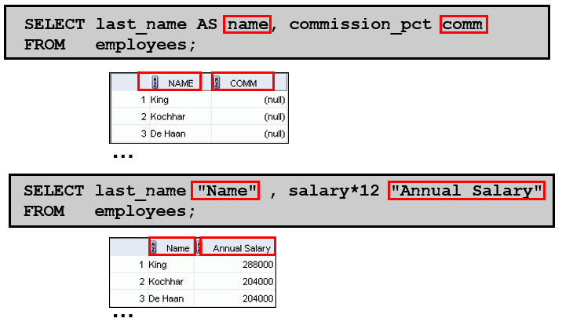

**Concatenation Operator**

A concatenation operator:

* + Links columns or character strings to other columns
  + Is represented by command concat
  + Creates a resultant column that is a character expression



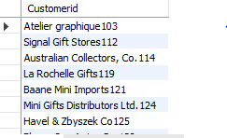

**Duplicate Rows**

The default display of queries is all rows, including duplicate rows.



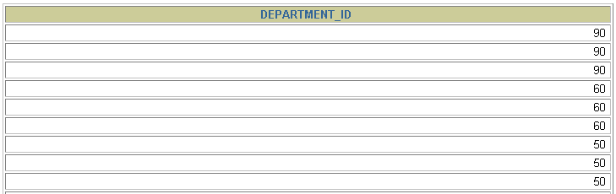

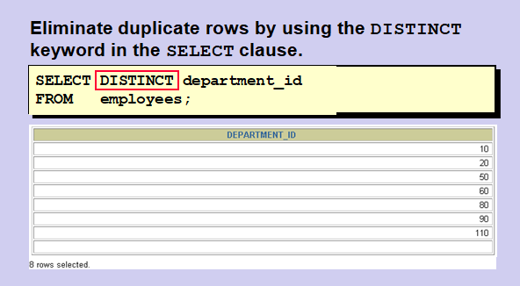

**Displaying the Table Structure**

* + Use the DESCRIBE command to display the structure of a table.
  + Or, select the table in the Connections tree and use the Columns tab to view the table structure.

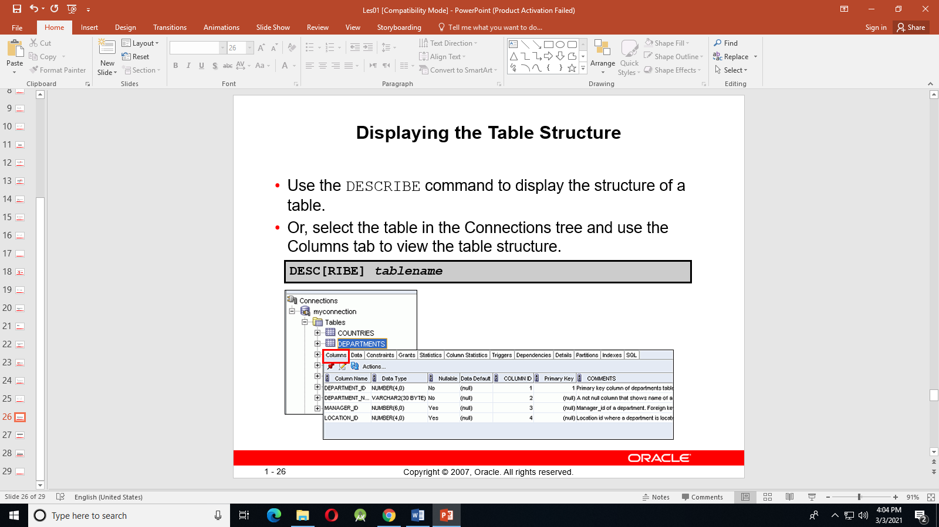

**Using the DESCRIBE Command**

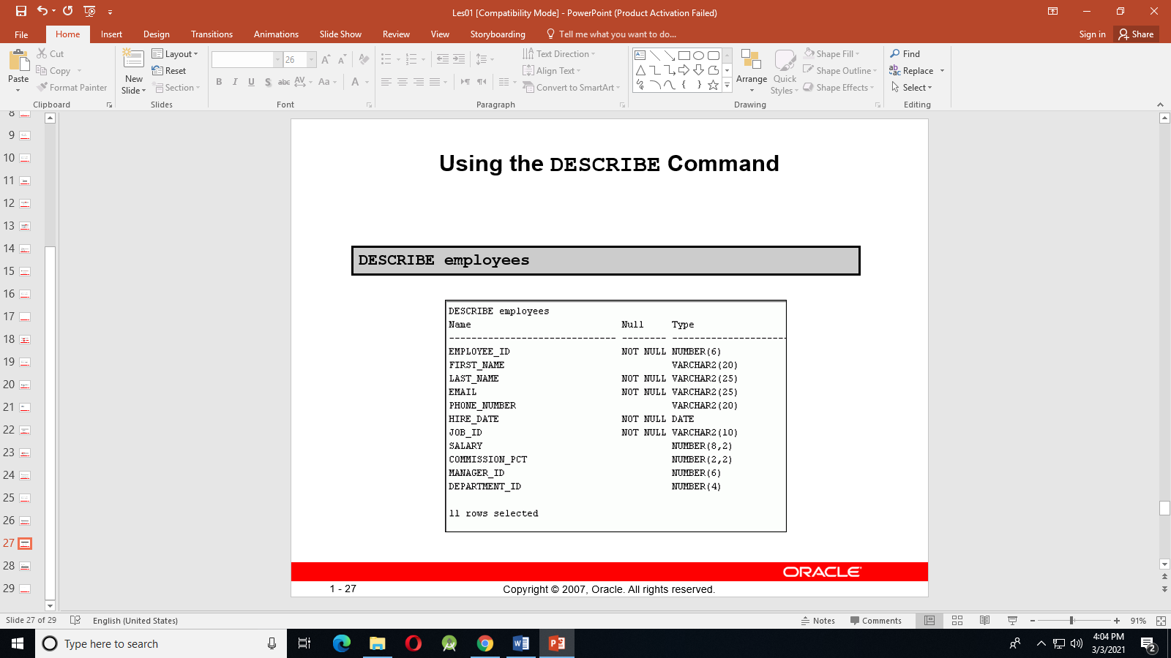

# **LAB 3: Restricting using where clause and Sorting Data using order by clause**

## **Purpose**

* + To limit the rows that are retrieved by a query
  + To sort the rows that are retrieved by a query
  + To use ampersand substitution to restrict and sort output at run time

## **Lab Activity/Code**

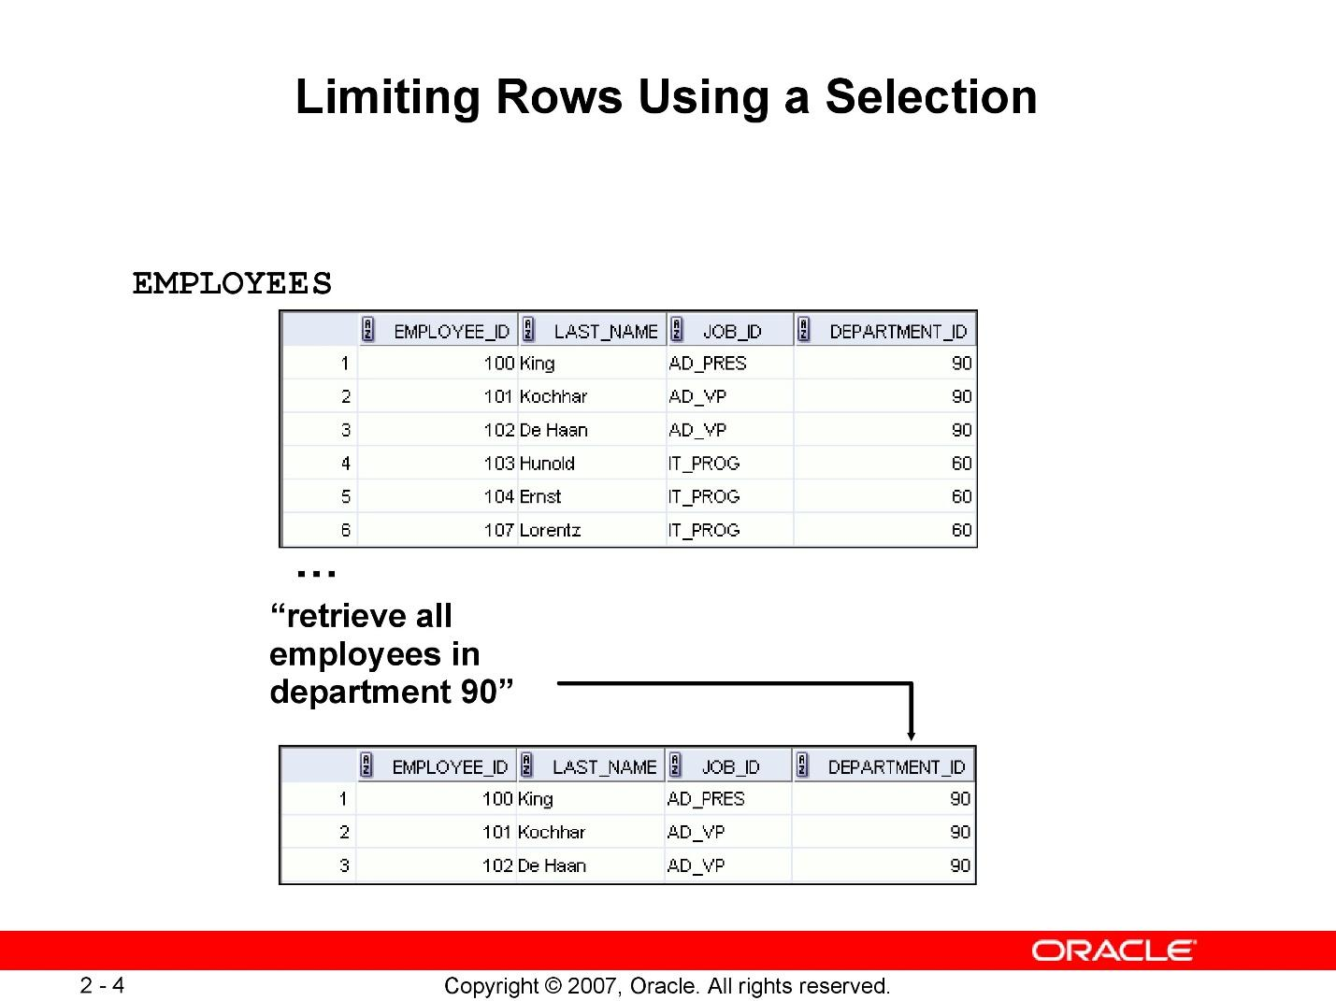

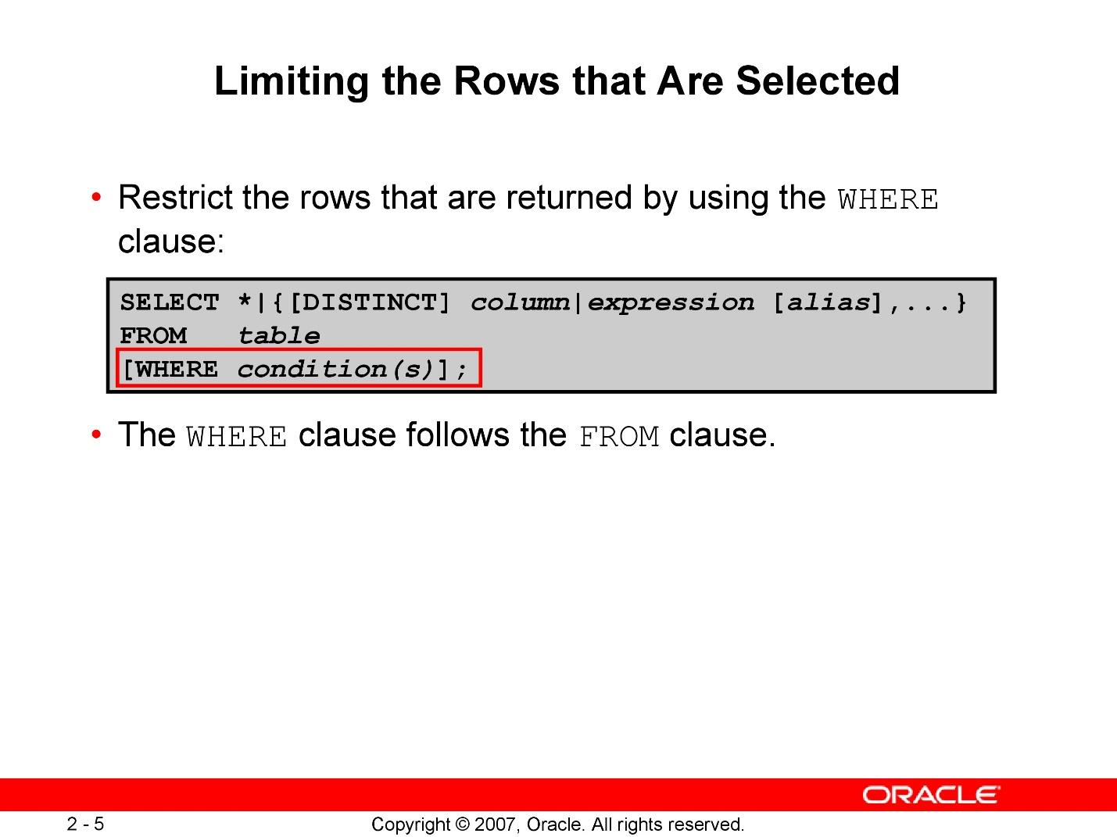

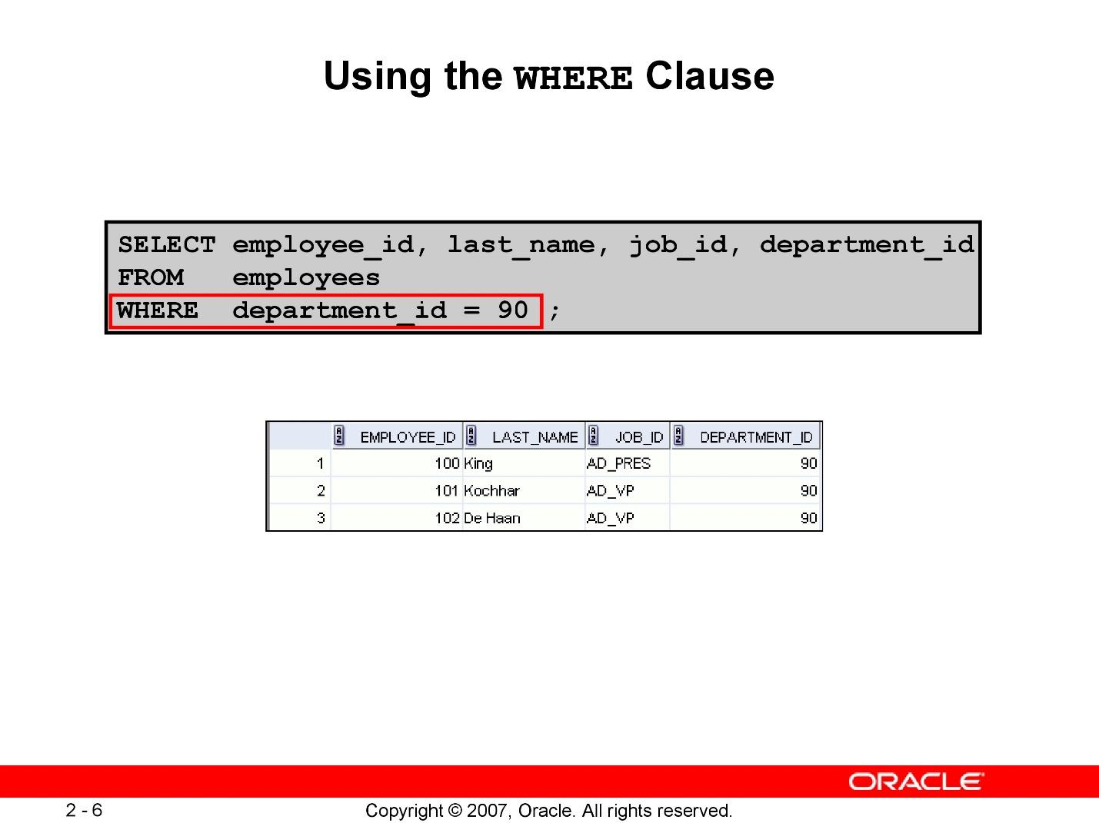

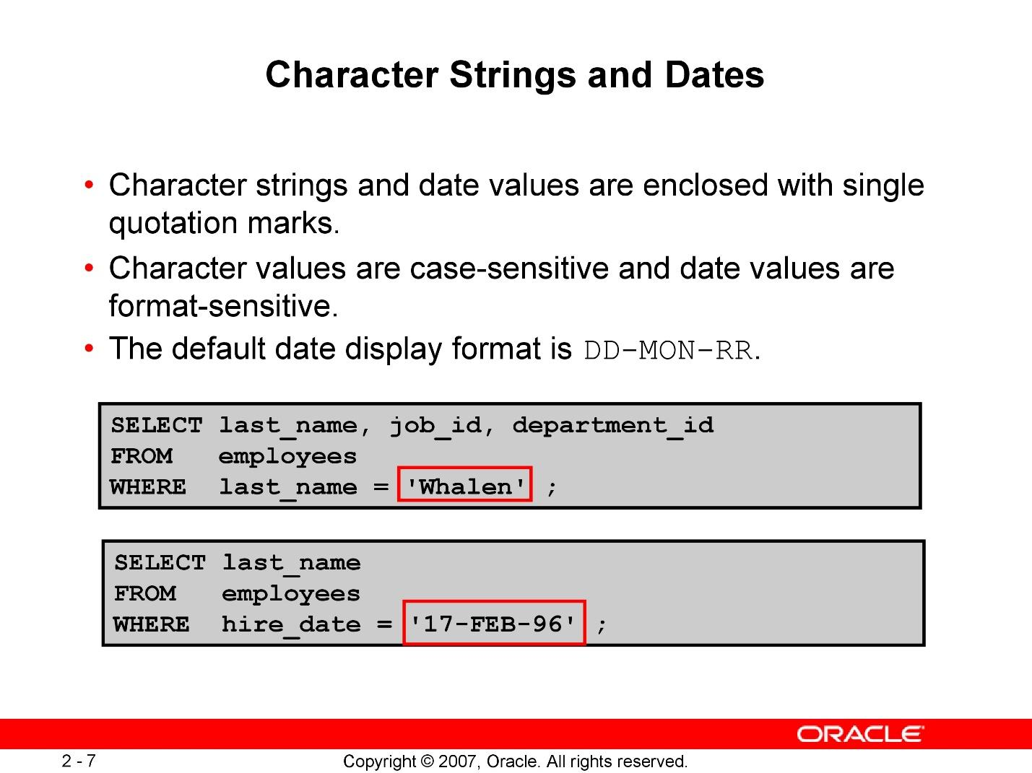

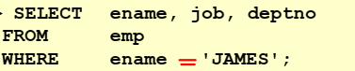

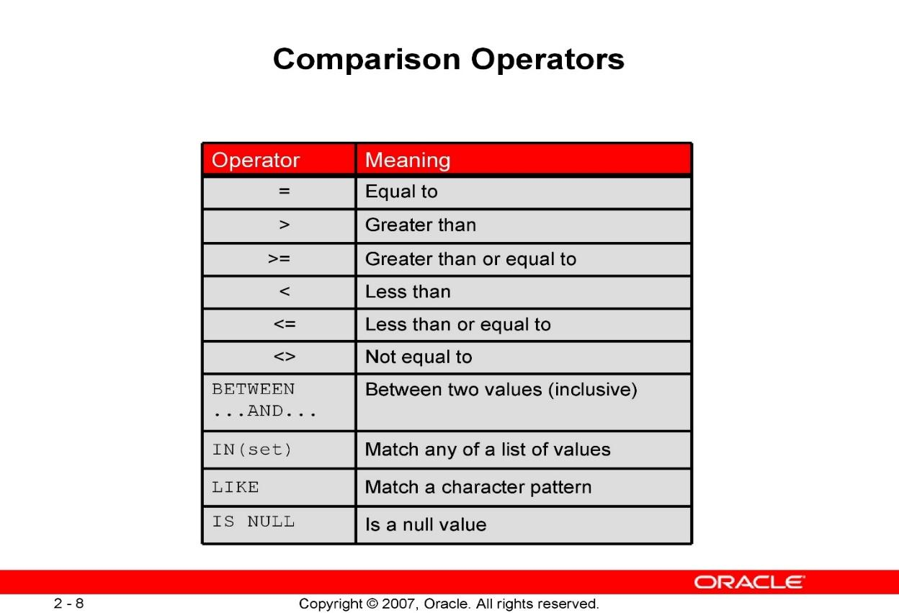

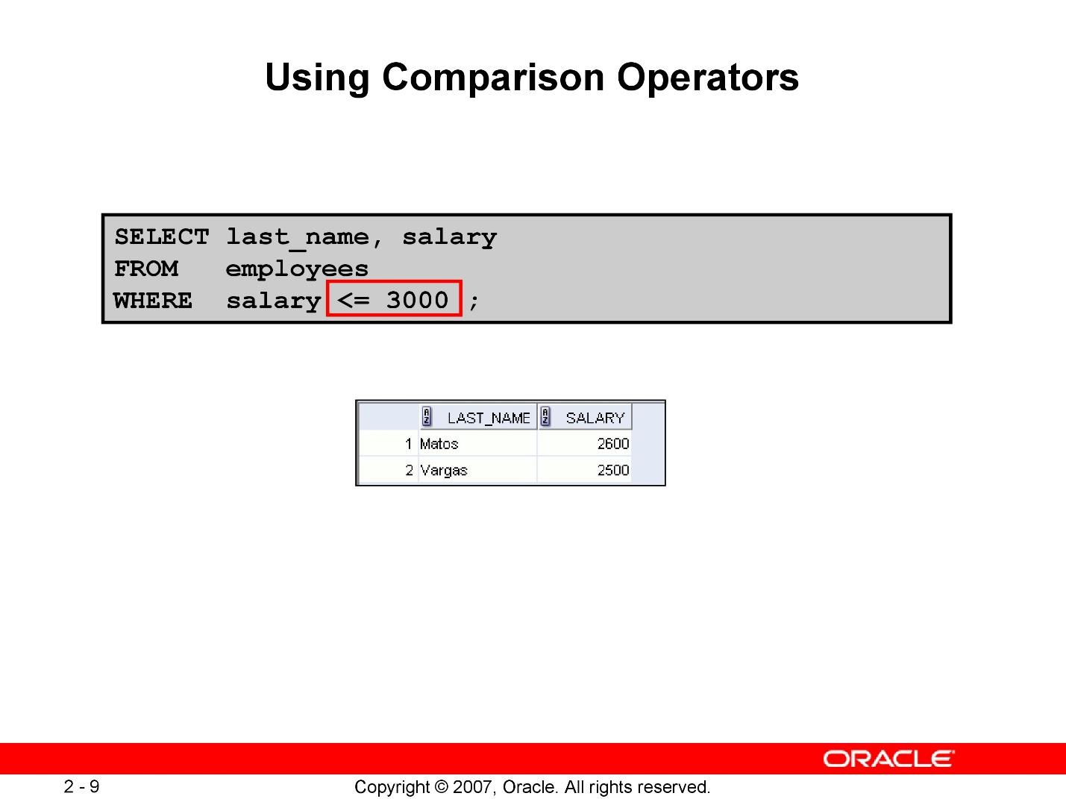

**OTHER COMPARISON OPERATORS**

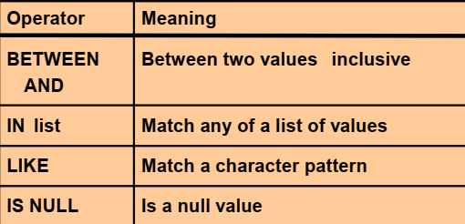

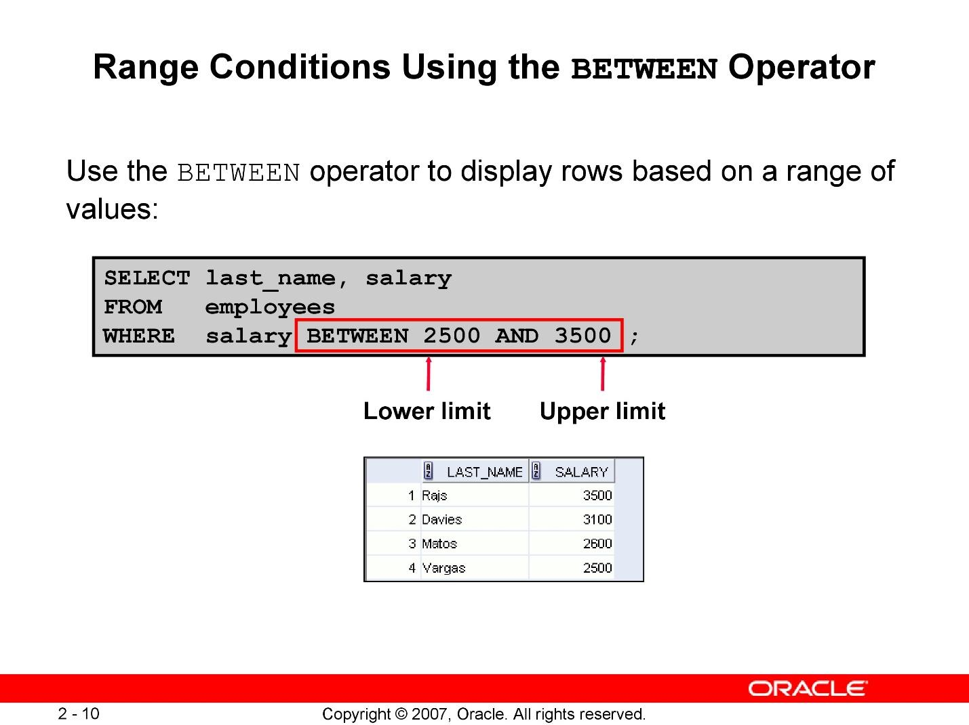

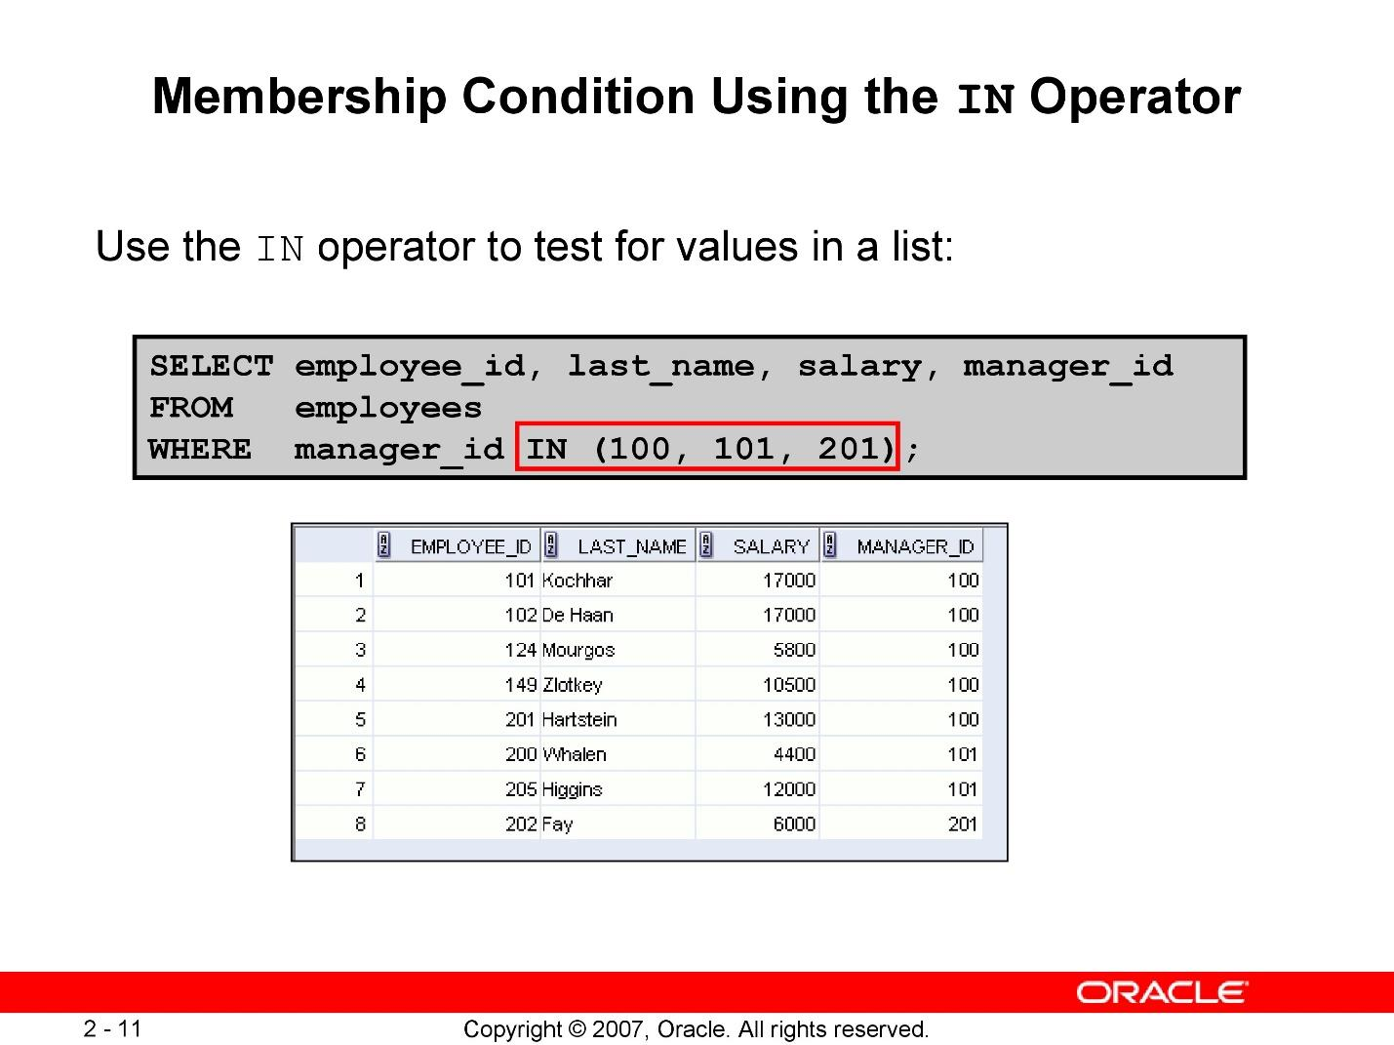

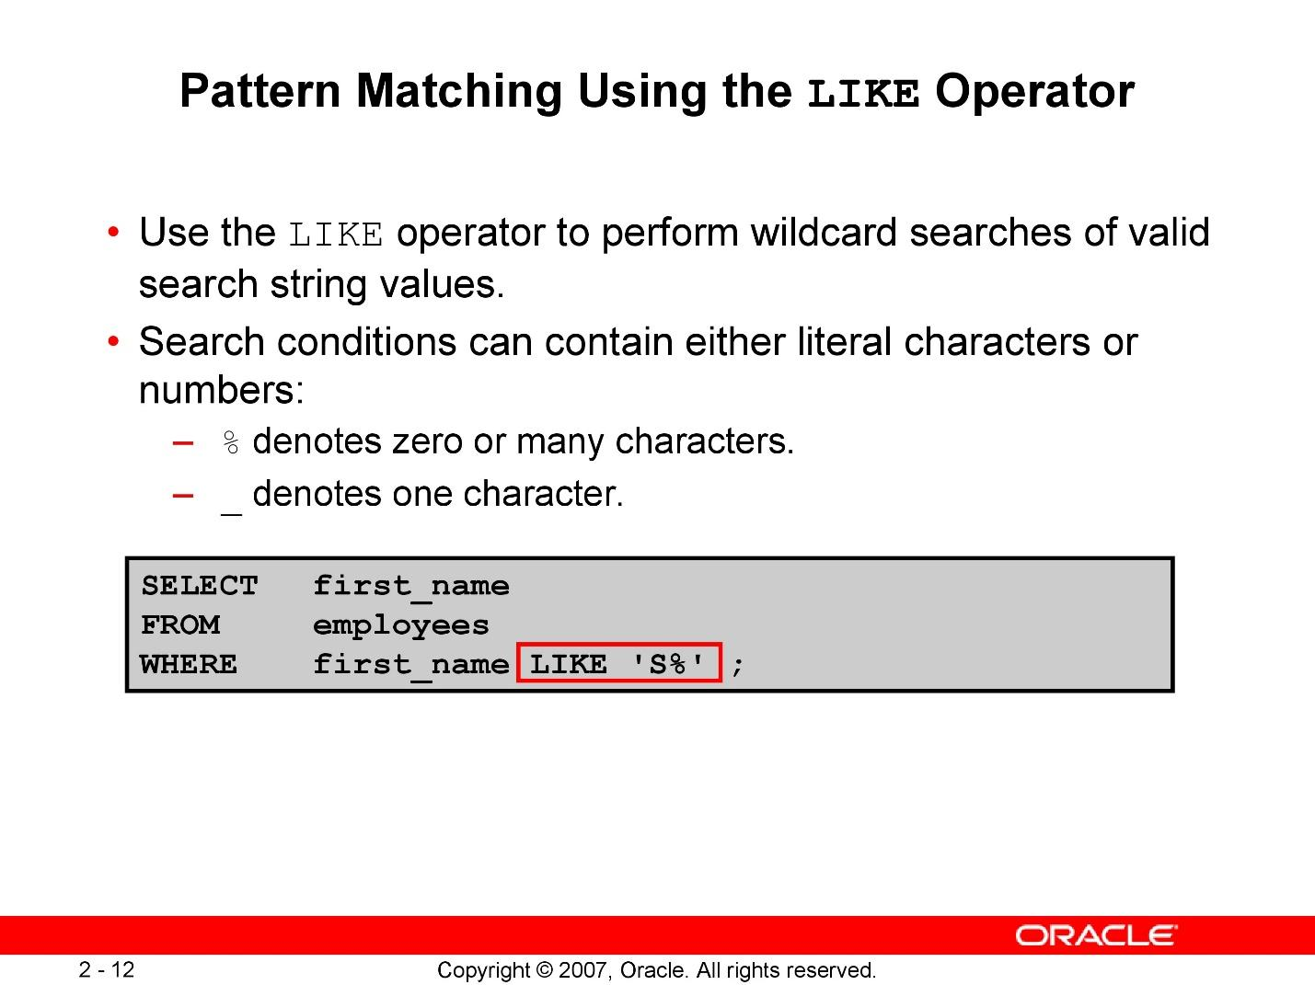

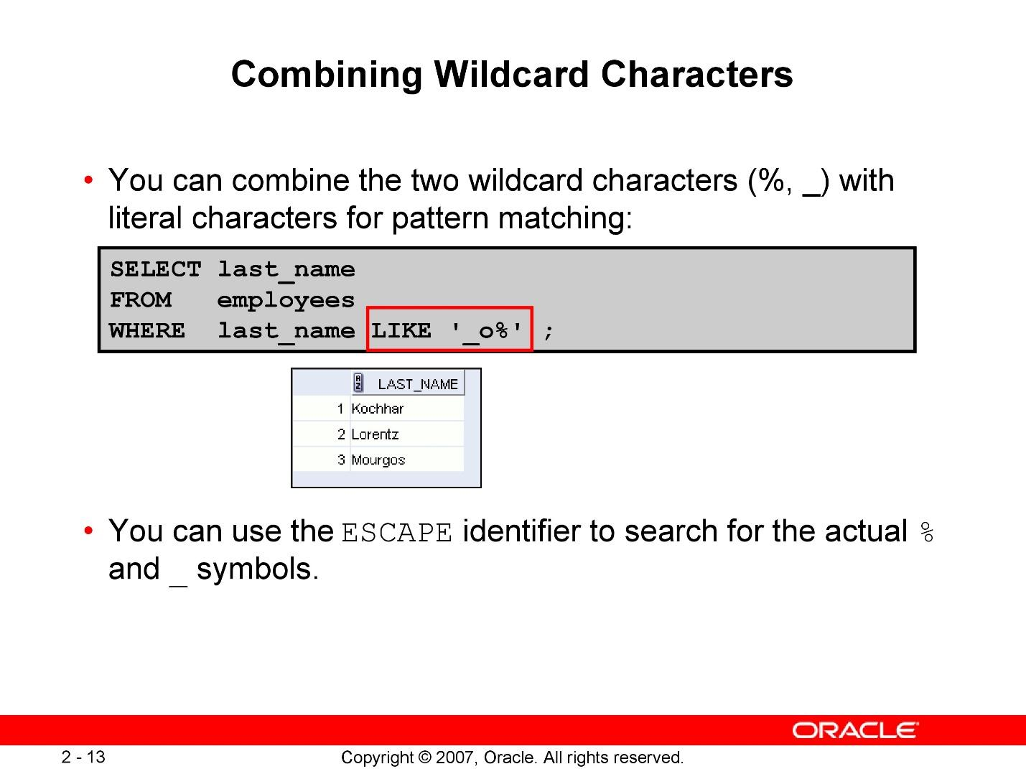

**Using Null operator**

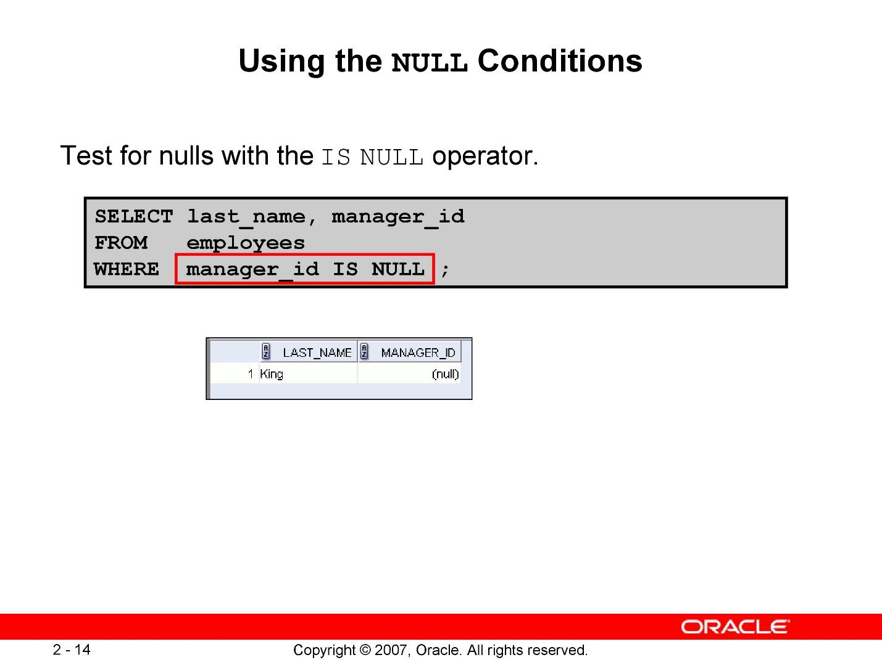

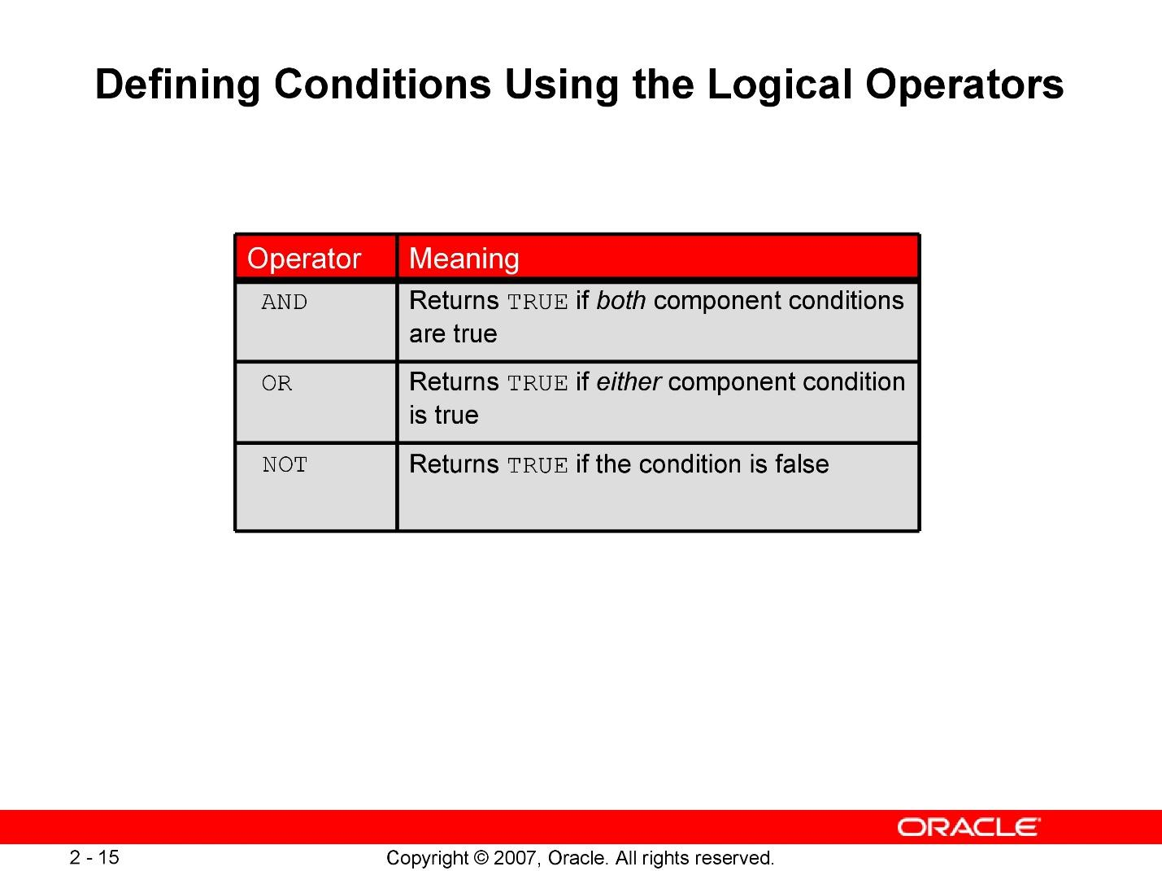

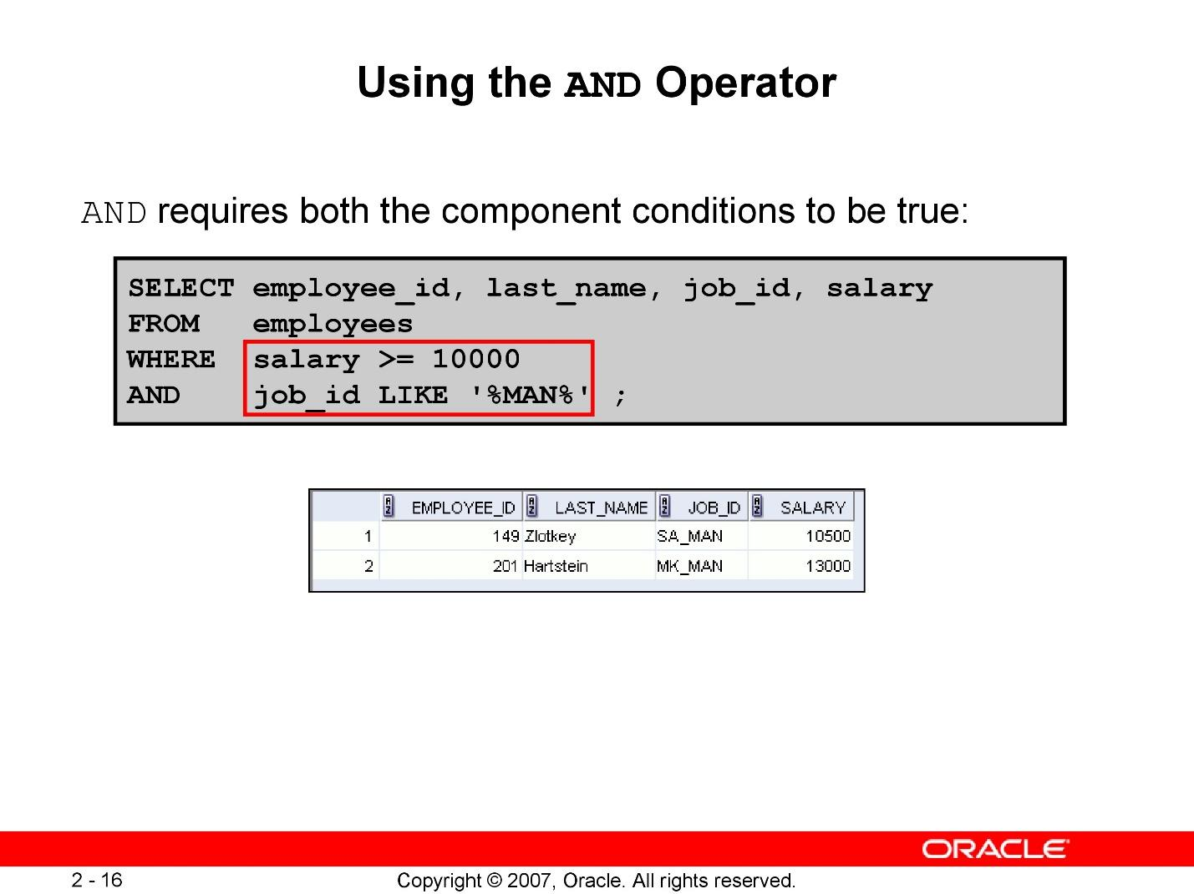

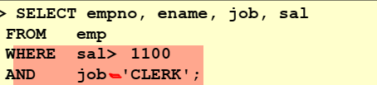

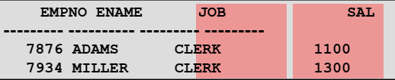

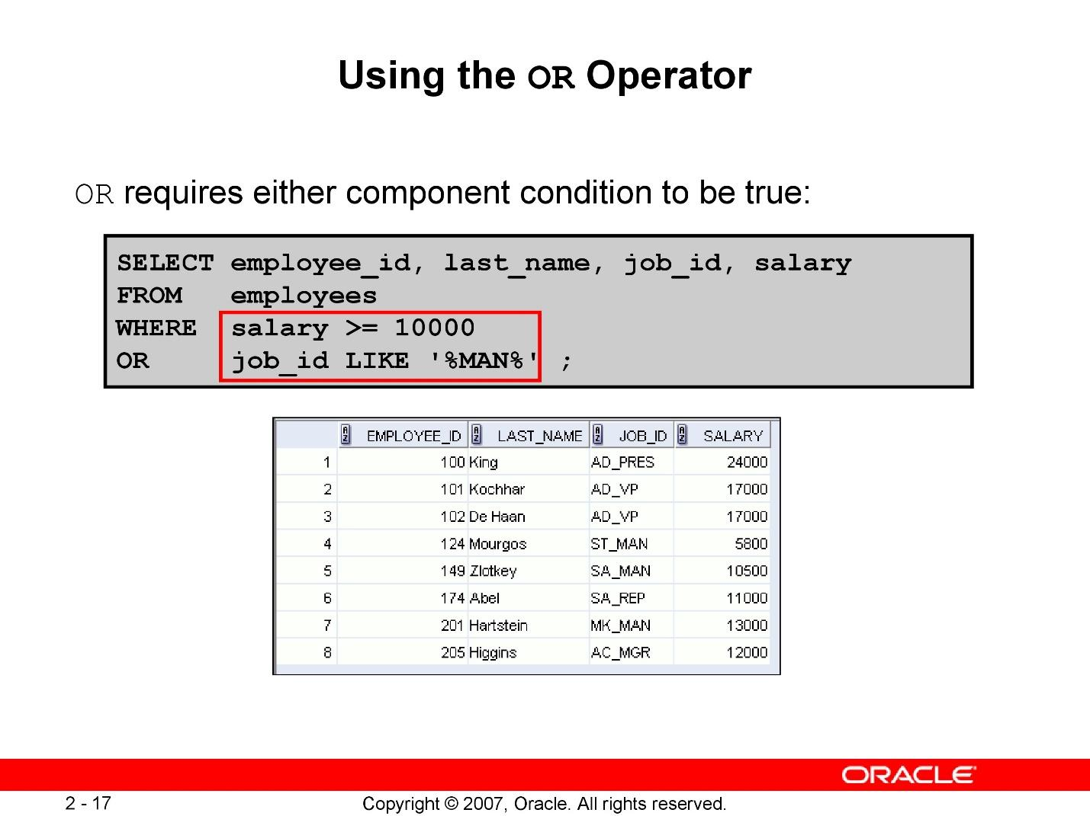

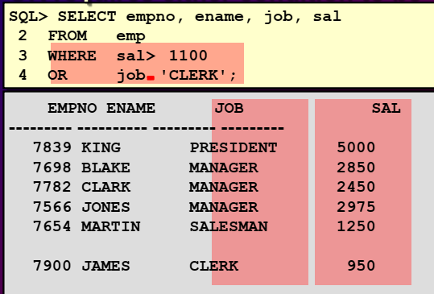

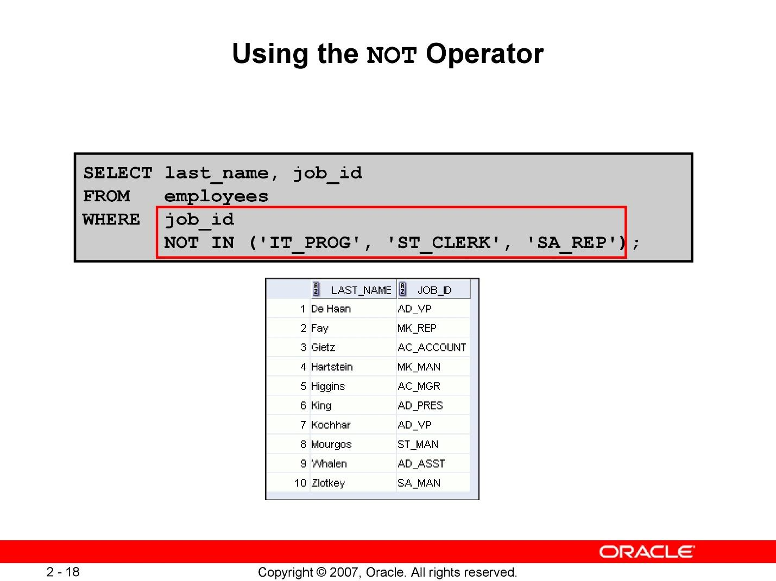

**RULES OF PRECENDENCE**

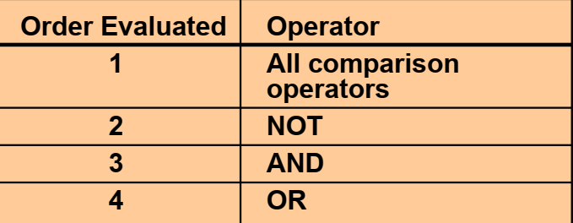

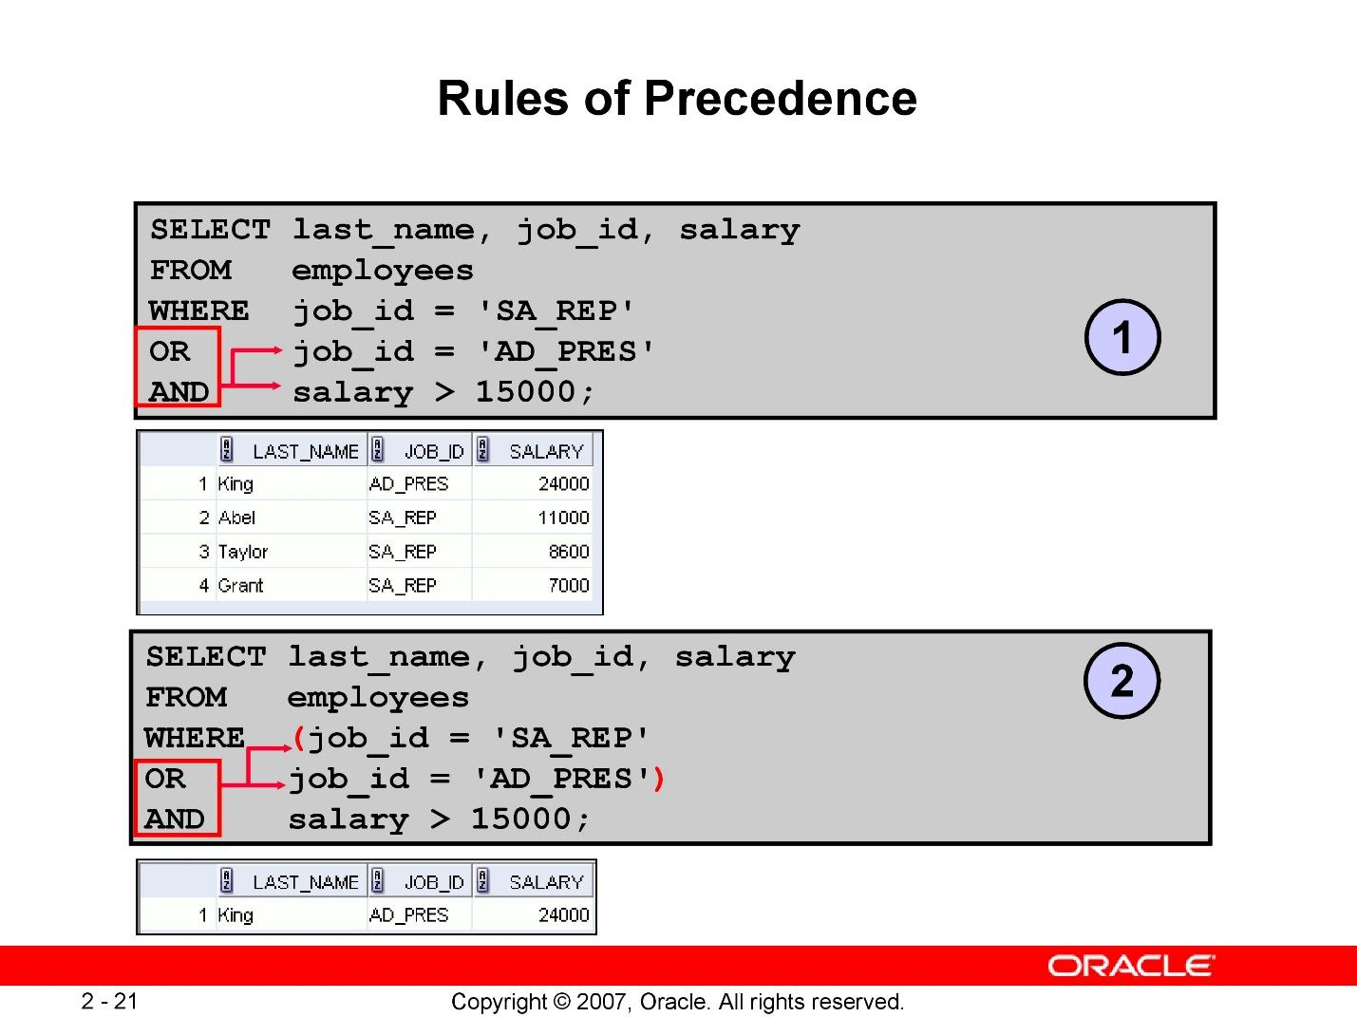

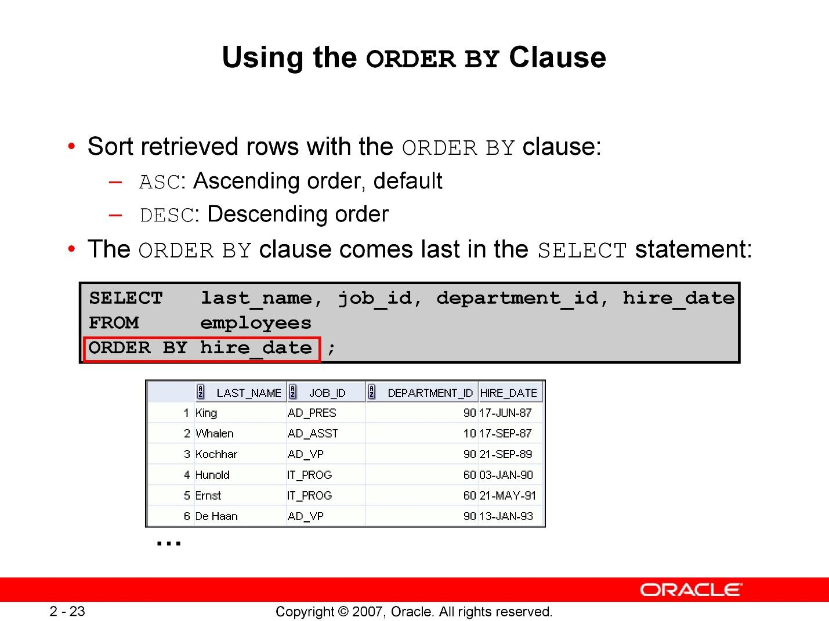

**SORTING IN DESCENDING ORDER**

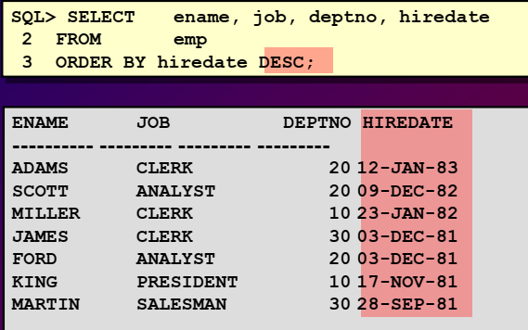

**SORTING BY COLUMN ALIAS**

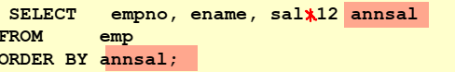

**SORTING MULTIPLE COLUMNS**

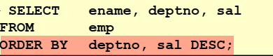

# **LAB 4: Using Single-Row Character Functions to Customize Output**

## **Purpose**

* + **To describe various types of functions available in SQL**
  + **To use character, number, and date functions in SELECT statements**

## **Lab Activity/Code**

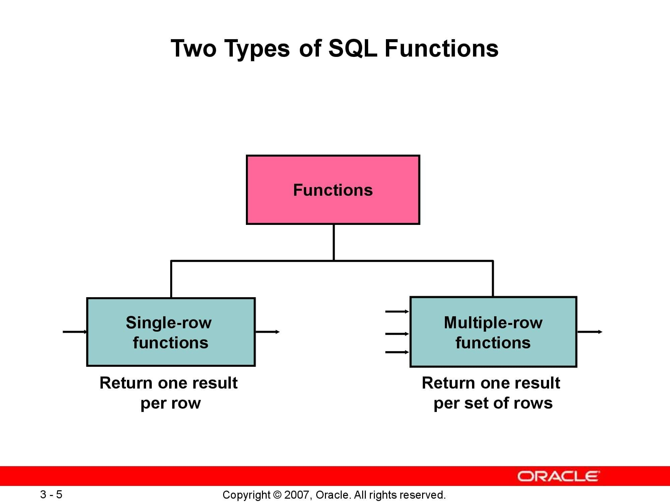

**SINGLE ROW FUNCTIONS**

**Single row functions are the one who work on single row and return one output per row.**

**For example, length and case conversion functions are single row functions.**

**Single row functions can be character functions, numeric functions, date functions, and conversion functions.**

**These functions require one or more input arguments and operate on each row, thereby returning one output value for each row.**

**Single row functions can be used in SELECT statement, WHERE and ORDER BY clause.**

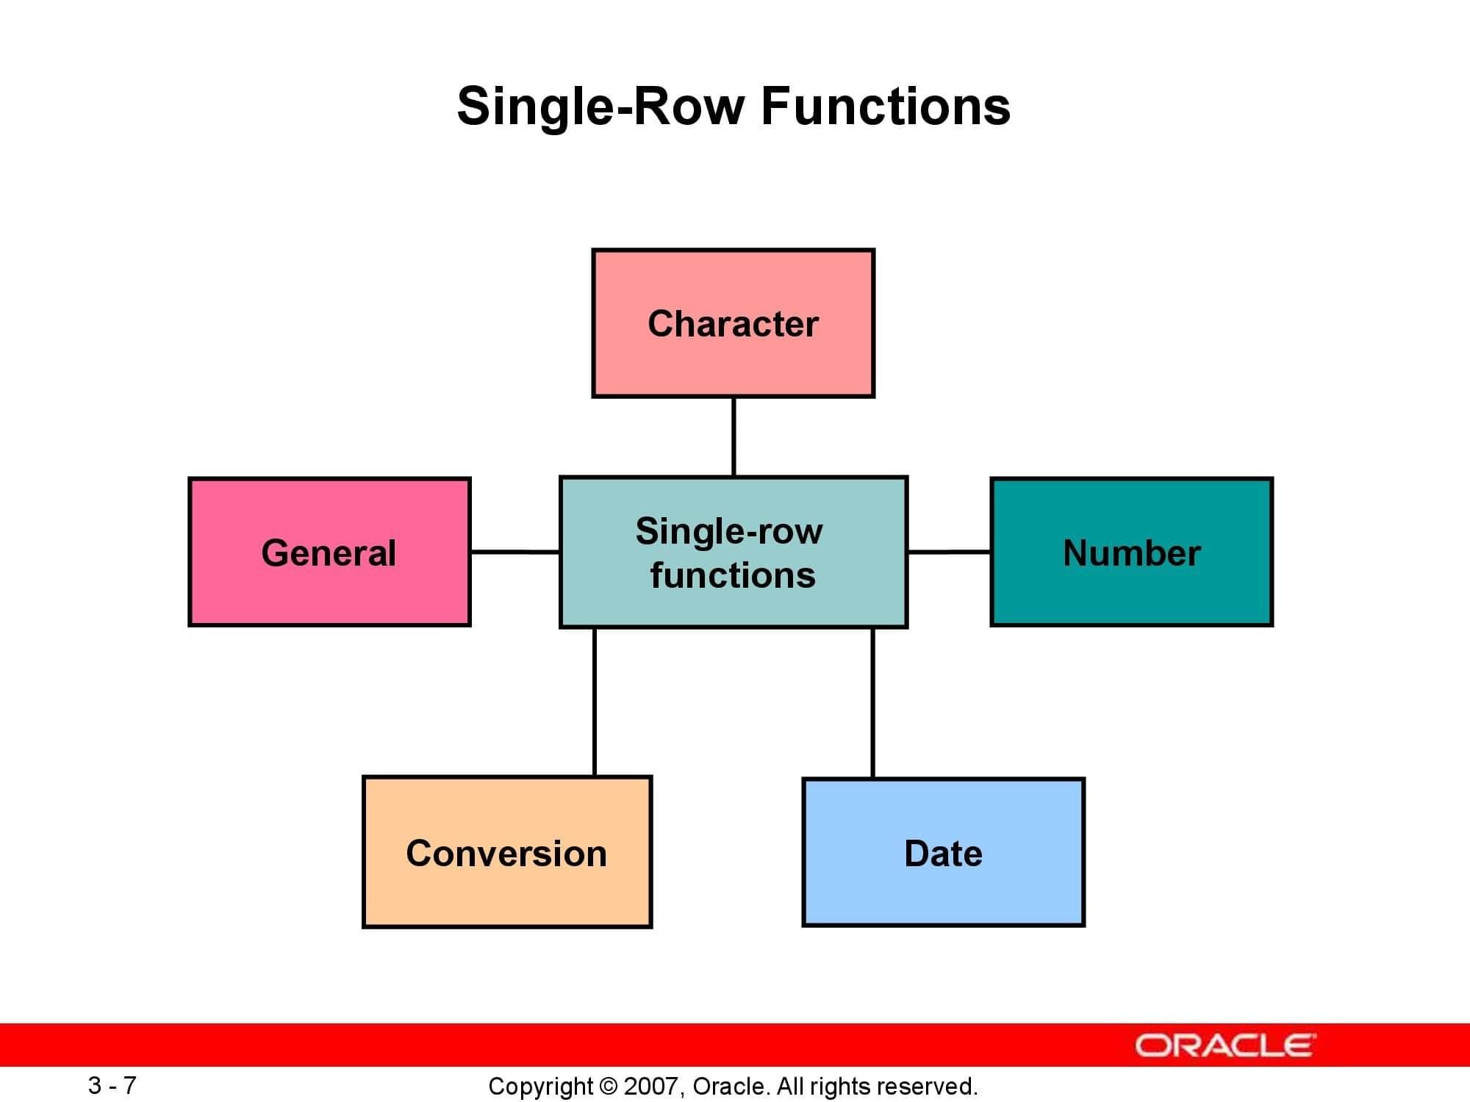

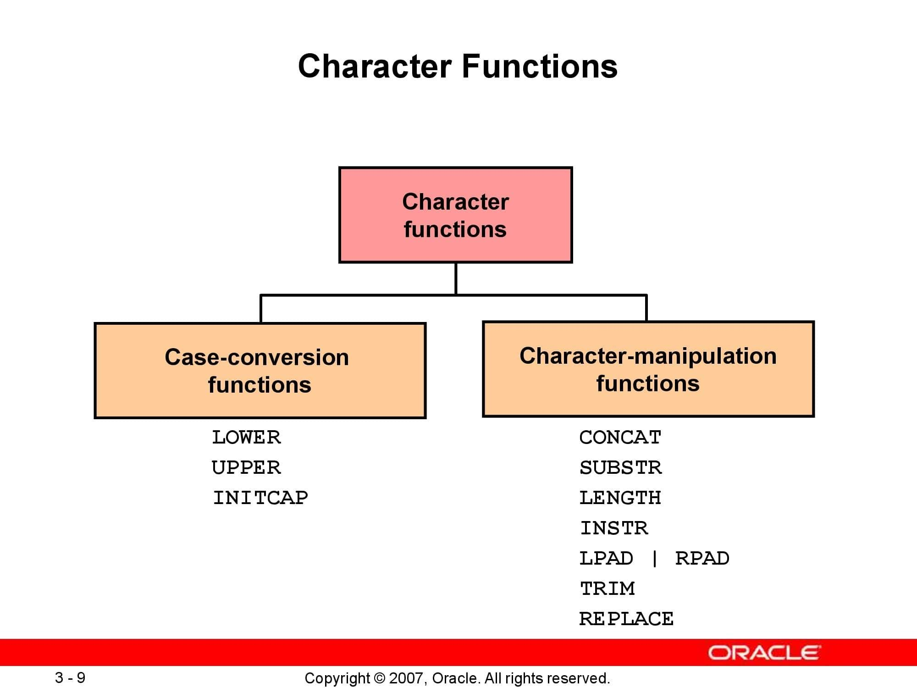

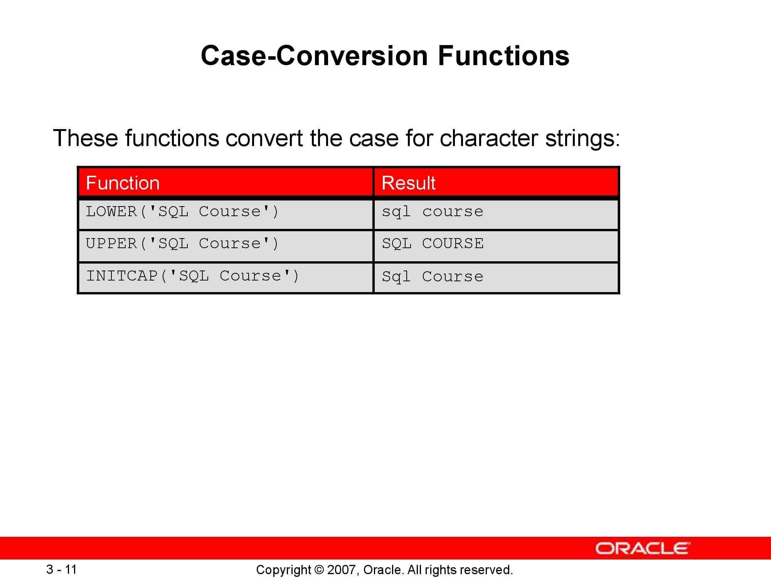

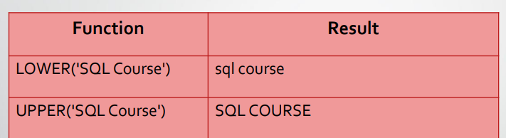

**USING CASE CONVERSION FUNCTIONS**

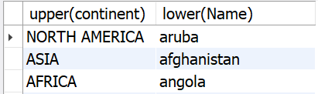

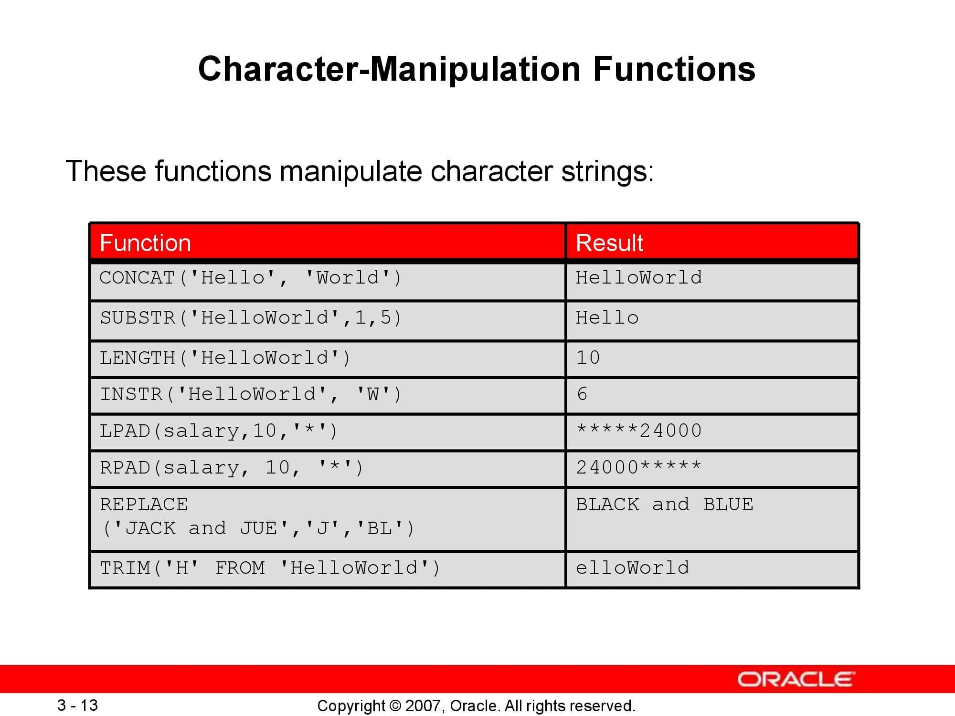

**EXAMPLE OF CHRACTER MANUPULATION FUNCTIONS**

1. **SUBSTR AND INSTR**

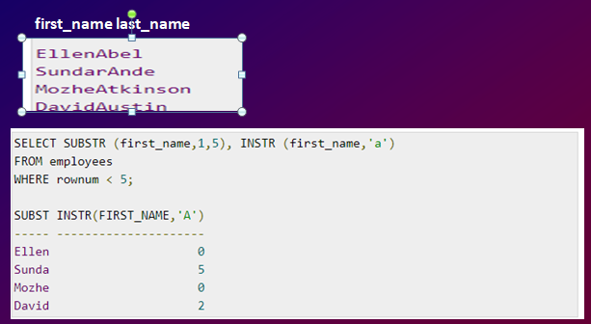

1. **TRIM**

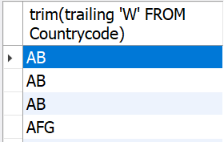

1. **RPAD**

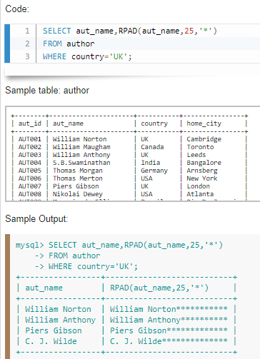

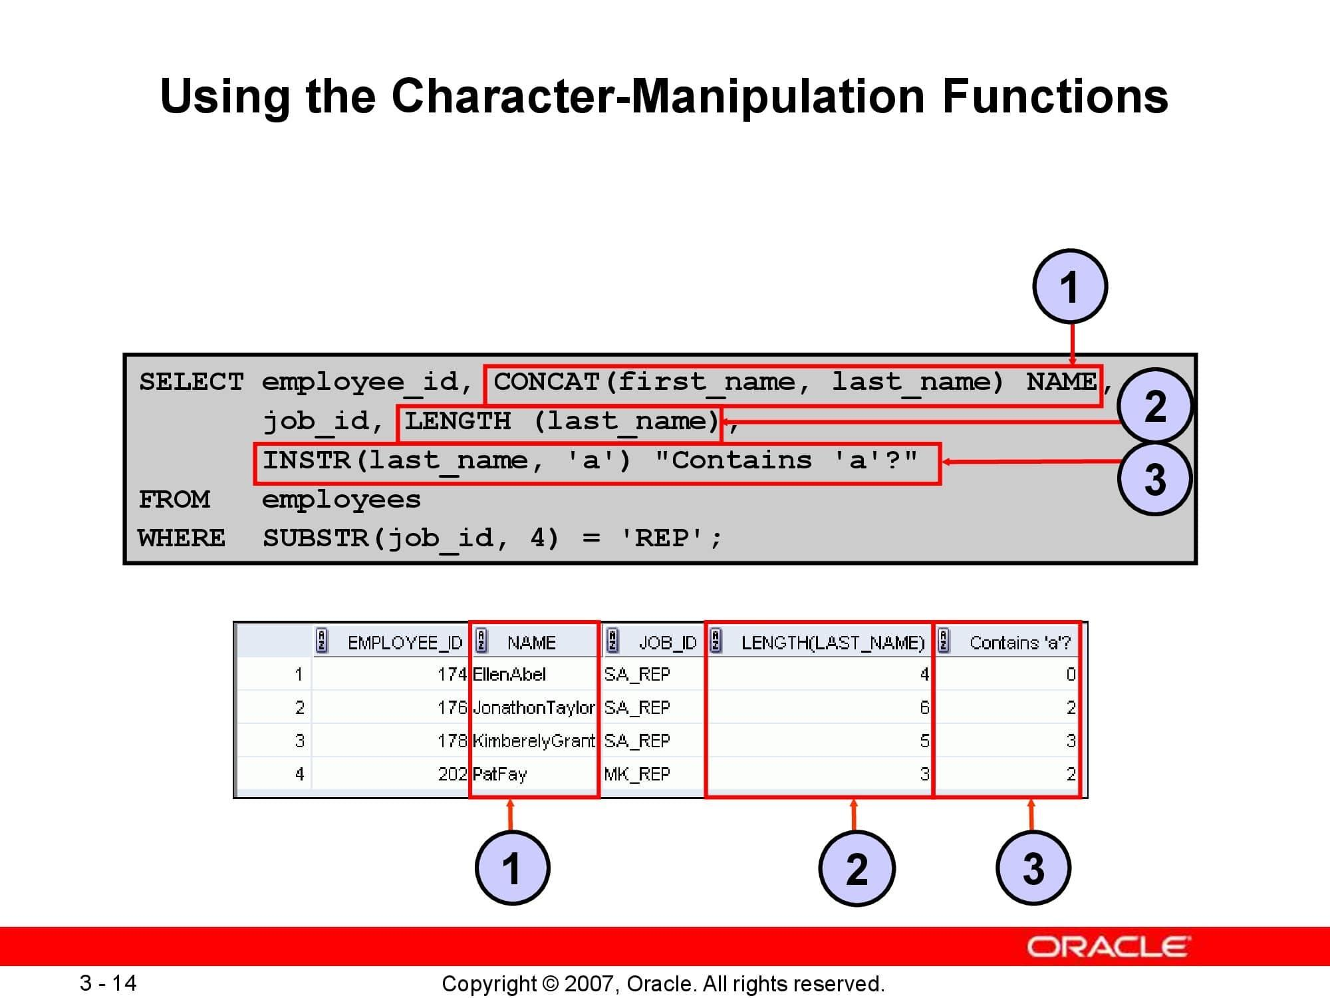

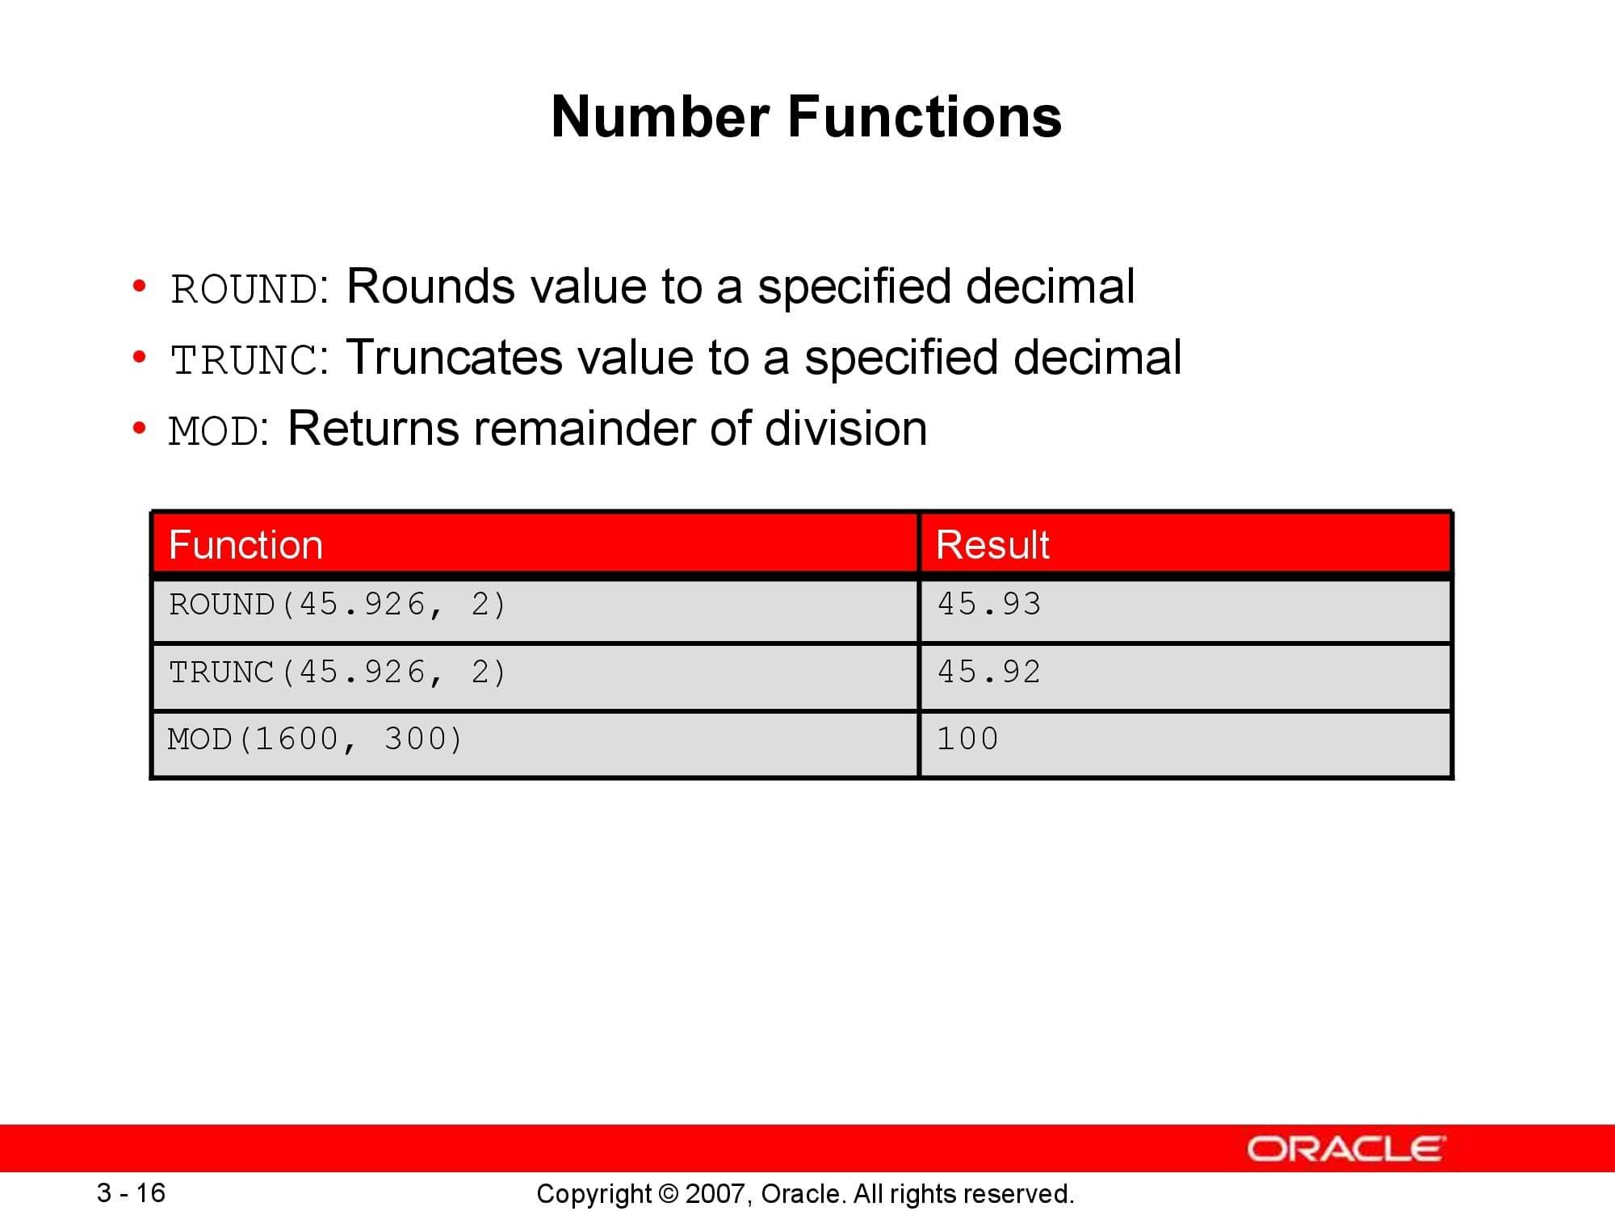

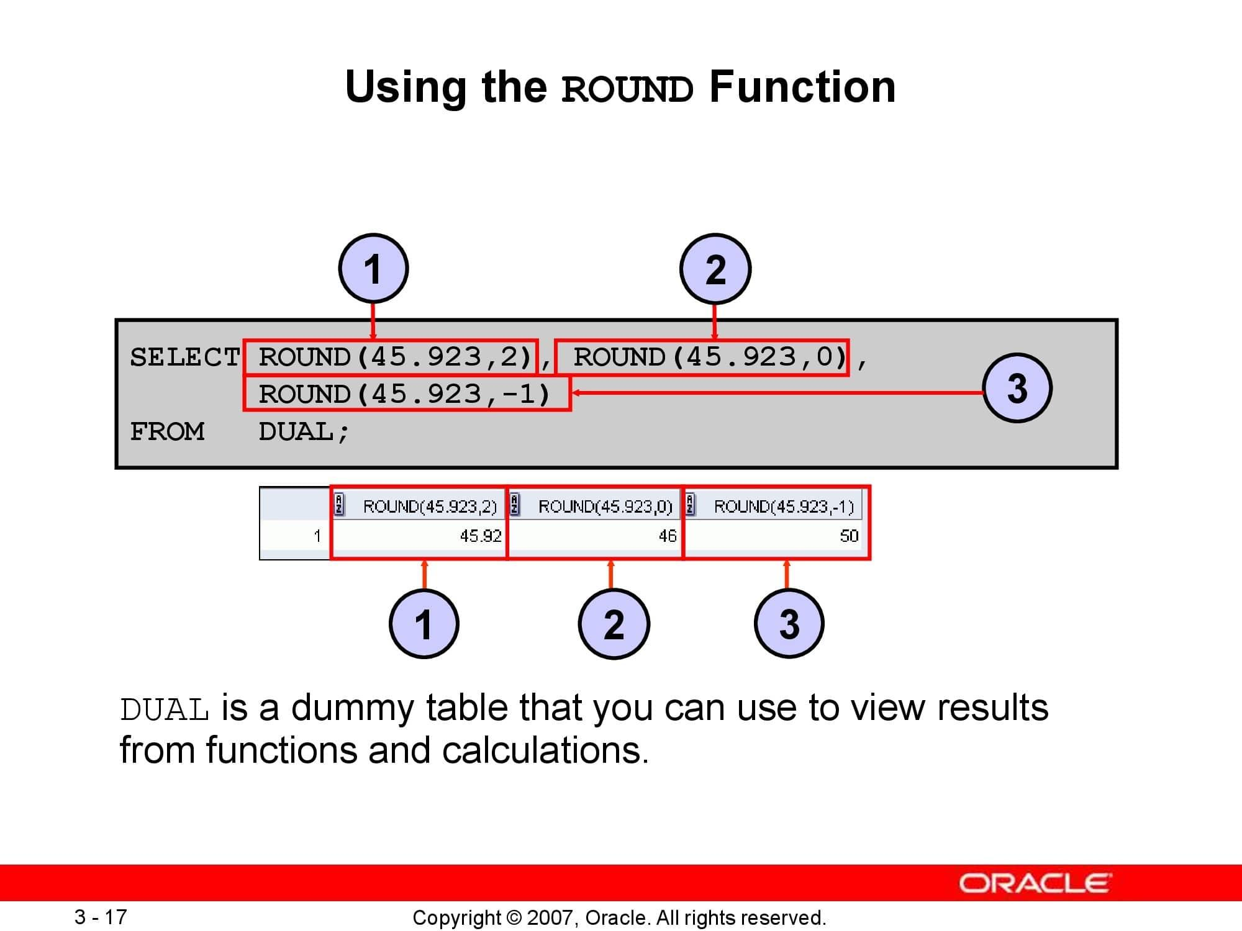

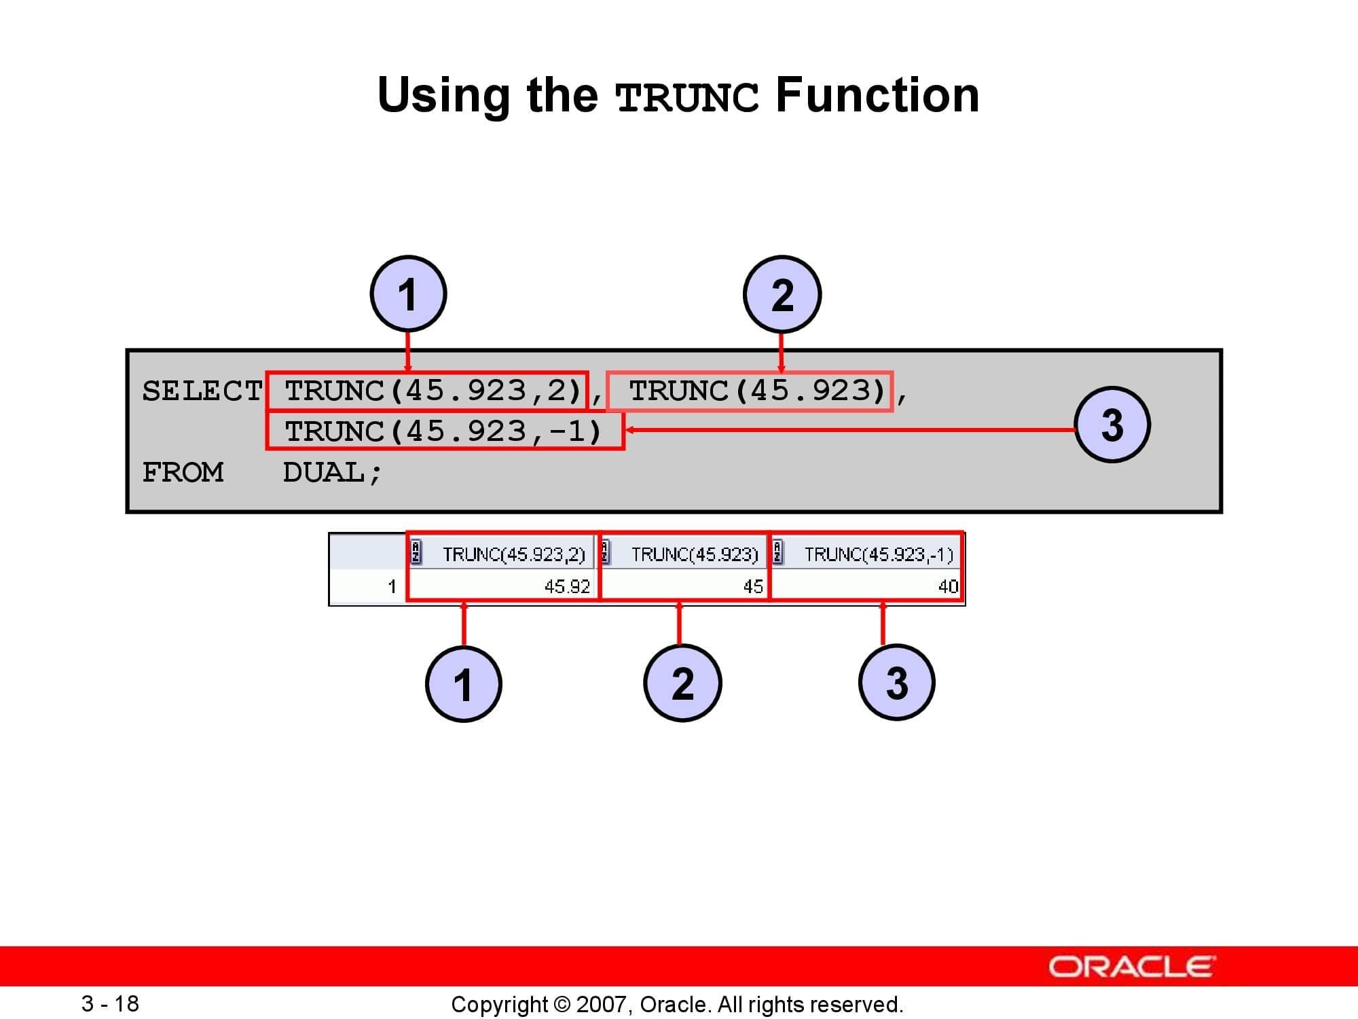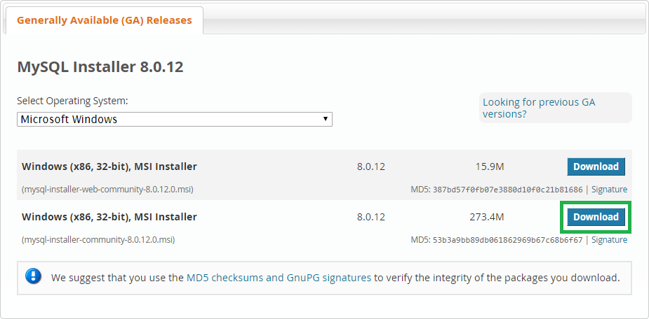

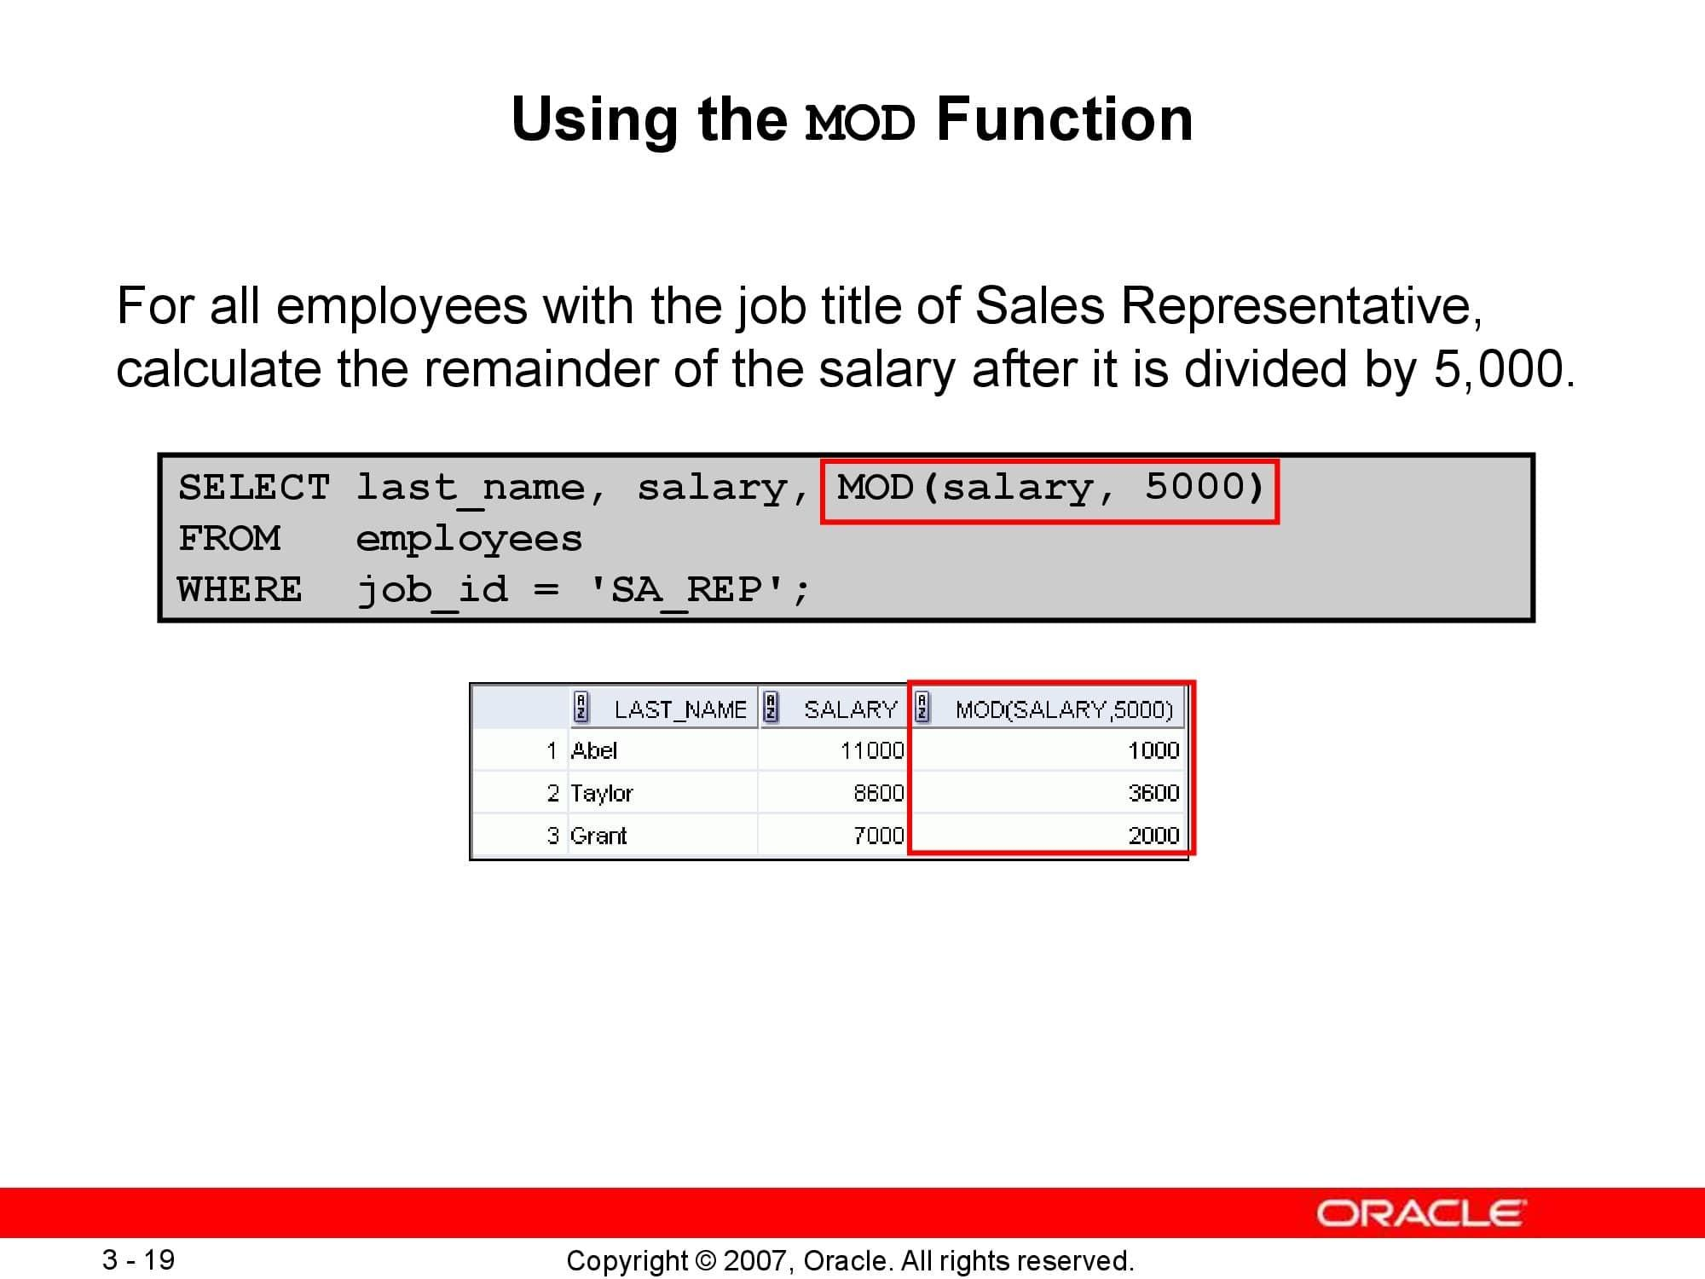

# **LAB 5: Using Single-Row Date Functions to Customize Output & Type conversion**

## **Purpose**

* + To describe various types of functions available in SQL
  + To use character, number, and date functions in SELECT statements

## **Lab Activity/Code**

**Date format functions**

This function allows the developer to format the date anyway that they wish by specifying a sequence of format strings. A string is composed of the percentage symbol '%' followed by a letter that signifies how we wish to display the date. These are some of the more common strings to use:

***Syntax:***

**DATE_FORMAT(date, sequence)**

**Date format functions**

| **String** | **Displays** | **Example** |
| --- | --- | --- |
| %d | The numeric day of the month | 01....10....17....24 etc |
| %D | The day of the month with a suffix | 1st, 2nd, 3rd.... etc |
| %m | The numeric month | 01....04....08....11 etc |
| %M | The Month name | January....April....August etc |
| %b | The Abbreviated Month Name | Jan....Apr....Aug....Nov etc |
| %y | Two digit year | 98, 99, 00, 01, 02, 03 etc |
| %Y | Four digit year | 1998, 2000, 2002, 2003 etc |
| %W | Weekday name | Monday.... Wednesday....Friday etc |
| %a | Abbreviated Weekday name | Mon....Wed....Fri etc |
| %H | Hour (24 hour clock) | 07....11....16....23 etc |
| %h | Hour (12 hour clock) | 07....11....04....11 etc |
| %p | AM or PM | AM....PM |
| %i | Minutes | 01....16....36....49 etc |
| %s | Seconds | 01....16....36....49 etc |
| % c | Month | Numeric (0…12) |
| % e | Day of month | Numeric (0….31) |
| %f | Microseconds |  |
| %r | Time 12 hour | hh:mm:ss followed by AM or PM |

**EXAMPLE**

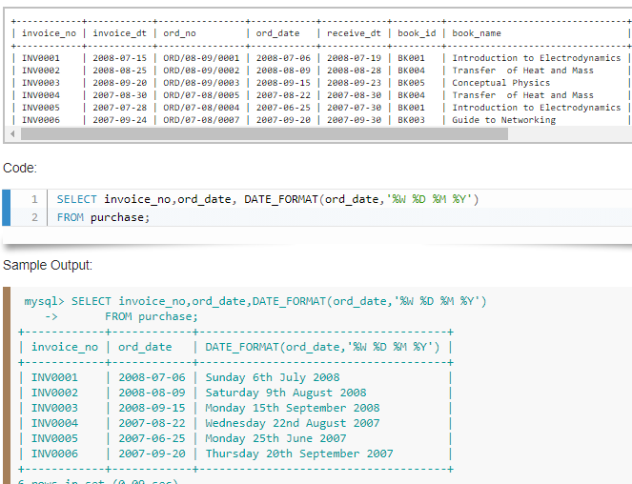

**DATE EXTRACTION FUNCTIONS**

As well as using DATE_FORMAT() there are other functions that allow we to extract specific information about a date (year, month, day etc). These include:

| **Function** | **Displays** | **Example** |
| --- | --- | --- |
| DAYOFMONTH(date) | The numeric day of the month | 01....10....17....24 etc |
| DAYNAME(date) | The Name of the day | Monday.... Wednesday.... |
| MONTH(date) | The numeric month | 01....04....08....11 etc |
| MONTHNAME(date) | The Month name | January....April....August etc |
| YEAR(date) | Four digit year | 1998, 2000, 2002, 2003 etc |
| HOUR(time) | Hour (24 hour clock) | 07....11....16....23 etc |
| MINUTE(time) | Minutes | 01....16....36....49 etc |
| SECOND(time) | Seconds | 01....16....36....49 etc |
| DAYOFYEAR(date) | Numeric day of the year | 1.....366 |

**EXAMPLE 1 DAY NAME**

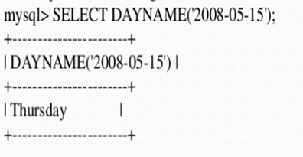

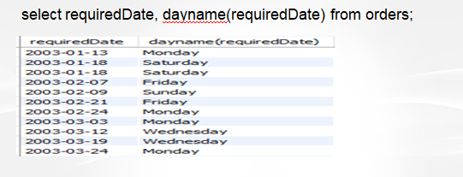

**EXAMPLE 2**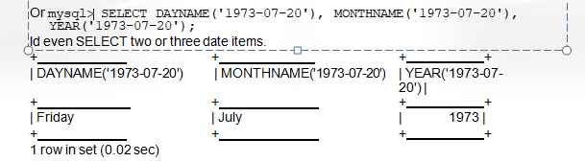

**CHANGING DATE VALUES**

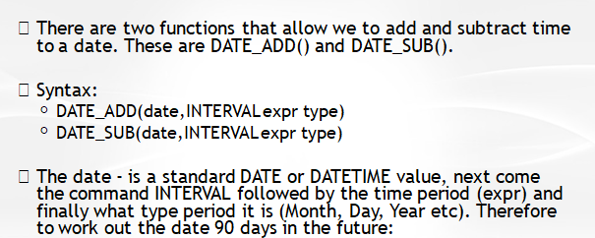

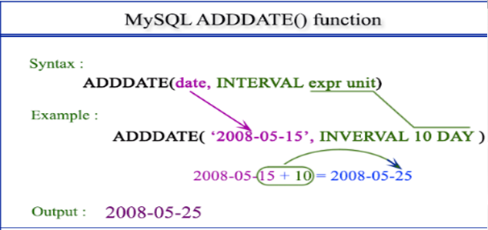



# **LAB 6: Constructing ERD using VISIO or draw.io**

## **Purpose**

* To learn about Entity Relationship Diagram (ERD).
* To learn about the notations used in tools.
* We will make an ER Diagram using SmartDRAW.

## **Lab Activity/Code**

**Entity Relationship Diagram:**

An entity–relationship model describes interrelated things of interest in a specific domain of knowledge. A basic ER model is composed of entity types and specifies relationships that can exist between entities. ER Diagrams are most often used to design or debug relational databases in the fields of software engineering, business information systems, education and research.

**Notations Used in ERD**:

| 1. Strong Entity SymbolEntity(strong) | These shapes are independent from other entities, and are often called parent entities, since they will often have weak entities that depend on them. They will also have a primary key, distinguishing each occurrence of the entity. |
| --- | --- |
| 1. Weak Entity SymbolEntity(Weak) | Weak entities depend on some other entity type. They don't have primary keys, and have no meaning in the diagram without their parent entity. |
| 1. Associative entity symbolAssociative entity | Associative entities relate the instances of several entity types. They also contain attributes specific to the relationship between those entity instances. |
| 1. Attribute SymbolAttributes | Attributes are characteristics of an entity, a many-to-many relationship, or a one-to-one relationship. |
| 1. Relationship SymbolRelationship | Relationships are associations between or among entities. |

**SmartDraw:**

SmartDraw is a diagram tool used to make flowcharts, organization charts, mind maps, project charts, and other business visuals. SmartDraw allows you to draw and print architectural and engineering diagrams to scale. SmartDraw even provides an AutoCAD-like annotation layer that automatically resizes to match a diagram.

**ERD Diagram**:

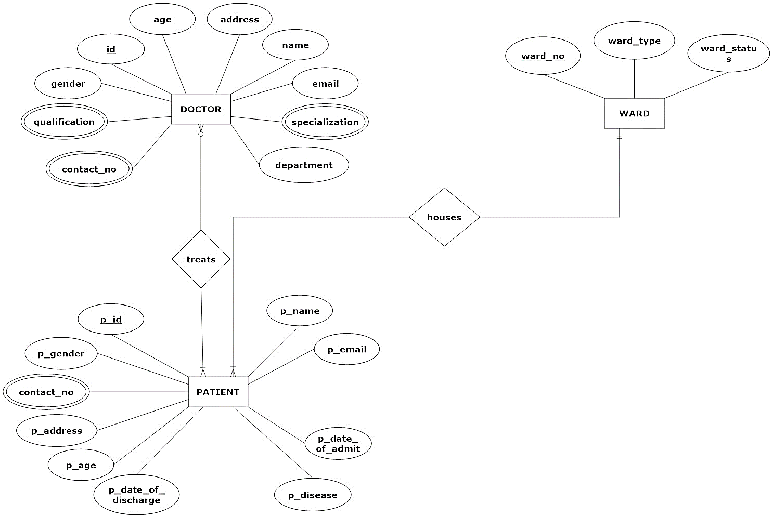

# **LAB 07: Using DDL Statements to Create and Manage Tables**

## **Purpose**

* + Categorize the main database objects
  + Review the table structure
  + List the data types that are available for columns
  + Create a simple table
  + Explain how constraints are created at the time of table creation
  + Describe how schema objects work

## **Lab Activity/Code**

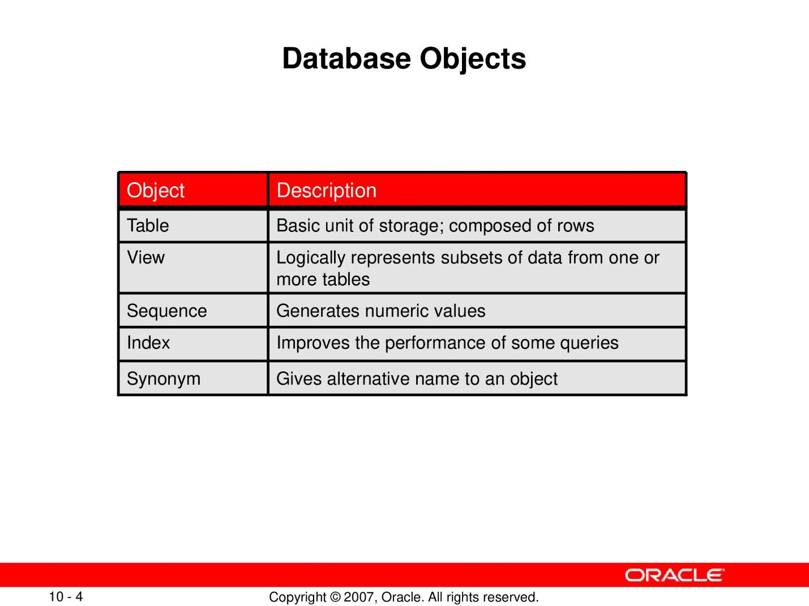

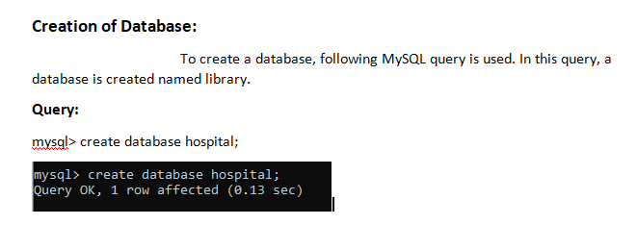

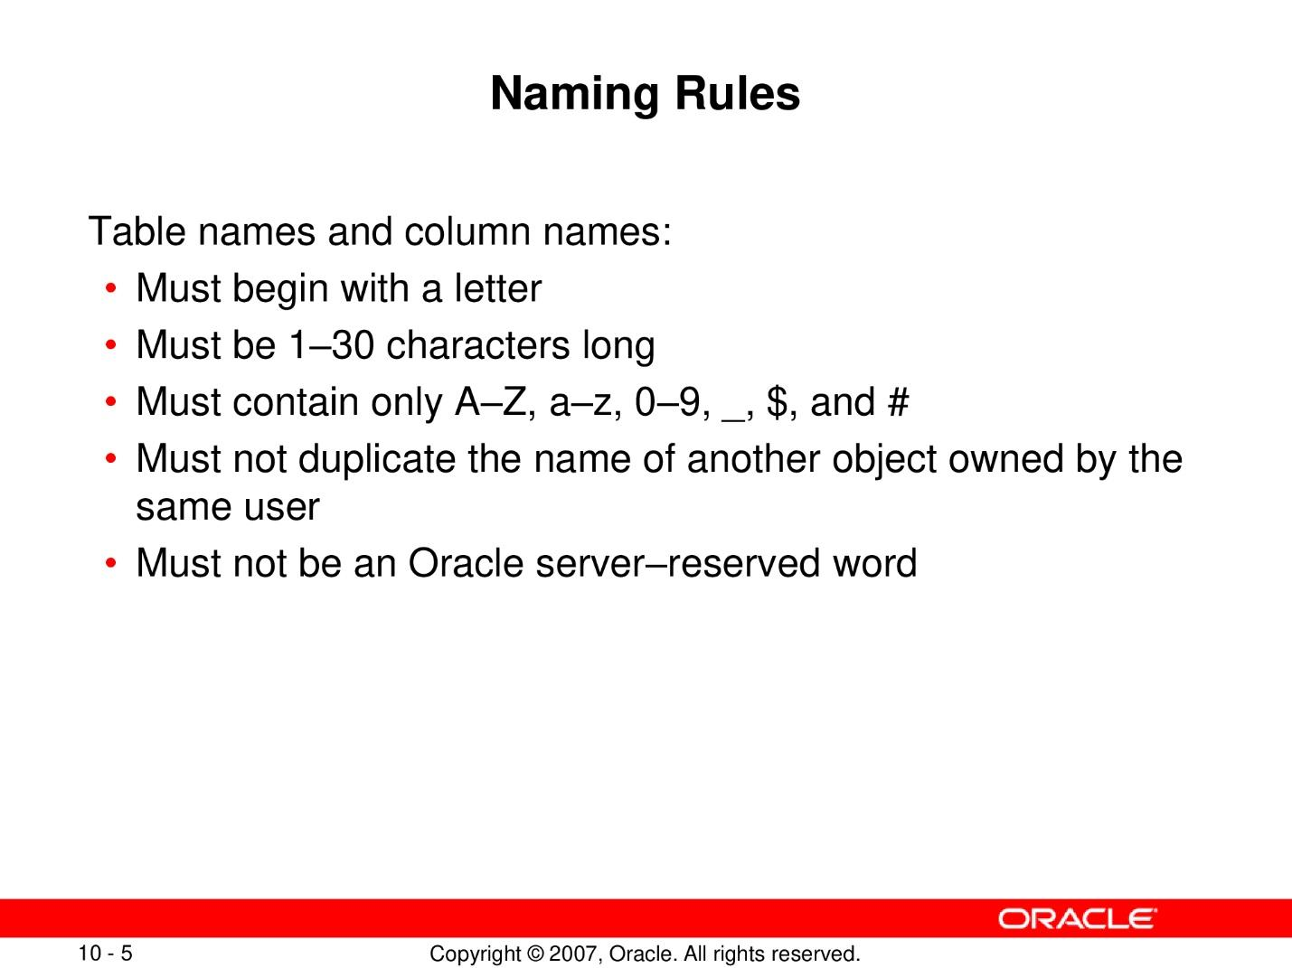

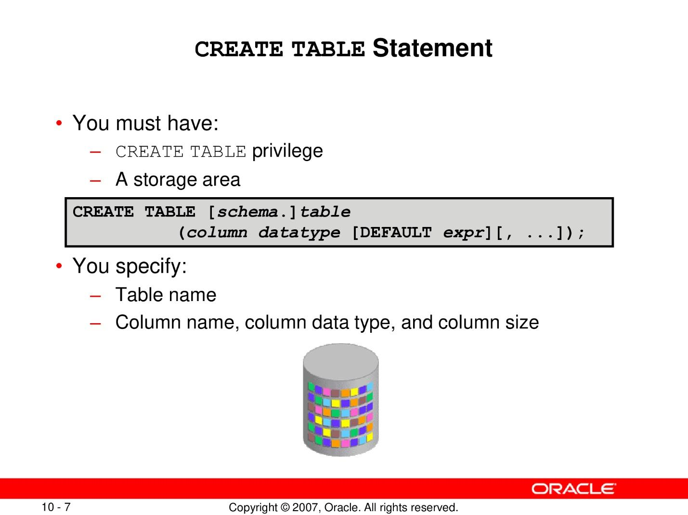

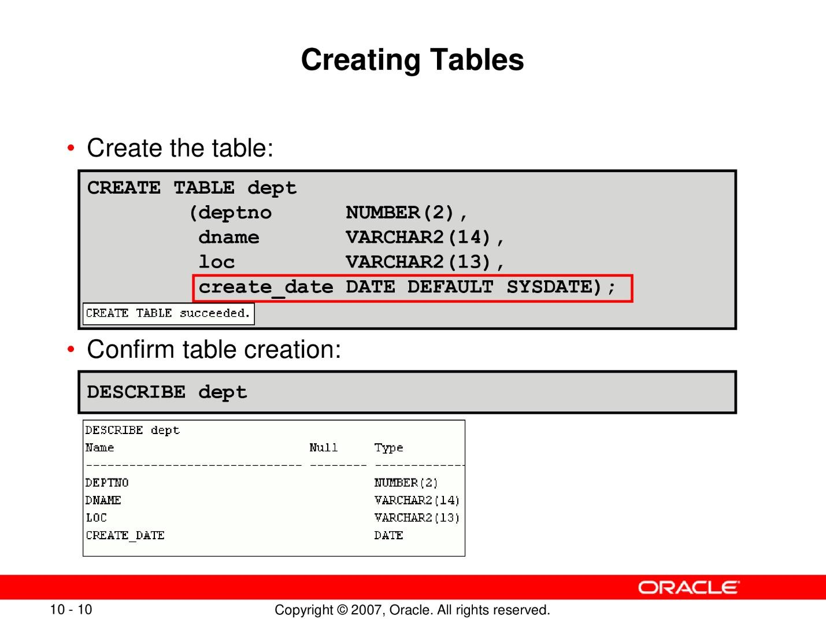

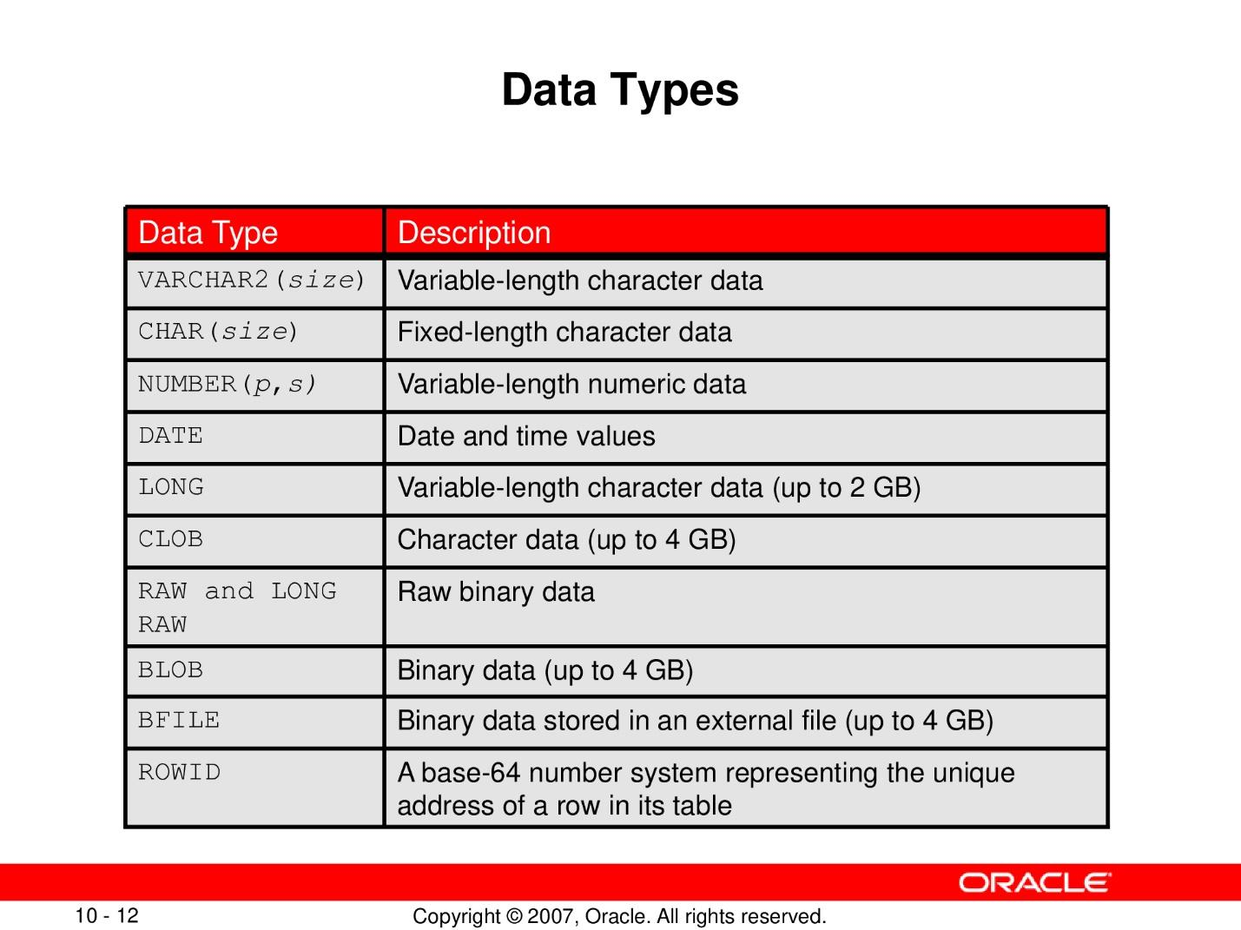

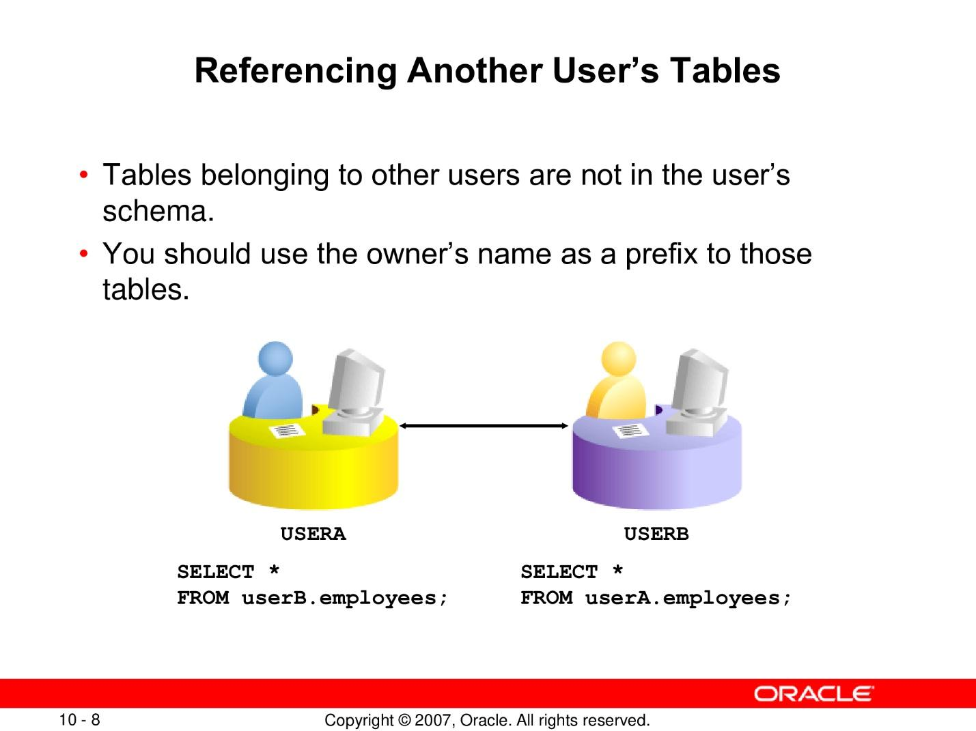

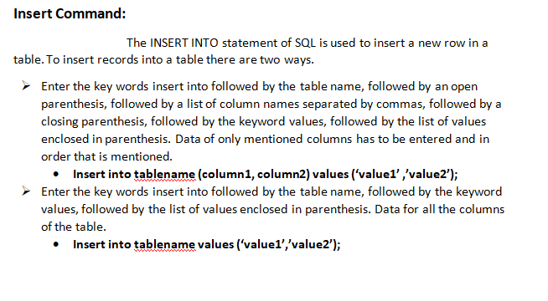

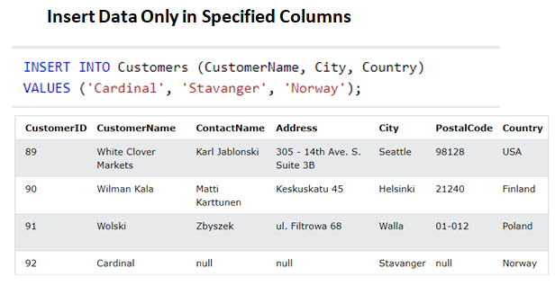

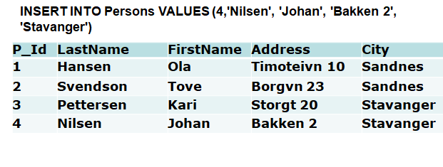

# **Lab 08 : Creating other schema objects like table level and column level constraints**

## **Purpose**

* Understand table level and column level constraints and their working

## **Lab activity/code**

**SQL Constraints**

* Constraints are used to limit the type of data that can go into a table.
* MySQL constraints are statements that can be applied at the column level or table level to specify rules for the data that can be entered into a column or data table

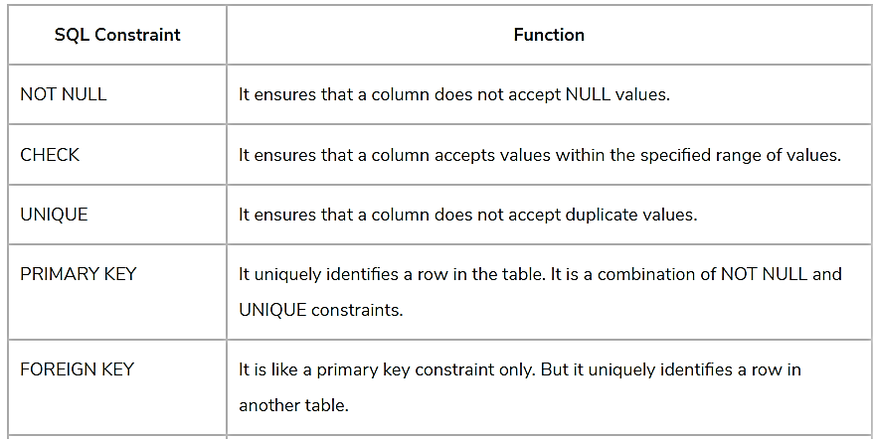

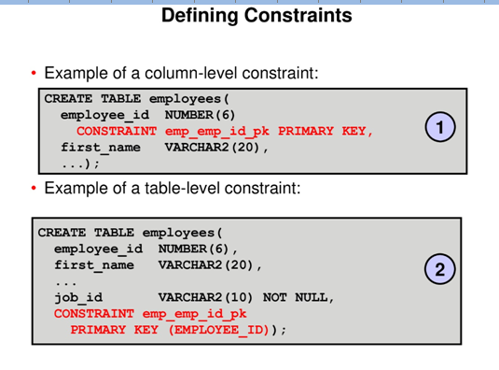

**NOT NULL CONSTRAINT**

* NOT NULL constraint is applied to a column, it ensures that the column will not accept NULL values.
* A null value means that a particular field has been left empty, and values such as zero or blank space do not come under Null values
* primary key column implicitly includes a not null constraint

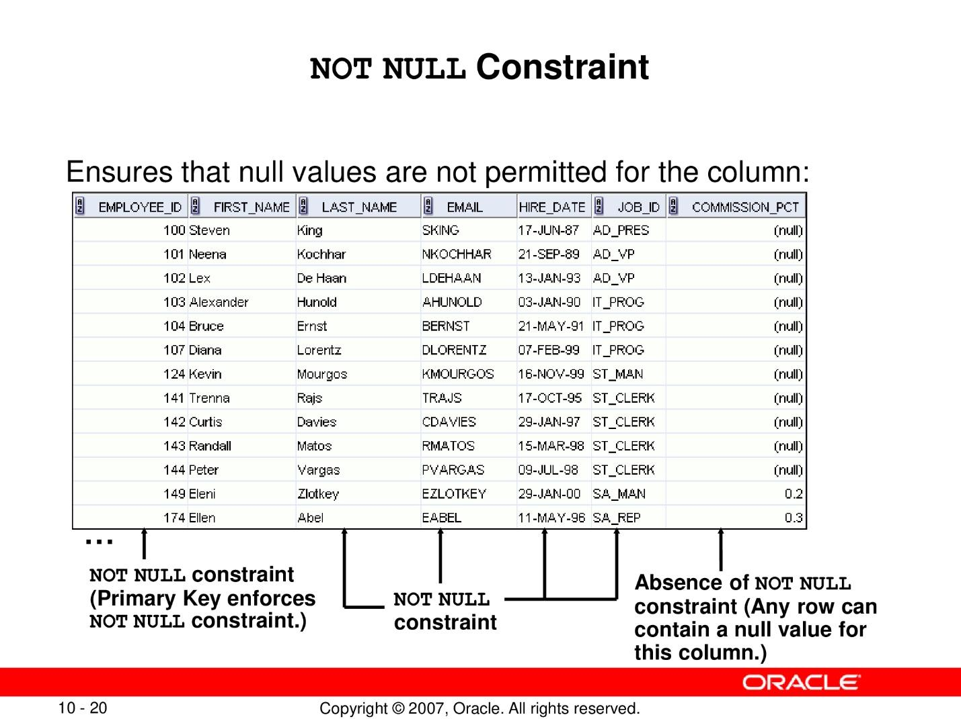

**UNIQUE KEY CONSTRAINT**

* A unique key is a constraint in SQL which helps in uniquely identifying a record in the data table.
* It is similar to the Primary key as both of them guarantees the uniqueness of a record.
* Unlike primary key, a [unique key can accept NULL values](https://www.educba.com/unique-key-in-mysql/),  a unique Key can include a NULL value but only one NULL value per column is allowed.

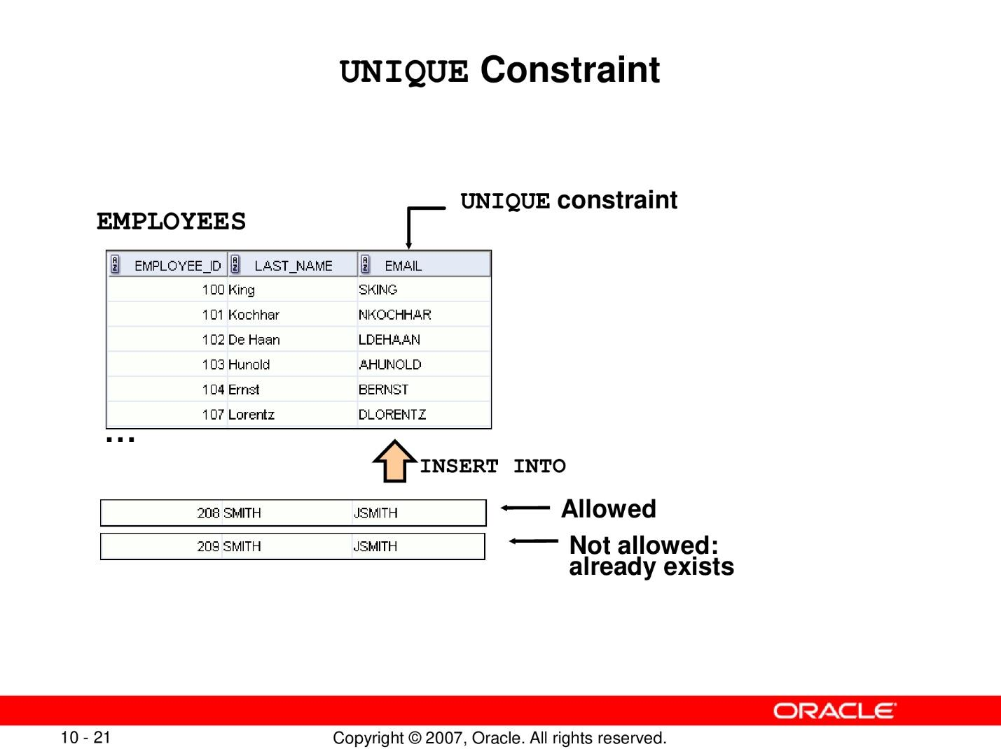

**EXAMPLE OF UNIQUE CONSTRAINT TABLE LEVEL AND COLUMN LEVEL**

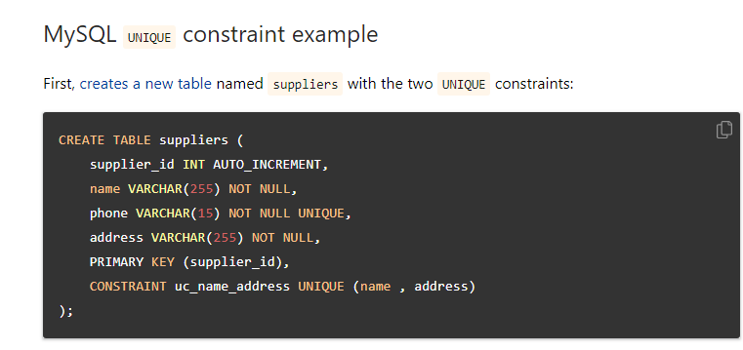

**PRIMARY KEY CONSTRAINT**

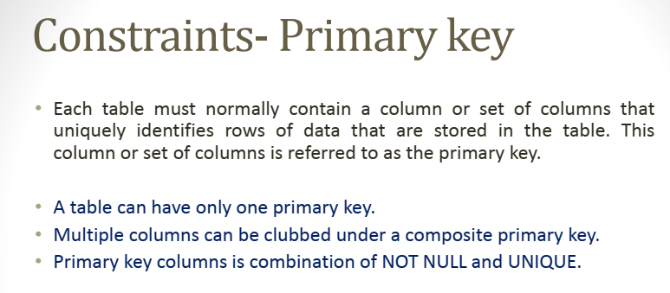

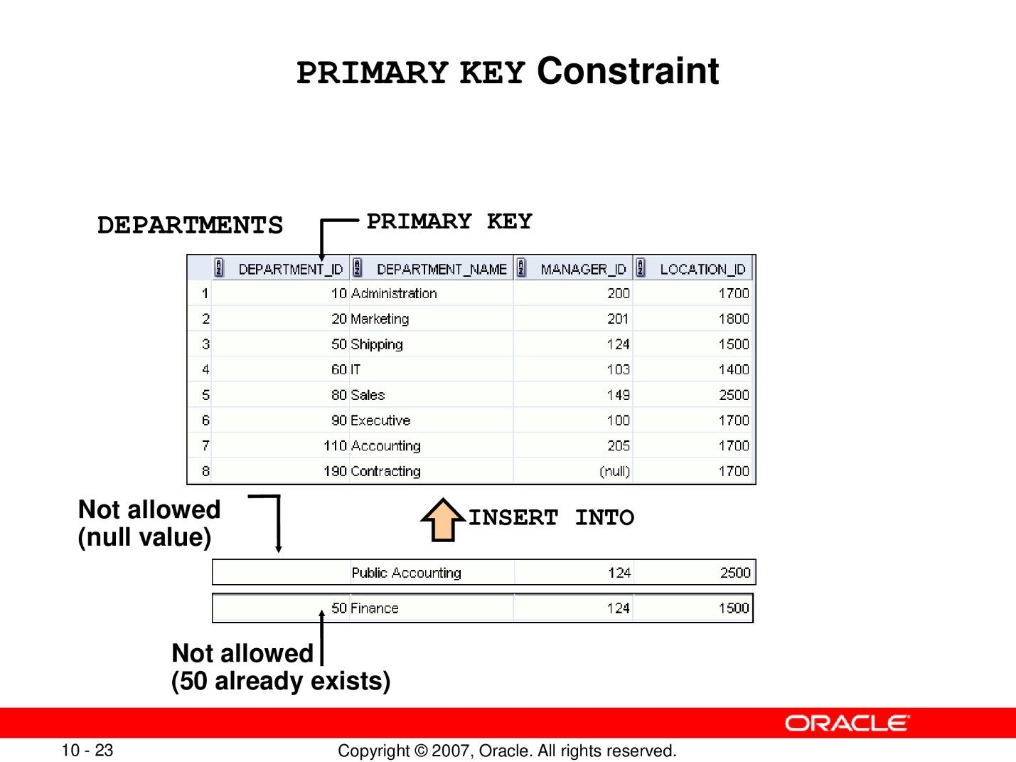

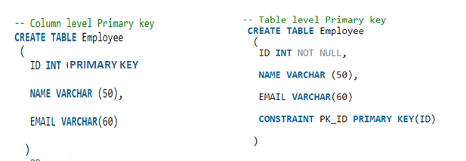

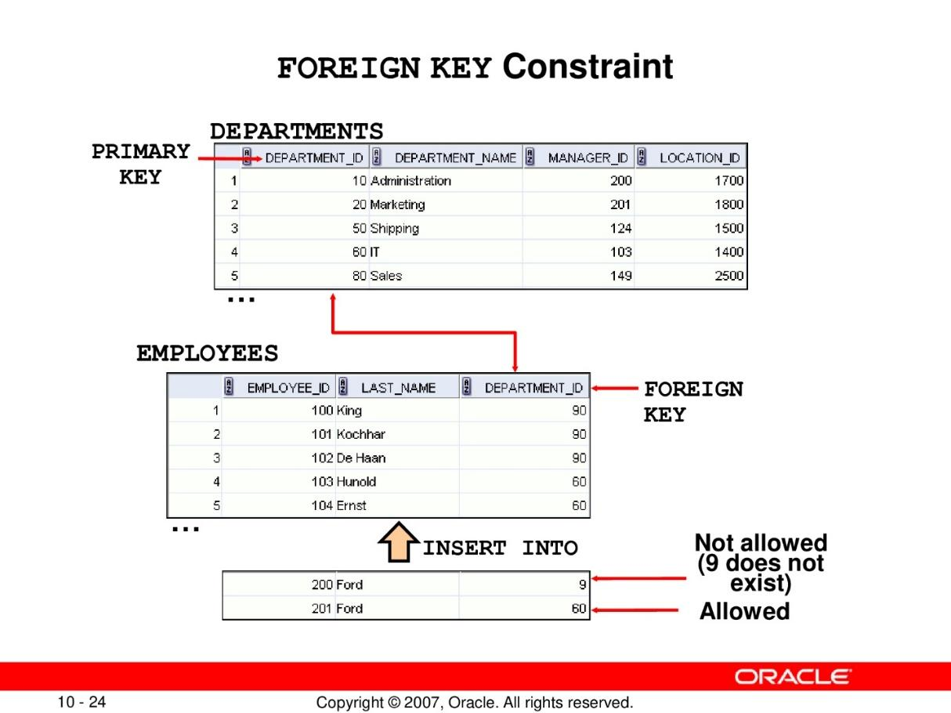

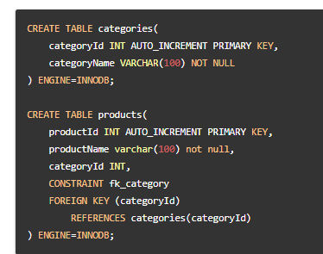

**CHECK CONSTRAINT COLUMN LEVEL AND TABLE LEVEL**

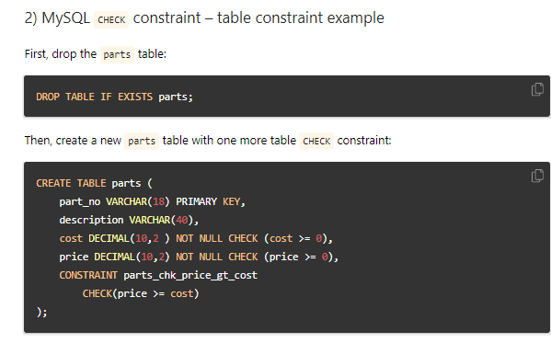

# **Lab 09: Aggregating data using SQL Aggregate functions and group functions**

## **Purpose**

* + Identify aggregate functions
  + Identify the available group functions
  + Describe the use of group functions
  + Group data by using the GROUP BY clause
  + Include or exclude grouped rows by using the HAVING clause

## **Lab Activity/Code**

**Group functions**

* They give the user the ability to answer business questions such as:
  + What is the average salary of an employee in the company?
  + What were the total salaries for a particular year?
  + What are the maximum and minimum salaries in the Computer Department?
* They perform a variety of actions such as counting all the rows in a table, averaging a column’s data, and summing numeric data.
* They can also search a table to find the highest “MAX” or lowest “MIN” values in a column.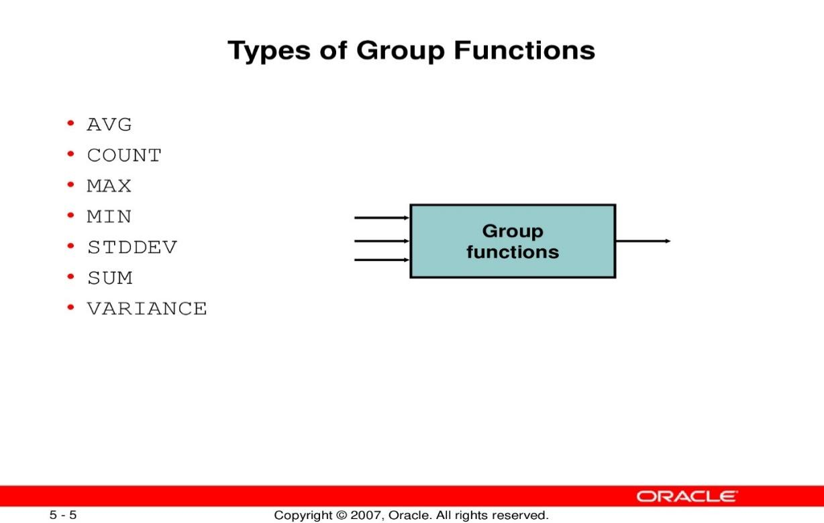

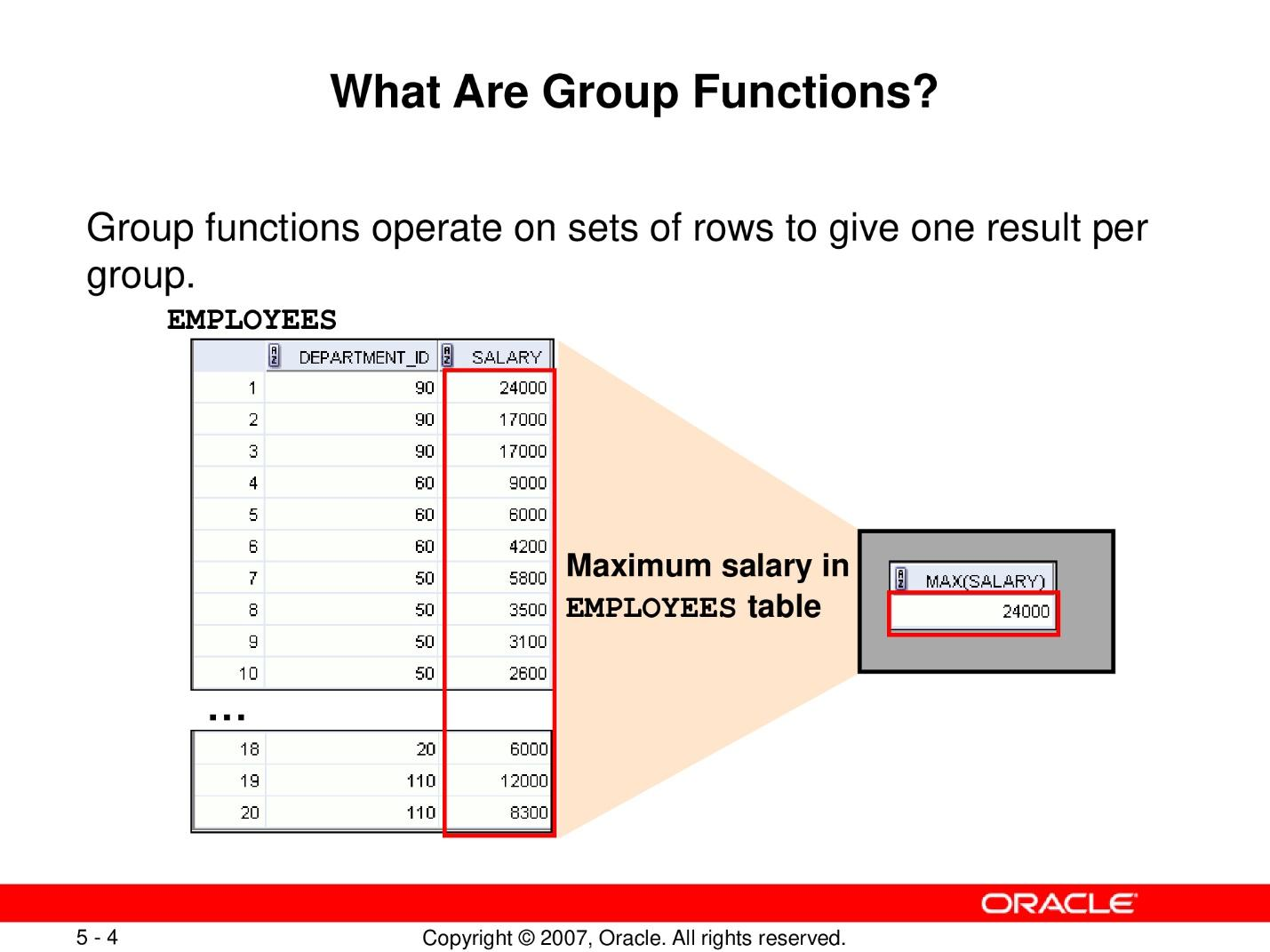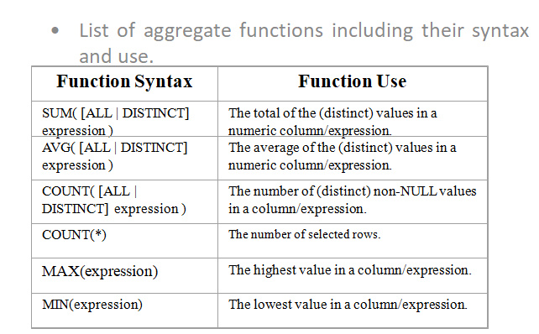

**Example**

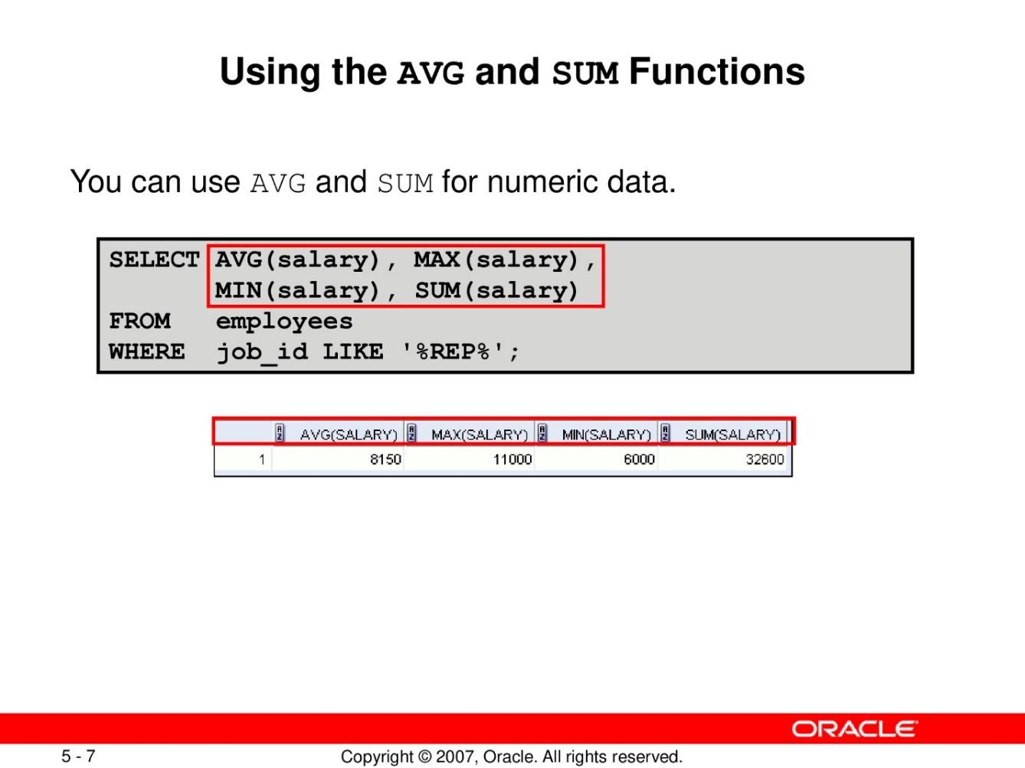

**Using Minimum and Max Functions**

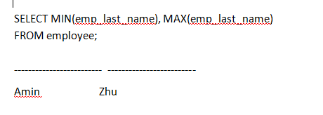

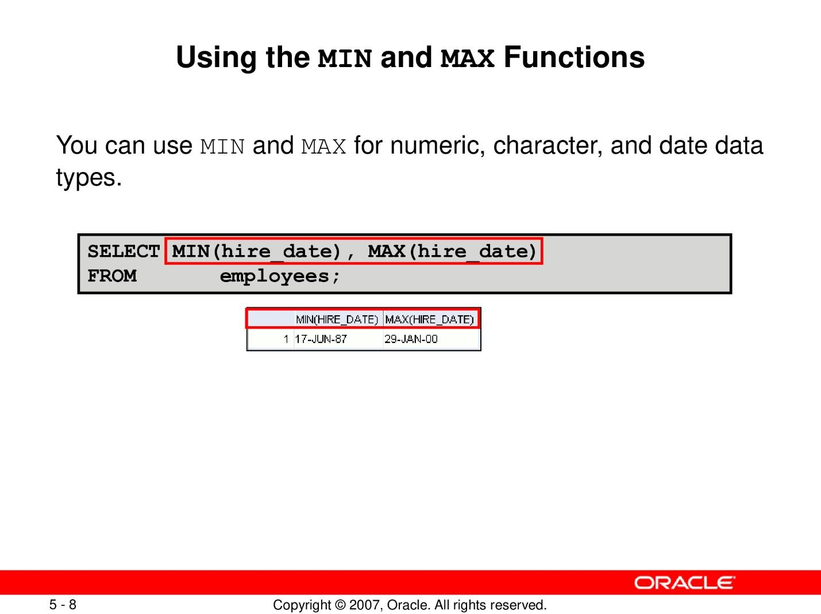

**Using count function**

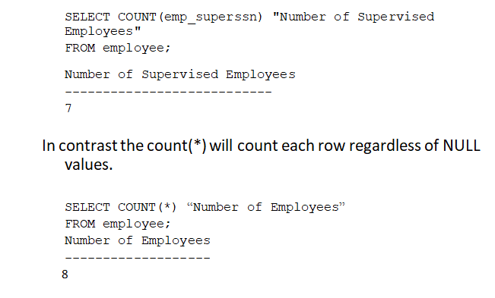

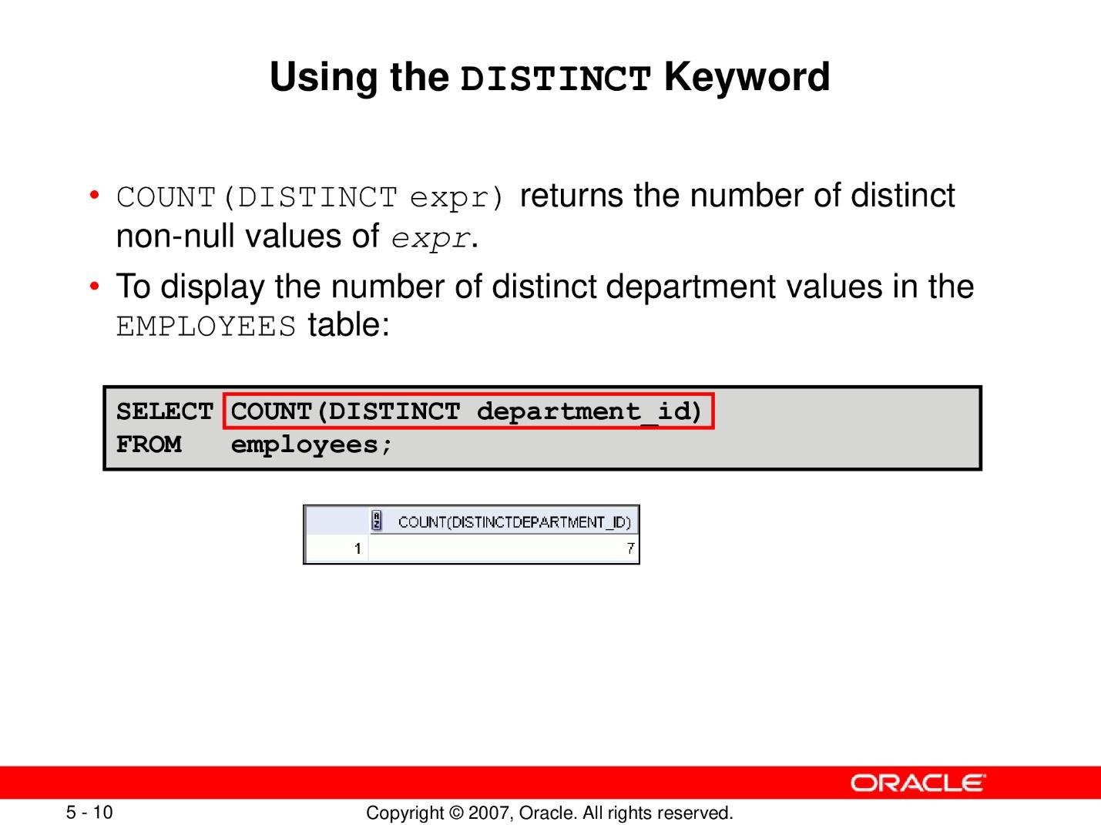

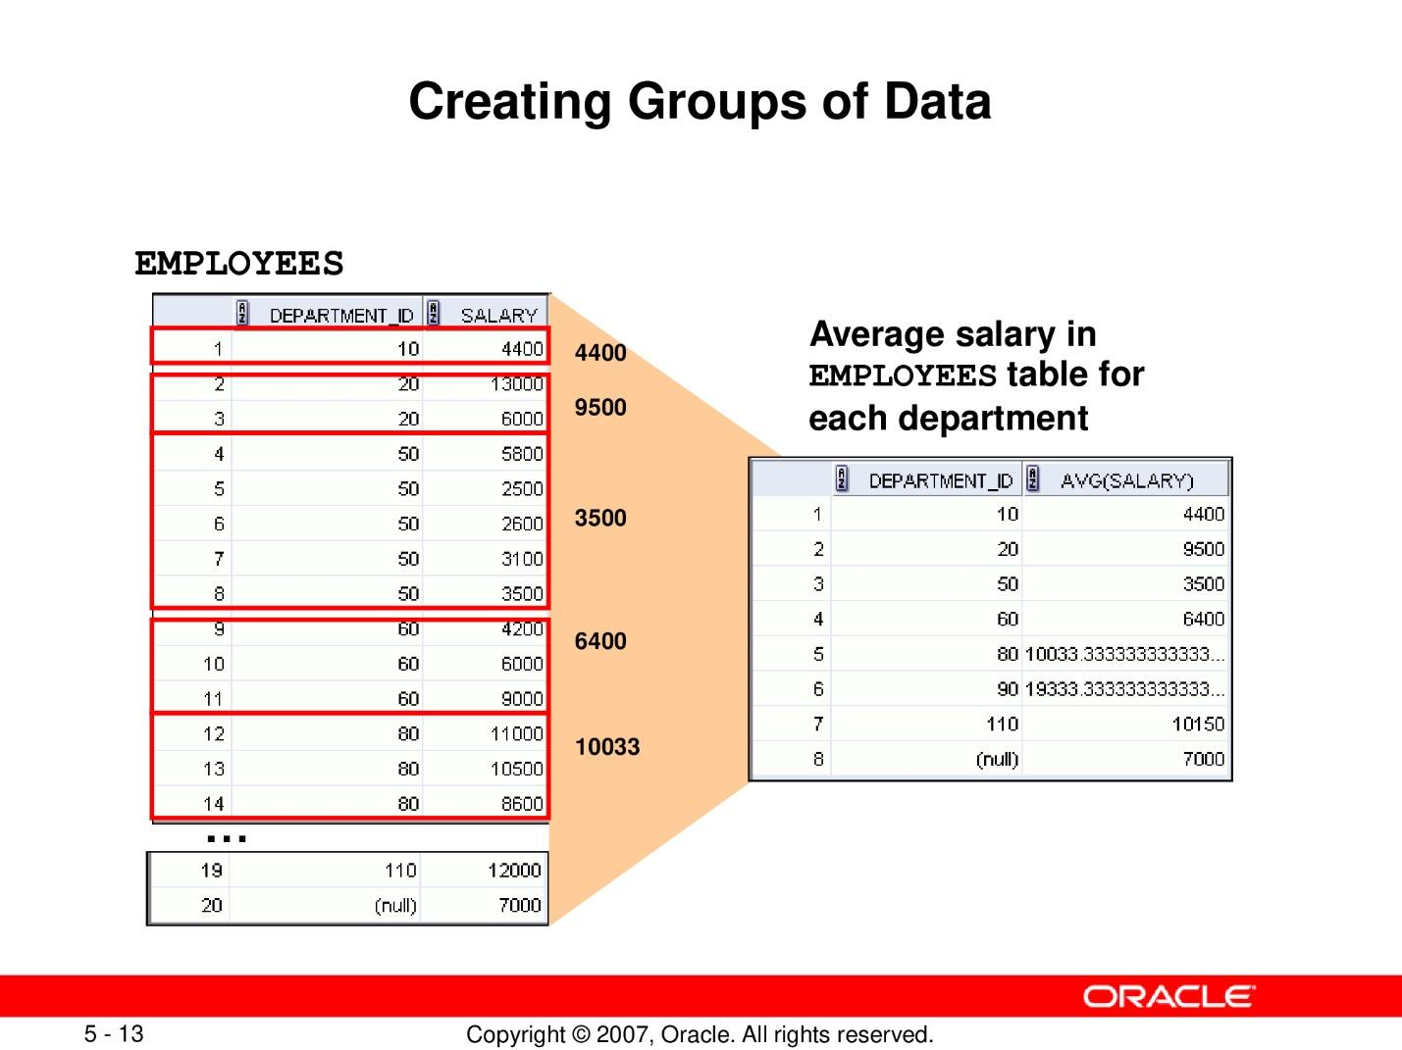

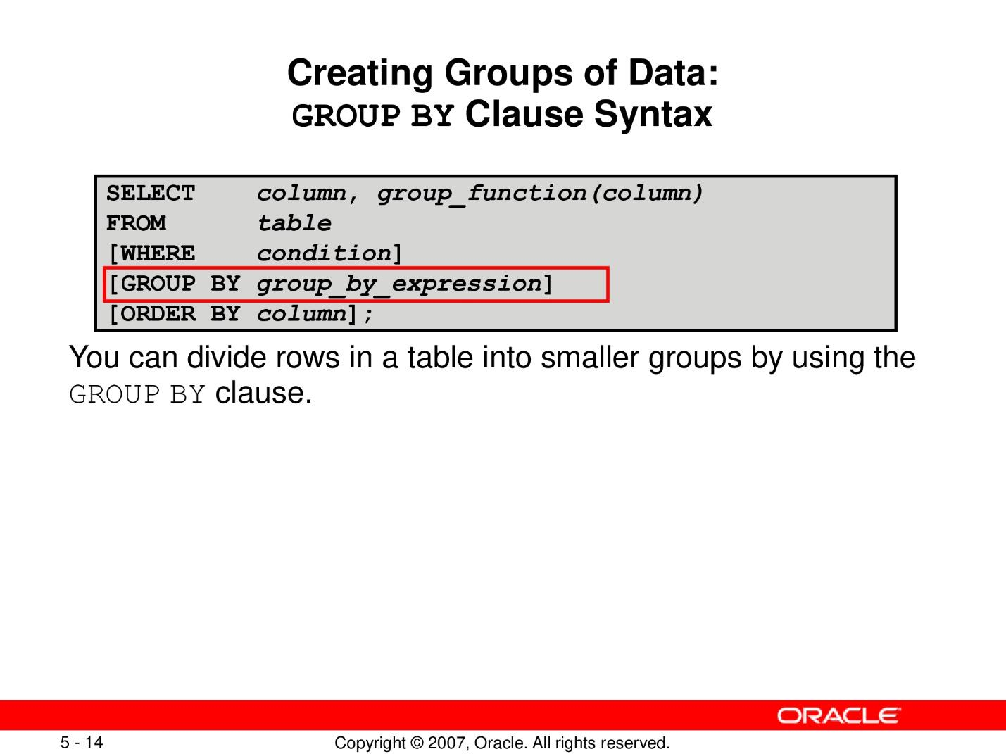

**Example of group by clause**

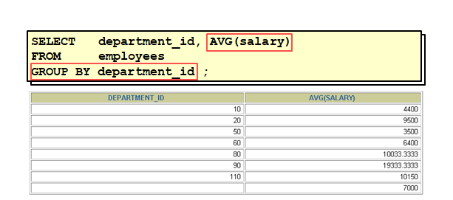

**Illegal queries using group by functions**

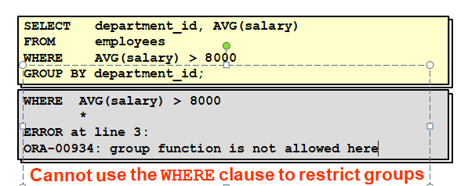

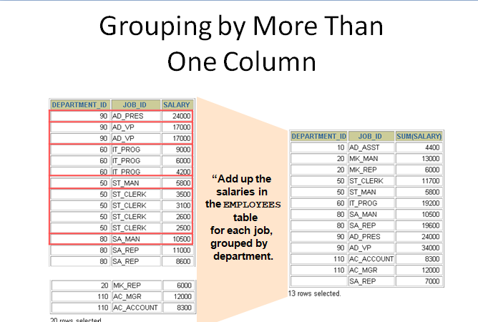

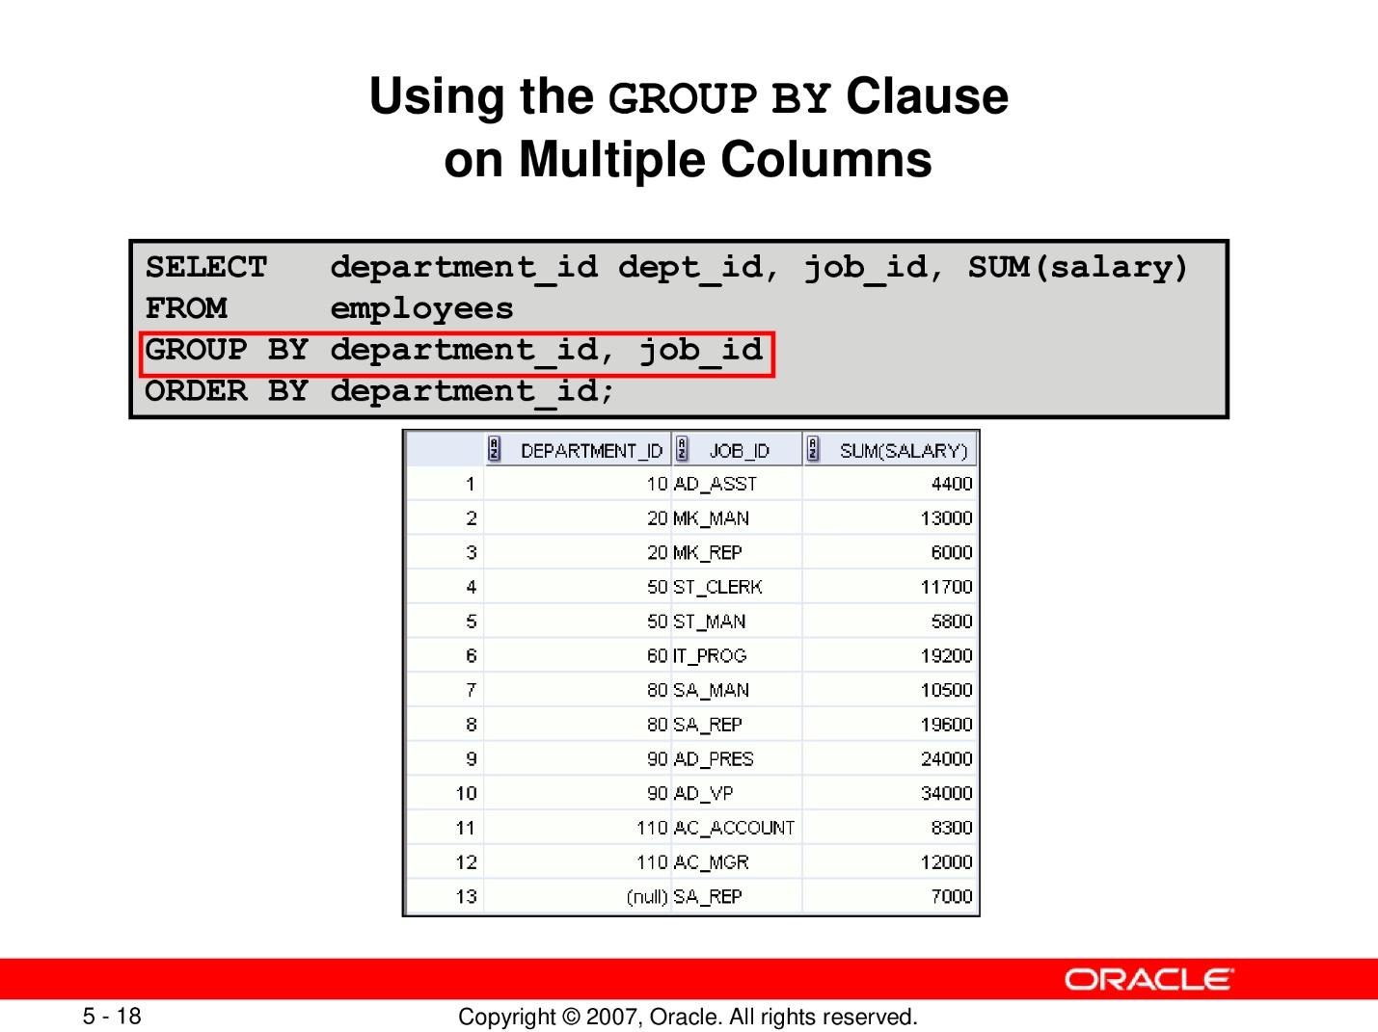

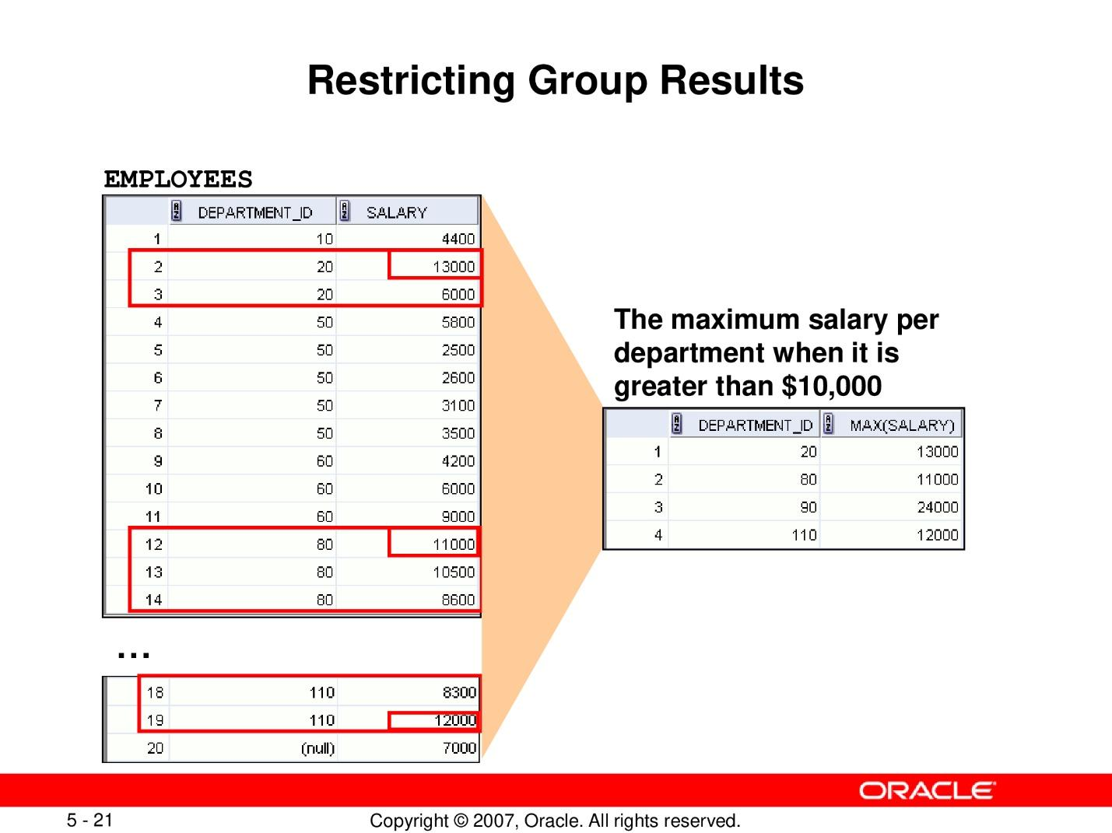

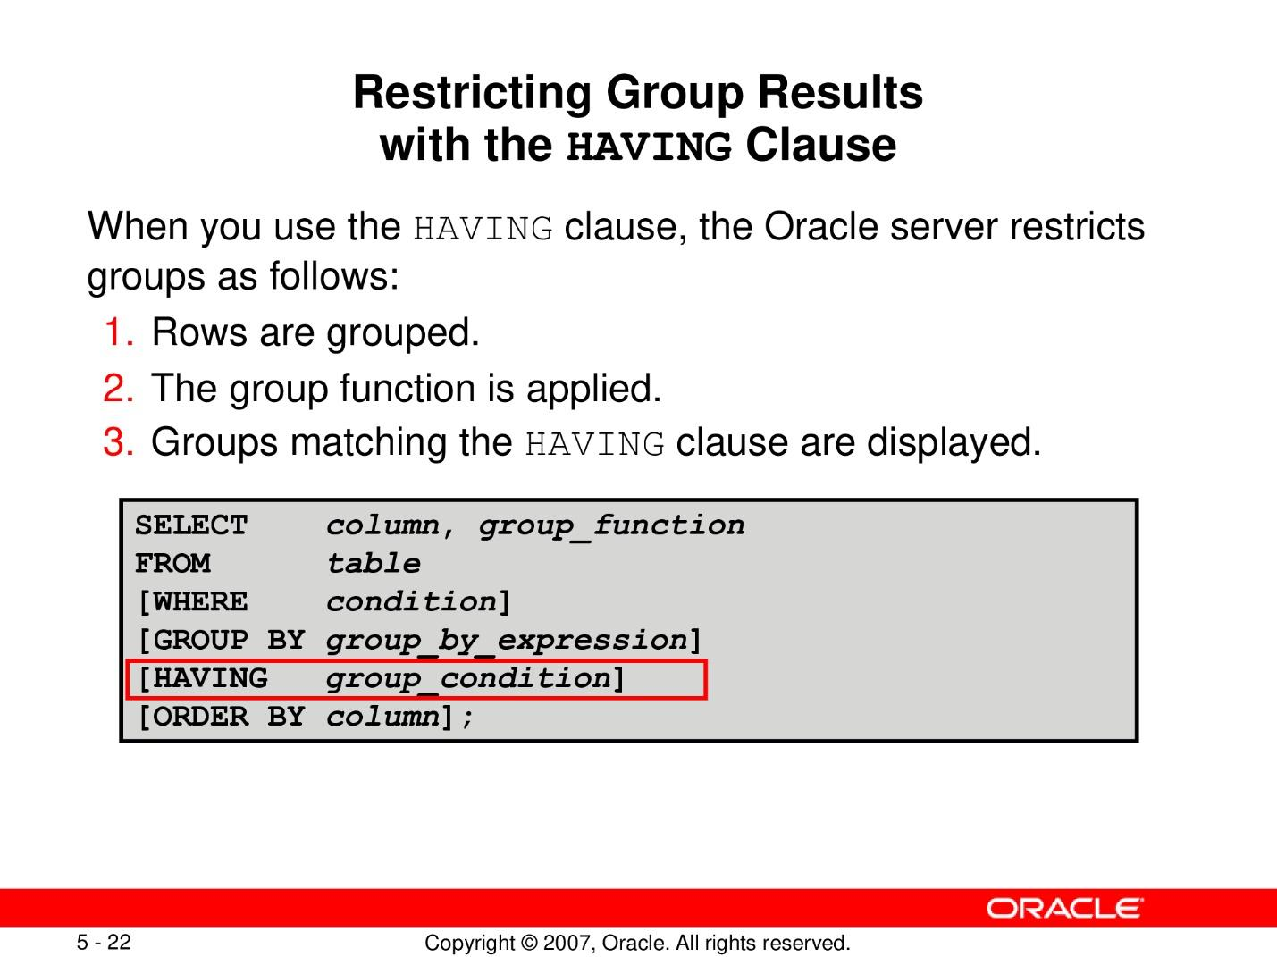

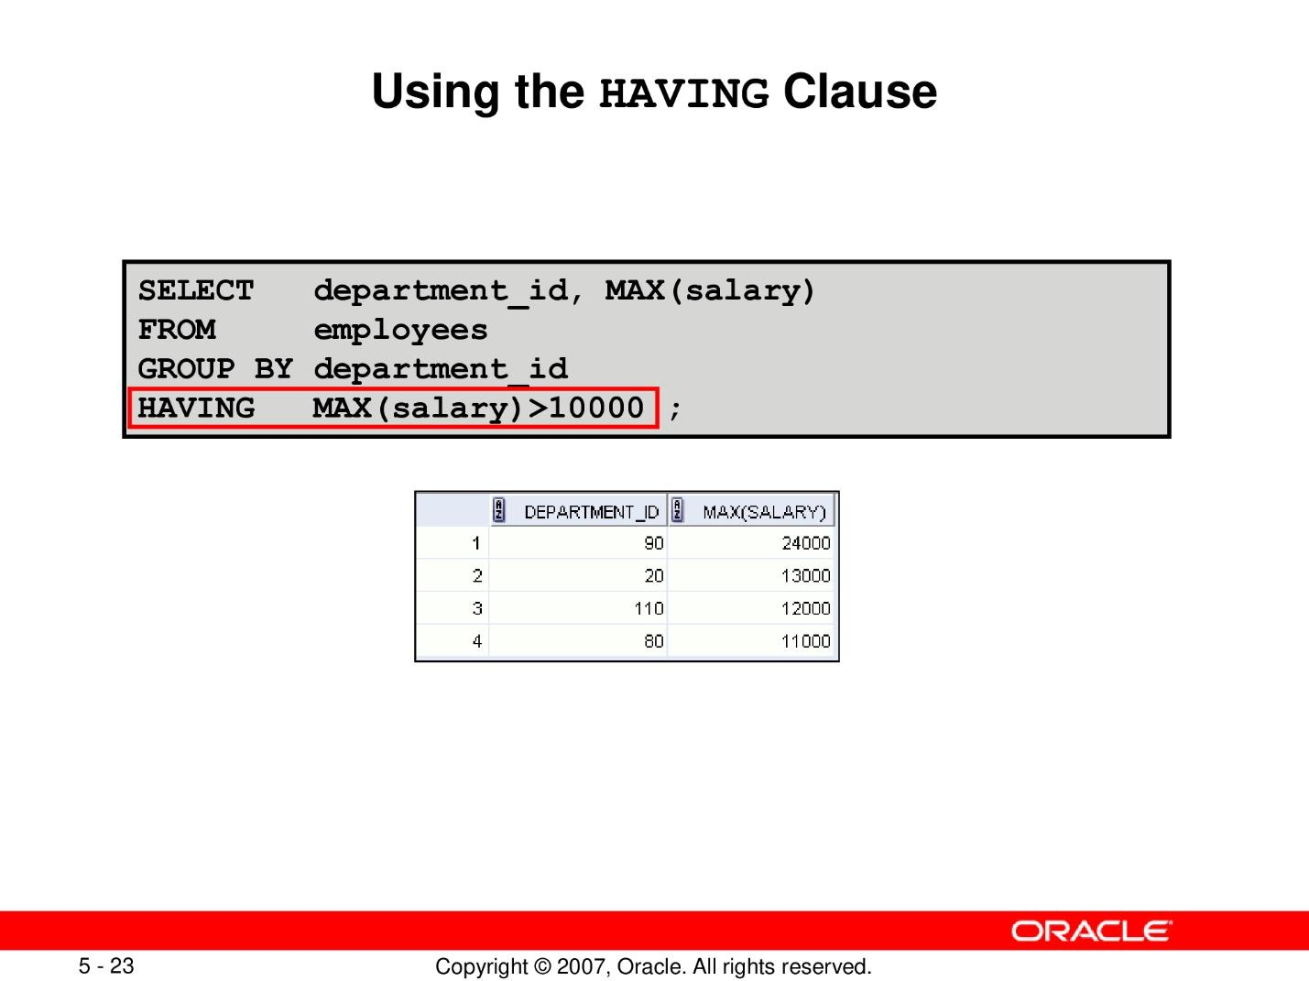

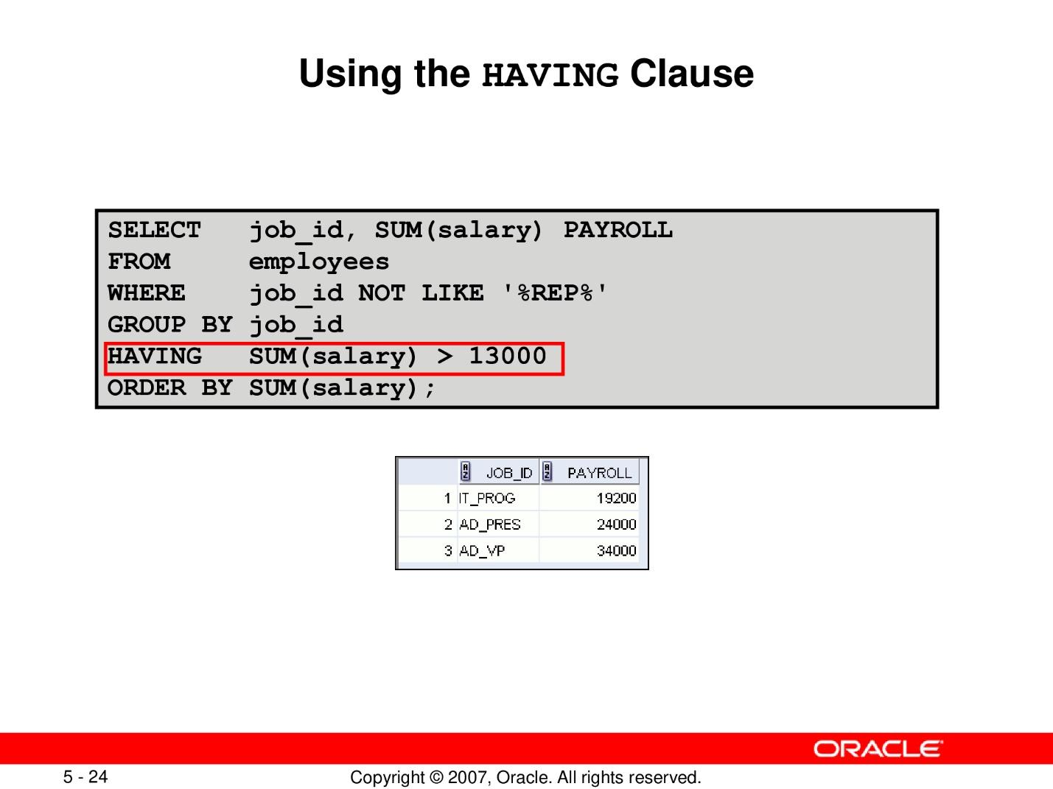

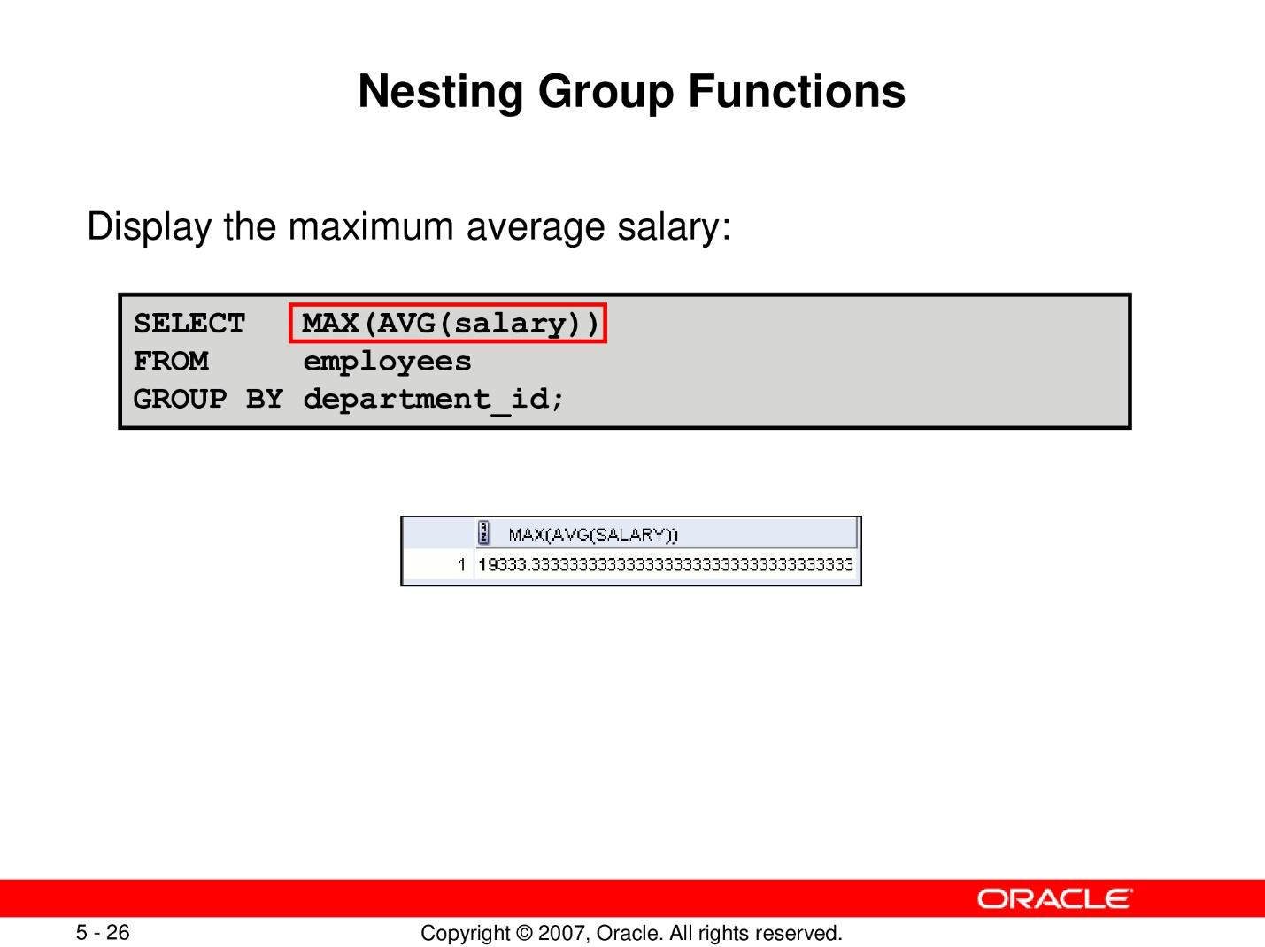

# **Lab 10: Constructing enhanced ERD using visio or draw.io**

## **Purpose**

* + Identify enhanced erd notations
  + Identify how to construct enhanced ERD

## **Lab Activity/Code**

Create an enhanced entity relationship diagram for following .

Ali as a customer wants to purchase plot/plots in a housing scheme for investment. He can buy plots of different sizes and categories like commercial, residential and farm house along Marla details.

On commercial plots tax payer ID details must be mentioned. System should also keep the record of Down Payment and quarterly installments.

Regional office information with respect to cities should be kept.

If regional office is removed then agent information should be removed.

Notifications regarding new plots/schemes should also be shared with the registered and unregistered users.

Note: Apply all Enhanced ERD concepts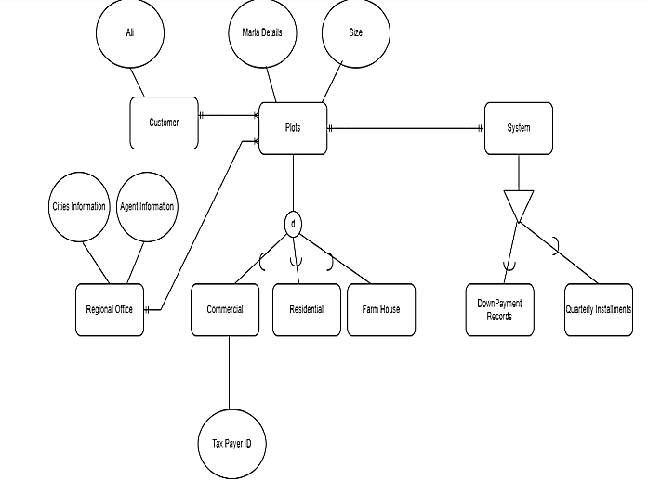

# **Lab 11: Use of joins for displaying data from multiple tables**

## **Purpose**

* + Retrieve data from different tables

## **Lab Activity/Code**

Create different tables applying referential integrity constraints. Use foreign keys for integrity constraints and then apply different joins to overserve the retrieved data.

A **JOIN** clause is used to combine rows from two or more tables, based on a related column between them.

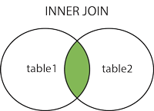

**Syntax:**

* SELECT column_name(s) FROM table1 **JOIN** table2 ON table1.column_name = table2.column_name;

JOIN and INNER JOIN are same in MySQL:

* SELECT column_name(s) FROM table1 **INNER JOIN** table2 ON table1.column_name = table2.column_name;

**Tables:**

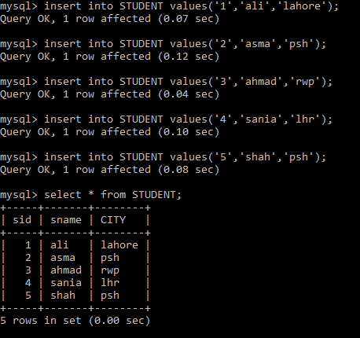 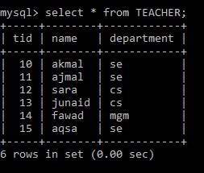

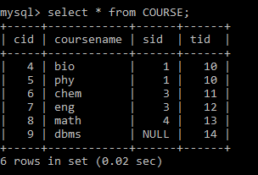

**Example:**

1. Now, we create the following SQL statement (that contains an INNER JOIN), that selects records that have matching values in both tables:

**mysql> select STUDENT.sname,COURSE.coursename from STUDENT JOIN COURSE ON STUDENT.sid=COURSE.sid;**

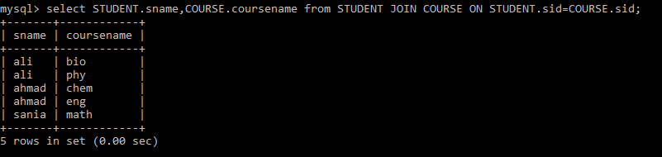

The INNER JOIN keyword selects all rows from both tables as long as there is a match between the columns. If there are records in the "STUDENT" table that do not have matches in "COURSE", these will not be shown.

1. Now, we create the following SQL statement (that contains an INNER JOIN), that selects all records that have matching values in both tables:

**mysql> select * from STUDENT JOIN COURSE ON STUDENT.sid=COURSE.sid;**

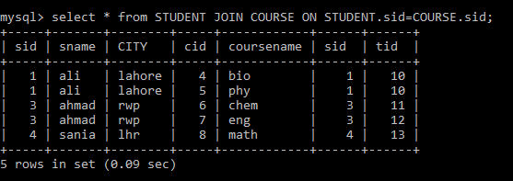

1. JOIN and INNER JOIN are same in MySQL:

**mysql> select * from STUDENT INNER JOIN COURSE ON STUDENT.sid=COURSE.sid;**

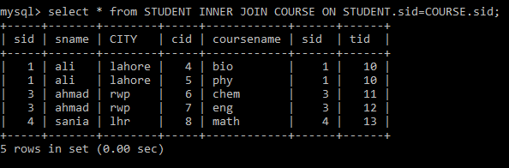

**JOIN Three Tables:**

**mysql> select * from STUDENT join COURSE ON STUDENT.sid=COURSE.sid join teacher on COURSE.tid=TEACHER.tid;**

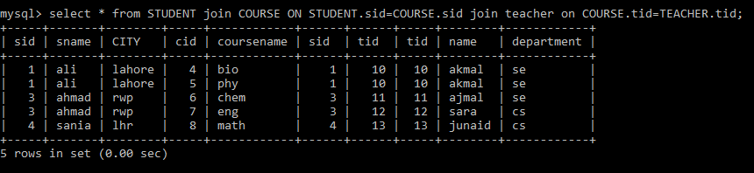

**mysql> select STUDENT.sname,COURSE.coursename,TEACHER.name from STUDENT join COURSE ON STUDENT.sid=COURSE.sid join teacher on COURSE.tid=TEACHER.tid;**

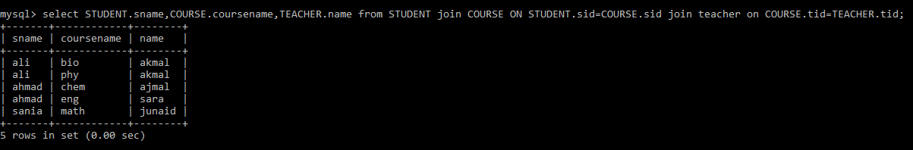

1. INNER JOIN with where clause:

**mysql> select STUDENT.sname,COURSE.coursename from STUDENT inner join COURSE ON STUDENT.sid=COURSE.sid where student.sid>2;**

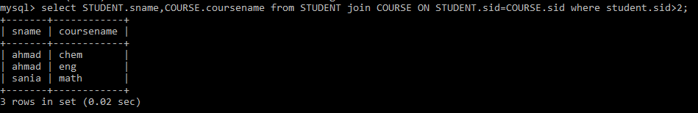

# **Lab 12: Sub Queries**

## **Purpose**

* + Learn different ways to extract data using sub queries
  + Learn Nesting of subqueries

## **Lab Activity/Code**

**Subquery Syntax :**

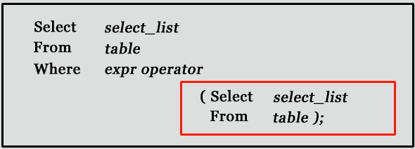

* The subquery (inner query) executes once before the main query (outer query) executes.
* The main query (outer query) use the subquery result.

**Subquery syntax as specified by the SQL standard and supported in MySQL**

DELETE FROM t1

WHERE s11 > ANY

(SELECT COUNT(*) /* no hint */ FROM t2

WHERE NOT EXISTS

(SELECT * FROM t3

WHERE ROW(5*t2.s1,77)=

(SELECT 50,11*s1 FROM t4 UNION SELECT 50,77 FROM

(SELECT * FROM t5) AS t5)));

A subquery can return a scalar (a single value), a single row, a single column, or a table (one or more rows of one or more columns). These are called scalar, column, row, and table subqueries.

**MySQL Subquery Example:**

Using a subquery, list the name of the employees, paid more than 'Alexander' from emp_details .

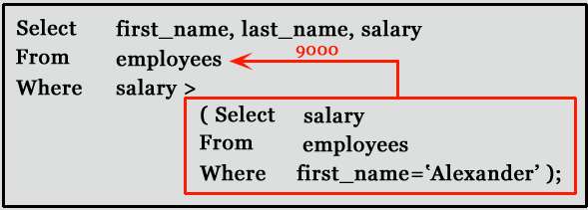

mysql> SELECT first_name,last_name, salary FROM emp_details

WHERE salary >(SELECT salary FROM emp_details

WHERE first_name='Alexander');

+------------+-----------+----------+

| first_name | last_name | salary |

+------------+-----------+----------+

| Steven | King | 24000.00 |

| Neena | Kochhar | 17000.00 |

| Lex | De Haan | 17000.00 |

| RABI | CHANDRA | 15000.00 |

| Ana | King | 17000.00 |

+------------+-----------+----------+

5 rows in set (0.00 sec)

**Subqueries: Guidelines**

There are some guidelines to consider when using subqueries :  
- A subquery must be enclosed in parentheses.   
- Use single-row operators with single-row subqueries, and use multiple-row operators with multiple-row subqueries.  
- If a subquery (inner query) returns a null value to the outer query, the outer query will not return any rows when using certain comparison operators in a WHERE clause.

**MySQL Subqueries: Using Comparisons**

A subquery can be used before or after any of the comparison operators. The subquery can return at most one value. The value can be the result of an arithmetic expression or a column function. SQL then compares the value that results from the subquery with the value on the other side of the comparison operator. You can use the following comparison operators:

| **Operator** | **Description** |
| --- | --- |
| = | Equal to |
| > | Greater than |
| >= | Greater than or equal to |
| < | Less than |
| <= | Less than or equal to |
| != | Not equal to |
| <> | Not equal to |
| <=> | NULL-safe equal to operator |

For example, suppose you want to find the employee id, first_name, last_name, and salaries for employees whose average salary is higher than the average salary throughout the company.

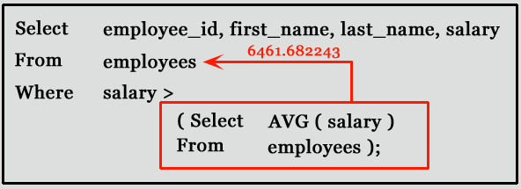

mysql> SELECT employee_id,first_name,last_name,salary

FROM employees WHERE salary >

(SELECT AVG(SALARY) FROM employees);

+-------------+-------------+------------+----------+

| employee_id | first_name | last_name | salary |

+-------------+-------------+------------+----------+

| 100 | Steven | King | 24000.00 |

| 101 | Neena | Kochhar | 17000.00 |

| 102 | Lex | De Haan | 17000.00 |

| 103 | Alexander | Hunold | 9000.00 |

| 108 | Nancy | Greenberg | 12000.00 |

| 109 | Daniel | Faviet | 9000.00 |

| 120 | Matthew | Weiss | 8000.00 |

| 121 | Adam | Fripp | 8200.00 |

| 122 | Payam | Kaufling | 7900.00 |

|- - - - - - - - - - - - - - - - - - - - - - - - - -|

|- - - - - - - - - - - - - - - - - - - - - - - - - -|

+-------------+-------------+------------+----------+

51 rows in set (0.00 sec)

**MySQL Subqueries with ALL, ANY, IN, or SOME**

You can use a subquery after a comparison operator, followed by the keyword ALL, ANY, or SOME.

The ALL operator compares value to every value returned by the subquery. Therefore ALL operator (which must follow a comparison operator) returns TRUE if the comparison is TRUE for ALL of the values in the column that the subquery returns.

**Syntax:**

operand comparison_operator ALL (subquery)

NOT IN is an alias for <> ALL. Thus, these two statements are the same:

Code:

SELECT c1 FROM t1 WHERE c1 <> ALL (SELECT c1 FROM t2);

SELECT c1 FROM t1 WHERE c1 NOT IN (SELECT c1 FROM t2);

Copy

Example: MySQL Subquery, ALL operator

The following query selects the department with the highest average salary. The subquery finds the average salary for each department, and then the main query selects the department with the highest average salary.

mysql> SELECT department_id, AVG(SALARY)

FROM EMPLOYEES GROUP BY department_id

HAVING AVG(SALARY)>=ALL

(SELECT AVG(SALARY) FROM EMPLOYEES GROUP BY department_id);

+---------------+--------------+

| department_id | AVG(SALARY) |

+---------------+--------------+

| 90 | 19333.333333 |

+---------------+--------------+

1 row in set (0.00 sec)

Note: Here we have used ALL keyword for this subquery as the department selected by the query must have an average salary greater than or equal to all the average salaries of the other departments.

The ANY operator compares the value to each value returned by the subquery. Therefore ANY keyword (which must follow a comparison operator) returns TRUE if the comparison is TRUE for ANY of the values in the column that the subquery returns.

**Syntax:**

operand comparison_operator ANY (subquery)

Example: MySQL Subquery, ANY operator

The following query selects any employee who works in the location 1800. The subquery finds the department id in the 1800 location, and then the main query selects the employees who work in any of these departments.

**employees table** :

**departments table**:

mysql> SELECT first_name, last_name,department_id

FROM employees WHERE department_id= ANY

(SELECT DEPARTMENT_ID FROM departments WHERE location_id=1800);

+------------+-----------+---------------+

| first_name | last_name | department_id |

+------------+-----------+---------------+

| Michael | Hartstein | 20 |

| Pat | Fay | 20 |

+------------+-----------+---------------+

2 rows in set (0.00 sec)

Note: We have used ANY keyword in this query because it is likely that the subquery will find more than one departments in 1800 location. If you use the ALL keyword instead of the ANY keyword, no data is selected because no employee works in all departments of 1800 location

When used with a subquery, the word IN (equal to any member of the list) is an alias for = ANY. Thus, the following two statements are the same:

Code:

SELECT c1 FROM t1 WHERE c1 = ANY (SELECT c1 FROM t2);

SELECT c1 FROM t1 WHERE c1 IN (SELECT c1 FROM t2);

Copy

The word SOME is an alias for ANY. Thus, these two statements are the same:

Code:

SELECT c1 FROM t1 WHERE c1 <> ANY (SELECT c1 FROM t2);

SELECT c1 FROM t1 WHERE c1 <> SOME (SELECT c1 FROM t2);

Copy

**MySQL Row Subqueries**

A row subquery is a subquery that returns a single row and more than one column value. You can use = , >, <, >=, <=, <>, !=, <=> [comparison operators](https://www.w3resource.com/mysql/comparision-functions-and-operators/between-and-operator.php). See the following examples:

Code:

SELECT * FROM table1 WHERE (col1,col2) = (SELECT col3, col4 FROM table2 WHERE id = 10);

SELECT * FROM table1 WHERE ROW(col1,col2) = (SELECT col3, col4 FROM table2 WHERE id = 10);

Copy

For both queries,

* if the table table2 contains a single row with id = 10, the subquery returns a single row. If this row has col3 and col4 values equal to the col1 and col2 values of any rows in table1, the WHERE expression is TRUE and each query returns those table1 rows.
* If the table2 row col3 and col4 values are not equal the col1 and col2 values of any table1 row, the expression is FALSE and the query returns an empty result set. The expression is unknown (that is, NULL) if the subquery produces no rows.
* An error occurs if the subquery produces multiple rows because a row subquery can return at most one row.

**Example: MySQL Row Subqueries**

In the following examples, queries shows differentr result according to above conditions :

**departments table**:

**employees table**:

mysql> SELECT first_name

FROM employees

WHERE ROW(department_id, manager_id) = (SELECT department_id, manager_id FROM departments WHERE location_id = 1800);

+------------+

| first_name |

+------------+

| Pat |

+------------+

1 row in set (0.00 sec)

Code:

mysql>SELECT first_name

FROM employees

WHERE ROW(department_id, manager_id) = (SELECT department_id, manager_id FROM departments WHERE location_id = 2800);

Empty set (0.00 sec)

Copy

Code:

mysql>SELECT first_name

FROM employees

WHERE ROW(department_id, manager_id) = (SELECT department_id, manager_id FROM departments WHERE location_id = 1700);

ERROR 1242 (21000): Subquery returns more than 1 row

# **Lab 13: Set Operations in MySQL**

## **Purpose**

* + Learn SET Operators (UNION, UNION ALL, INTERSECT, & EXCEPT) in MySQL.
  + Implement SET operations examples.

## **Lab Activity/Code**

The SET Operators in MySQL are basically used to combine the result of more than 1 select statement and return the output as a single result set. In SQL, 4 types of set operators are. They are as follows:

1. **UNION**: It is used to combine two or more result sets into a single set, without duplicates.
2. **UNION ALL**: It is used to combine two or more result sets into a single set, including duplicates.
3. **INTERSECT**: It is used to combine two result sets and returns the data which are common in both the result set.
4. **EXCEPT**: It is used to combine two result sets and returns the data from the first result set which is not present in the second result set.

We are going to use the following EmployeeUK and EmployeeUSA tables to understand the SET Operators in MySQL.

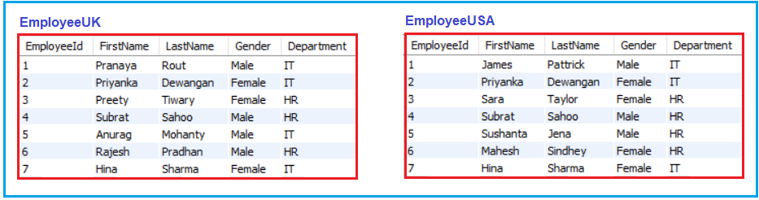

UNION Operator in MySQL

The UNION operator is used to combine the result set of two or more SELECT statements into a single result set by removing the duplicate records. That means the UNION Operator selects only the distinct values. Following is the Syntax to use UNION Operator in MySQL.

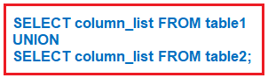

MySQL UNION Operator Example:

The following query combines two select statements using the UNION operator. In our example, both the EmployeeUK and EmployeeUSA tables having seven records.

**SELECT** FirstName, LastName, Gender, Department **FROM** EmployeeUK

**UNION**

**SELECT** FirstName, LastName, Gender, Department **FROM** EmployeeUSA;

Once you execute the above query, you will get the following result set. Please observe, here we don’t have any duplicate data. Here, in the result set, we got a total of 11 rows out of 14 rows. This is because 3 rows are present in both the result set.

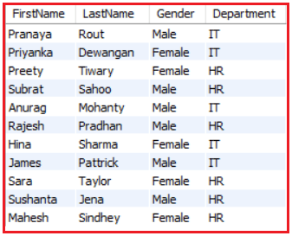

UNION ALL Operator in MySQL

The UNION ALL operator is used to combine the result set of two or more SELECT statements into a single result including the duplicate values. Following is the Syntax to use UNION ALL Operator in MySQL.

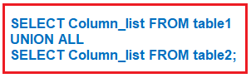

MySQL UNION ALL Operator Example:

The following query combines two select statements using the UNION ALL operator

**SELECT** FirstName, LastName, Gender, Department **FROM** EmployeeUK

**UNION** ALL

**SELECT** FirstName, LastName, Gender, Department **FROM** EmployeeUSA;

Once you execute the above query, you will get the following result set. Please observe, here we got all the 14 rows in the result set.

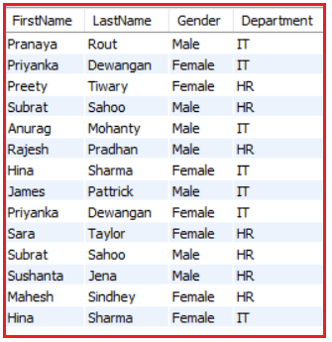

Differences between UNION and UNION ALL Operator in MySQL

From the output, it is very clear to us that UNION Operator removes duplicate rows whereas UNION ALL operator does not remove the duplicate rows. When we use a UNION operator, in order to remove the duplicate rows from the result set, it has to do a distinct operation which is time-consuming. For this reason, UNION ALL is much faster than UNION Operator in MySQL.

UNION/UNION ALL with ORDER BY Clause in MySQL

The UNION/UNION ALL Operator can be used with the ORDER BY clause to sort the result returned from the query. Suppose we want to sort the employees by First Name column values. ORDER BY clause should be part of the last select statement. The SQL statement will be:

**SELECT** FirstName, LastName, Gender, Department **FROM** EmployeeUK

**UNION**

**SELECT** FirstName, LastName, Gender, Department **FROM** EmployeeUSA

**ORDER BY** FirstName;

Now execute the query and you should get the following output.

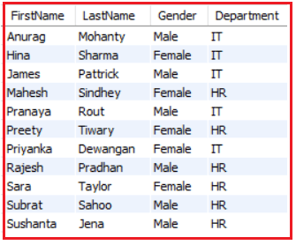

Here you can see the employees are sorted according to their FirstName column values.

MySQL EXCEPT Operator:

The EXCEPT operator is used to combine two tables or two result sets and will return rows from the first select statement that are not present in the second select statement. Following is the syntax of EXCEPT Operator.

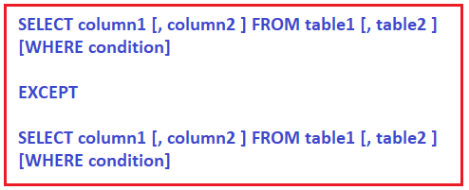

But, the EXCEPT Operator is not supported by MYSQL. We can achieve the EXCEPT Operator functionality in MySQL using the following ways.

Using NOT IN Operator to achieve EXCEPT functionality:

Here, we are checking the FirstName column value only. Following is the SQL Query using the NOT IN Operator which returns the employees from the first EmployeeUK table that are not present in the EmployeeUSA table.

**SELECT** * **FROM** EmployeeUK

**WHERE** FirstName NOT IN (**SELECT** FirstName **FROM** EmployeeUSA);

Once you execute the above query, you will get the following result set.

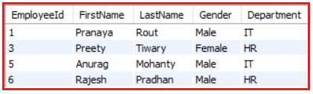

Using Join to achieve EXCEPT functionality in MySQL:

We can use LEFT JOIN to achieve the functionality of EXCEPT Operator. Here, the join clause needs to contain all 4 columns FirstName, LastName, Gender, and Department. The where clause picks null values in EmployeeId in EmployeeUSA, which limits to rows that exist in EmployeeUK only.

**SELECT** t1.* **FROM** EmployeeUK **AS** t1

**LEFT** **JOIN** EmployeeUSA **AS** t2 **ON**

t1.FirstName=t2.FirstName

AND t1.LastName=t2.LastName

AND t1.Gender=t2.Gender

AND t1.Department=t2.Department

**WHERE** t2.EmployeeId IS NULL;

Once you execute the above join query, you will get the following result set.

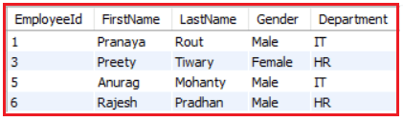

INTERSECT Operator in MySQL

The INTERSECT operator is used to combine two result sets and returns the data which are common in both the result set. Following is the syntax of INTERSECT operator.

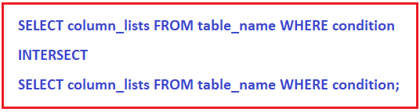

But the INTERSECT Operator is not supported by MYSQL. We can achieve the INTERSECT Operator functionality in MySQL using the following ways.

Using IN Operator to achieve INTERSECT functionality:

Here, we are checking the FirstName column value only. Following is the SQL Query using the IN Operator which returns the common employees i.e. the employees which are present in both t EmployeeUK and EmployeeUSA tables. Here, we are checking common based on the First Name column value.

**SELECT** * **FROM** EmployeeUK

**WHERE** FirstName IN (**SELECT** FirstName **FROM** EmployeeUSA);

Once you execute the above query, you will get the following result set.

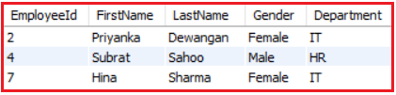

Using Join to achieve INTERSECT functionality in MySQL:

We can use INNER JOIN to achieve the functionality of INTERSECT Operator. Here, the join clause needs to contain all 4 columns FirstName, LastName, Gender, and Department.

**SELECT** t1.* **FROM** EmployeeUK **AS** t1

**INNER** **JOIN** EmployeeUSA **AS** t2 **ON**

t1.FirstName=t2.FirstName

AND t1.LastName=t2.LastName

AND t1.Gender=t2.Gender

AND t1.Department=t2.Department;

Once you execute the above join query, you will get the following result set.

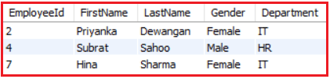

# **Lab 14: SQL project evaluation lab**

## **Purpose**

* + This lab is based on project evaluation, intended to take viva of students regarding their project i.e., a database design, implementation and use of CRUD operations if used.

## **Lab Activity**

Students will present their projects and answer the questions asked by students and teachers.